How to Teach
Text Types
===============================================
General Instructional Objectives:

At the end of this course, the students generally are expected to be able to write texts based on the genres of writing.
Specific Instructional Objectives:

At the end of this course, the students specifically are expected to:
- To know the basic theory of the genres of texts: recount, report, analytical exposition, news item, anecdote, narration, procedure, description, hortatory exposition, explanation, discussion, review, and commentary.
- To be able to analyze the social function, schematic structure, and significant grammatical patterns of texts.
- To be able to write texts based on the genres.
The Four Stages in the Teaching-Learning Cycle:

Building knowledge of the field:
Step 1
CLASS ↔ TEACHER STUDENTS ↔ STUDENTS
- Cultural context
- Shared experience
- Control relevant vocabulary
- Grammatical patterns

Tasks and Activities:

- Use of visual—photographs, filmstrips, video—to build context.
- Do activities such as cooking, going for a vacation, interviewing an informant, listening to guest speakers, etc.
- Reconstruct and discuss activities done when back in the classroom.
- Design activities in order to share, discuss, and argue about aspects of the topic.
- Set language lesson focused on vocabulary or grammatical patterns.
- Study a broad range of written texts related to the topic, such as school brochures, notes, newsletter, labels, leaflets, and enrolment forms.
- Develop reading strategies appropriate to the texts, including predicting, skimming, scanning, or identifying the logo.

Modeling of Text:
Step 2
CLASS ↔ TEACHER
- Cultural context
- Social function
- Schematic structure
- Linguistic features
Tasks and Activities:

- Study the model text shown by the teacher or read it yourself or collectively in the references.
- Develop an understanding of the social function and purpose of the text:
- Why are such texts written?
- By whom are they written and read?
- What is the context in which they will be used?

- Analyze the schematic structure of the text (distinguishing and labeling stages within the schematic structure of the genre).
- Analyze the grammatical pattern or language features of the text (use of tense, technical language, specific or generic participants).

Joint Construction of Text:
Step 3
STUDENTS ↔ STUDENTS TEACHER ↔ CLASS
- Schematic structure
- Linguistic features
- Knowledge of field
Tasks and Activities:

- Revise and discuss the purpose, context, and structure of genre/text.
- Explore further field building activities where necessary.
- Negotiate the beginning, middle and end construction of text between teacher and students, and between students, draw on shared knowledge about the genre.
- Re-draft and edit the text, draw on shared knowledge about the genre together in groups (between teacher and students, and between students).

Independent Construction Text:
Step 4
STUDENTS ↔ STUDENTS TEACHER ↔ STUDENTS
- Schematic structure
- Linguistic features
- Knowledge of field
Tasks and Activities:

- Build and develop knowledge of the field through activities such as reading, information gathering, and note taking.
- Write your own text with appropriate schematic structure and grammatical patterns.
- Consult with other students or with teacher regarding the appropriateness of the text.
- Re-drafting and editing where necessary.
- Discuss any difficulties with students or teachers in writing texts.
- Focus on language lessons (spelling, punctuation, layout of text, handwriting). (Hammond, 1992)

Text Types Analysis
===============================================
Text | Recount
1 | Recount

A. Study the schematic structure of the following text.

Schematic

17/8/2005

Dear Dewi,

On Saturday I went to Mount Bromo. I stayed at Nisa and Achmad’s house at Cemara Lawang, Probolinggo. It has a big garden with lots of colourful flowers and a fishpond.

On Sunday Nisa and I saw Gunung Batok and went on the scenic ride on horseback. It was scary. Then we went to get a closer look at the mountain. We took pictures of the beautiful sceneries there.

On Monday we went to the Zoo at Wonokromo. We saw cockatoos having a shower. In the afternoon I went home.

It was fun.

Love,

Dini

Structure

Orientation

Event

Event

Reorientation


B. Study the linguistic features of the following text.

Language
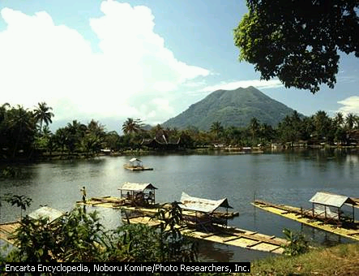

17/8/2005

Dear Dewi,

On Saturday I went to Mount Bromo. I stayed at Nisa and Achmad’s house at Cemara Lawang, Probolinggo. It has a big garden with lots of colourful flowers and a fishpond.

On Sunday Nisa and I saw Gunung Batok and went on the scenic ride on horseback. It was scary. Then we went to get a closer look at the mountain. We took pictures of the beautiful sceneries there.

On Monday we went to the Zoo at Wonokromo. We saw cockatoos having a shower. In the afternoon I went home.

It was fun.

Love,

Dini

Features

Who

When?

Where?
What?

Specific Participant

Past Tense

Linking Word to Do with Time

Action Verb/Past Tense

AV/Past Tense

Past Tense

Past Tense

Text | Spoof
2 | Spoof

- Text Analysis (Schematic Structure)
Study the schematic structure analysis of the spoof text below.

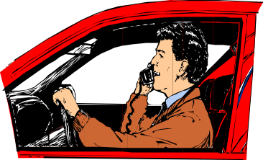

Do You Speak English?
Orientation
Event
Twist
I had an amusing experience last year.

After I had left a small village in the south of France, I drove on to the next town. On the way, a young man waved to me. I stopped and he asked me for a lift. As soon as he had got into the car, I said good morning to him in French and he replied in the same language. Apart from a few words, I do not know any French at all. Neither of us spoke during the journey.

I had nearly reached the town, when the young man suddenly said, very slowly, ‘Do you speak English?’ As I soon learned, he was English himself!

(Source: Practice and Progress, 1979)

- Text Analysis (Linguistic Features)
Study the linguistic features analysis of the spoof text below.

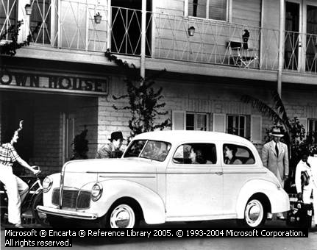

Do You Speak English?
Individual
Participant
Temporal Circum-stance
Past Tense
Action verb
Human participants
Past Tense
Spatial Circum-stance
Action verb
Past Tense
Past Tense
Action verb
Past Tense
Past Tense
Spatial Circum-stance

I had an amusing experience last year.

After I had left a small village in the south of France, I drove on to the next town. On the way, a young man waved to me. I stopped and he asked me for a lift. As soon as he had got into the car, I said good morning to him in French and he replied in the same language. Apart from a few words, I do not know any French at all. Neither of us spoke during the journey.

I had nearly reached the town, when the young man suddenly said, very slowly, ‘Do you speak English?’ As I soon learned, he was English himself!

(Source: Practice and Progress, 1979)

Text | Analytical  Exposition
3 | Analytical  Exposition

A. Study the schematic structure of the text.

The Public Trustee is a Sound Investment

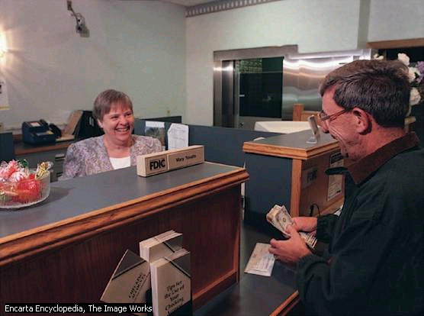

It is a well-known fact that it is a dilemma for many people to make a will, without the added problems of deciding who should draw up this document.
Thesis: Position
Arguments
Reiteration/
Summing Up

This task is made simple with the availability of service from the Public Trust Officer.

Firstly the Office has a large efficient staff which includes barristers, solicitors, accountants, valuers, and qualified property inspector. Knowledge of the legal aspect is very well covered.

Also the charges need consideration. Here at this Office there are no charges for making or the holding of a will.

Furthermore, the Public Trustee is guaranteed by the State of Queensland and has special powers to solve problems or simplify procedures which, in the long term, save expense.

Therefore, it can be clearly seen that there is only one sound choice in making your will – the Public Trustee – as it is permanent, efficient, and secure. You should consider this!

B. Study the linguistic features of the text.



Words that indicate writer’s attitude
Verbs of having and being
Verbs of having and being
Verbs of thinking and feeling
Verbs of thinking and feeling
Modalities
It is a well-known fact that it is a dilemma for many people to make a will, without the added problems of deciding who should draw up this document.
This task is made simple with the availability of service from the Public Trust Officer.
Firstly the Office has a large efficient staff which includes barristers, solicitors, accountants, valuers, and qualified property inspector. Knowledge of the legal aspect is very well covered.
Also the charges need consideration. Here at this Office there are no charges for making or the holding of a will.
Furthermore, the Public Trustee is guaranteed by the State of Queensland and has special powers to solve problems or simplify procedures which, in the long term, save expense.
Therefore, it can be clearly seen that there is only one sound choice in making your will – the Public Trustee – as it is permanent, efficient, and secure. You should consider this!

Text | News Item
4 | News Item

- Study the schematic structure of the text.

Russian Nuclear Catastrophe 
Headline
Moscow—A Russian journalist has uncovered evidence of another Soviet nuclear catastrophe, which killed 10 sailors and contaminated an entire town.
Newsworthy Event
Yelena Vazrshavskya is the first journalist to speak to people who witnessed the explosion of a nuclear submarine at the naval base of Shkotovo-22 near Vladivostock.
The accident, which occurred 13 months before the Chernobyl disaster, spread radioactive fall-out over the base and nearby town, but was covered up by officials of the then Soviet Union. Residents were told the explosion in the reactor of the Victor-class submarine during a refit had been a ‘thermal’ and not a nuclear explosion. And those involved in the clean-up operation to remove more than 600 tons of contaminated materials were sworn to secrecy.
Background Events
A board of investigators was later to describe it as the worst accident in the history of the Soviet Navy.
Sources

Taken from Making Sense of Functional Grammar, 1995.

- Study the linguistic features of the text.

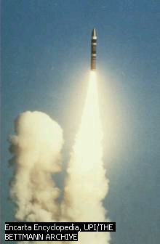
Moscow—A Russian journalist has uncovered evidence of another Soviet nuclear catastrophe, which killed 10 sailors and contaminated an entire town.
Action verb
Action verb
Action verb
Circumstance of place
Saying verb
Circumstance of time
Yelena Vazrshavskya is the first journalist to speak to people who witnessed the explosion of a nuclear submarine at the naval base of Shkotovo-22 near Vladivostock.
The accident, which occurred 13 months before the Chernobyl disaster, spread radioactive fall-out over the base and nearby town, but was covered up by officials of the then Soviet Union. Residents were told the explosion in the reactor of the Victor-class submarine during a refit had been a ‘thermal’ and not a nuclear explosion. And those involved in the clean-up operation to remove more than 600 tons of contaminated materials were sworn to secrecy.
A board of investigators was later to describe it as the worst accident in the history of the Soviet Navy.

Taken from Making Sense of Functional Grammar, 1995.

Text | Narrative
5 | Narrative

- Study the schematic structure of the text.

Cinderella
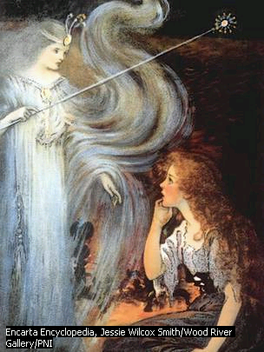
Once upon a time there was a young girl named Cinderella who lived with her stepmother and two stepsisters.
Orientation
Major Complication
Complication
Cinderella’s stepmother and stepsisters were conceited and bad tempered. They treated Cinderella very badly. Her stepmother made Cinderella do the hardest work in the house, such as scrubbing the floor and cleaning the pots and pans. She gave Cinderella an old ragged dress to wear. The two stepsisters, on the other hand, did no work about the house, and their mother gave them many handsome dresses to wear.
One day the two stepsisters received an invitation to a ball that the king’s son was going to give at the palace. They were excited about this and spent so much time choosing the dresses they would wear. At last the day of the ball came, and away went the sisters to it. Cinderella could not help crying after they had left.

“Why are you crying, Cinderella? A voice asked. She looked up and saw her fairy godmother standing beside her. “Because I want so much to go to the ball,” said Cinderella. “Well,” said her godmother, “you’ve been such a cheerful, uncomplaining, hardworking girl that I am going to see that you do go to the ball”.
Resolution
Major Complication/
Crisis
Major Resolution
Magically, the fairy godmother changed a pumpkin into a fine coach and mice into a coachman and two footmen. Her godmother tapped Cinderella’s ragged dress with her wand, and it became a beautiful ball gown. Then she gave her a pair of pretty glass slippers. “Now, Cinderella,“ she said, “you must leave before midnight.” Then, away she drove in her beautiful coach.
Cinderella was having a wonderfully good time. She danced again and again with the king’s son. Suddenly, the clock began to strike twelve. She ran towards the door as quickly as she could. In her hurry, one of her glass slippers came off and was left behind.
A few days later the king’s son proclaimed he would marry the girl whose foot fitted the glass slipper. The king’s page came to Cinderella’s house. Her stepsisters tried on the slipper but it was too small for them no matter how hard they squeezed their toes into it. The king’s page let Cinderella try on the slipper. She stuck out her foot, and the page slipped the slipper on. It fitted perfectly.
Finally, she was driven to the palace. The king’s son was overjoyed to see her again. They were married and lived happily ever after.

- Study the following text and its language features.

Cinderella
Once upon a time there was a young girl named Cinderella who lived with her stepmother and two stepsisters.
Cinderella’s stepmother and stepsisters were conceited and bad tempered. They treated Cinderella very badly. Her stepmother made Cinderella do the hardest work in the house, such as scrubbing the floor and cleaning the pots and pans. She gave Cinderella an old ragged dress to wear. The two stepsisters, on the other hand, did no work about the house, and their mother gave them many handsome dresses to wear.
Specific Participant
Action Verb
Past Tense
Conjunction
Connector
Action Verb
Saying verb
Connector
Circumstances of time
Linking verb
Circumstances of place
Saying verb
Past tense
Saying verb
Past tense
Mental verb
One day the two stepsisters received an invitation to a ball that the king’s son was going to give at the palace. They were excited about this and spent so much time choosing the dresses they would wear. At last the day of the ball came, and away went the sisters to it. Cinderella could not help crying after they had left.
“Why are you crying, Cinderella? A voice asked. She looked up and saw her fairy godmother standing beside her. “Because I want so much to go to the ball,” said Cinderella. “Well,” said her godmother, “you’ve been such a cheerful, uncomplaining, hardworking girl that I am going to see that you do go to the ball”.
Magically, the fairy godmother changed a pumpkin into a fine coach and mice into a coachman and two footmen. Her godmother tapped Cinderella’s ragged dress with her wand, and it became a beautiful ball gown. Then she gave her a pair of pretty glass slippers. “Now, Cinderella,“ she said, “you must leave before midnight.” Then, away she drove in her beautiful coach.
Cinderella was having a wonderfully good time. She danced again and again with the king’s son. Suddenly, the clock began to strike twelve. She ran towards the door as quickly as she could. In her hurry, one of her glass slippers came off and was left behind.
A few days later the king’s son proclaimed he would marry the girl whose foot fitted the glass slipper. The king’s page came to Cinderella’s house. Her stepsisters tried on the slipper but it was too small for them no matter how hard they squeezed their toes into it. The king’s page let Cinderella try on the slipper. She stuck out her foot, and the page slipped the slipper on. It fitted perfectly.
Finally, she was driven to the palace. The king’s son was overjoyed to see her again. They were married and lived happily ever after.

Text | Procedure
6 | Procedure

- Study the schematic structure of the text.
Schematic Structure
Step 1
Step 2
Step 3
Step 4
Step 5
Step 6
Step 7
Step 8
Here is the recipe you need to make
Mushroom Soup.

Goal : Mushroom Soup
Materials : 12 ounces mushrooms
4 eggs yolks
½ teaspoon grated nutmeg
2 tablespoons chopped parsley
1½ teaspoons salt
6 tablespoons cream
¼ teaspoon pepper
2 pints chicken stock
Procedure :
- Prepare mushrooms and place in frying pan with melted butter.
- Cover and cook for 10 minutes. Add stock.
- Season with salt, pepper and nutmeg.
- Bring to boil and then simmer for 30 minutes.
- Sieve and blend until smooth, with remaining ingredients.
- Return to pan and heat. Remove pan from stove and cool.
- Add beaten egg yolks and cream, stirring gently. Do not boil.
- Garnish with chopped parsley and serve.

Taken from International Cooking Recipes

- Study the following text and its language features.

Goal: Playing the Hole Game
Materials needed:
- One marble per person
- A hole in ground
- A line (distance) to start from
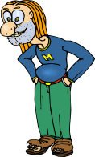
Temporal Connective
Numbering of point
Imperative
Generalized human agent
(often implicit)
Action verb
Temporal Connective
Action verb
Action verb

- First you must dub (click marbles together)
- Then check that the marbles are in good condition and are nearly worth the same value.
- Next you must dig a hole in the ground and draw a line a fair distance away from the hole.
- The first player carefully throws his or her marble towards the hole.
- Then the second player tries to throw his or her marble closer to the hole than his or her opponent.
- The player whose marble is closest to the hole tries to flick his or her marble into the hole. If successful, this player tries to flick his or her opponent’s marble into the hole. The person flicking the last marble into the hole wins and gets to keep both marbles.

Taken from
Making Sense of Functional Grammar

Text | Descriptive
7 | Descriptive

  - Study the schematic structure of the text.

Borobudur Temple
Identification
Description
Borobudur is a great Buddhist temple.

The temple is located in Magelang on the island of Java in Indonesia. Built in the 9th century under the Sailendra dynasty of Java, it was abandoned in the 11th century and partially excavated by archaeologists in the early 20th century.

Influenced by the Gupta architecture of India, the temple is constructed on a hill 46 m (150 ft) high and consists of eight steplike stone terraces, one on top of the other. The first five terraces are square and surrounded by walls adorned with Buddhist sculpture in bas-relief; the upper three are circular, each with a circle of bell-shaped stupas (Buddhist shrines). The entire edifice is crowned by a large stupa at the center of the top circle. The way to the summit extends through some 4.8 km (some 3 mi) of passages and stairways. The design of Borobudur, a temple-mountain symbolizing the structure of the universe, influenced temples built at Angkor, Cambodia. Borobudur was rededicated as an Indonesian national monument in 1983 following extensive reclamation, aided by the United Nations.

(Microsoft ® Encarta ® Reference Library 2005)

  - Study the linguistic features of the text.
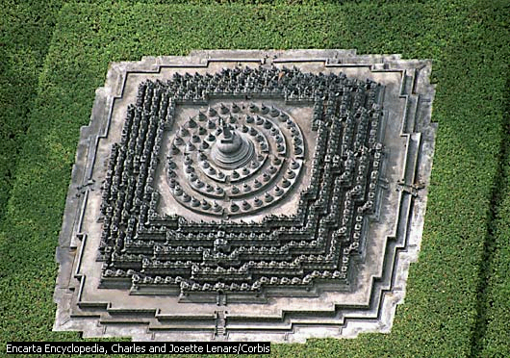
Borobudur Temple

Borobudur is a great Buddhist temple.
Specific
participant
Simple Present
Tense
Noun phrase
Being verb
Adjective
Simple Present Tense
Being verb
Noun phrase

The temple is located in Magelang on the island of Java in Indonesia. Built in the 9th century under the Sailendra dynasty of Java, it was abandoned in the 11th century and partially excavated by archaeologists in the early 20th century.

Influenced by the Gupta architecture of India, the temple is constructed on a hill 46 m (150 ft) high and consists of eight steplike stone terraces, one on top of the other. The first five terraces are square and surrounded by walls adorned with Buddhist sculpture in bas-relief; the upper three are circular, each with a circle of bell-shaped stupas (Buddhist shrines). The entire edifice is crowned by a large stupa at the center of the top circle. The way to the summit extends through some 4.8 km (some 3 mi) of passages and stairways. The design of Borobudur, a temple-mountain symbolizing the structure of the universe, influenced temples built at Angkor, Cambodia. Borobudur was rededicated as an Indonesian national monument in 1983 following extensive reclamation, aided by the United Nations.

(Microsoft ® Encarta ® Reference Library 2005)

Text | Hortatory Exposition
8 | Hortatory Exposition

- Study the schematic structure of the text.

OPEN LETTER TO THE PRIME MINISTER

The Hon RJ Hawke, MP
Prime Minister
Parliament House
CANBERRA ACT 2600

Dear Prime Minister,

Into the Mouth of Babes
We are writing to you because we are concerned about the way food is being advertised to children.
Thesis
Argument
1
Argument
2
Argument
3
Recom-mendation
What we eat now affects our health in years to come. Bad dietary habits start while we are very young. For this reason, your government supports health education that encourages a balanced healthy diet. Australians are encouraged to get the bulk of their nutrients from fresh fruits, vegetables, and wholegrain cereals, a lesser amount from foods high in fat, salt and sugar.
TV advertising to children presents a completely different message. Nearly 80% of food advertising pushes fatty snacks or sweets – the very foods that should be eaten least. To make matter worse, these ads take up much of the advertising time. This must be stopped.
TV advertising is powerful and influential. Parents, however strong-willed, find it hard to resist pressures created by this advertising. Children are least able to understand the tricks of the advertising industry.
For the hours when children are the main audience, TV advertising of foods must be made to reinforce, not undermine, the message about a balanced diet. We appeal to you, as Prime Minister, to take the lead in calling together the advertisers, TV networks, consumers and public health bodies to decide how this is to be done.

Yours sincerely,

Signed by Barbara Biggins and other prominent signatories.

- Study the following text and its language features.
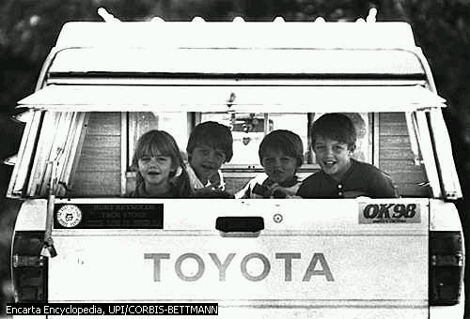
OPEN LETTER TO THE PRIME MINISTER

The Hon RJ Hawke, MP
Prime Minister
Parliament House
CANBERRA ACT 2600

Dear Prime Minister

Into the Mouth of Babes
Causal Connective
Action verb
Generic participant
Strong modality
Being verb
Specific participant
Simple Present Tense
Simple Present Tense
Generic participant

We are writing to you because we are concerned about the way food is being advertised to children.

What we eat now affects our health in years to come. Bad dietary habits start while we are very young. For this reason, your government supports health education that encourages a balanced healthy diet. Australians are encouraged to get the bulk of their nutrients from fresh fruits, vegetables, and wholegrain cereals, a lesser amount from foods high in fat, salt and sugar.

TV advertising to children presents a completely different message. Nearly 80% of food advertising pushes fatty snacks or sweets – the very foods that should be eaten least. To make matter worse, these ads take up much of the advertising time. This must be stopped.

TV advertising is powerful and influential. Parents, however strong-willed, find it hard to resist pressures created by this advertising. Children are least able to understand the tricks of the advertising industry.

For the hours when children are the main audience, TV advertising of foods must be made to reinforce, not undermine, the message about a balanced diet. We appeal to you, as Prime Minister, to take the lead in calling together the advertisers, TV networks, consumers and public health bodies to decide how this is to be done.

Yours sincerely,

Signed by Barbara Biggins and other prominent signatories.

Text | Explanation
9 | Explanation

- Study the following schematic structure of the text.


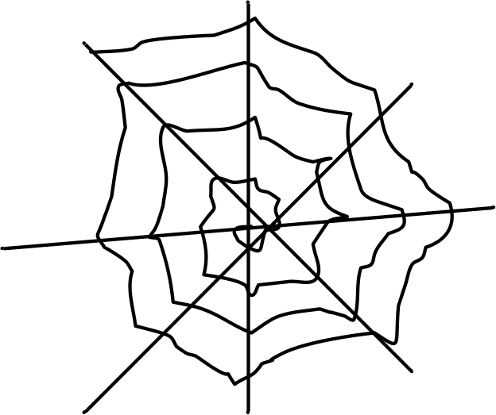
How a Spider’s Web Forms
A spider web looks delicate but it is very strong. It can hold 4000 times a spider’s weight. But how does it form

First the spider spins a thread of silk. The thread gets blown over to a branch by the wind. Then she makes another two threads and makes a Y shape. Next she makes more threads and they look like spokes off a wheel. Then the spider goes in a spiral, out and back in, sits in the middle and waits for food.

This is how a web is formed.
www.tki.org.nz/r/assessment/exemplars/eng/

General Statement
Explanation:
Shows the processes

Closing

- Study the following text and its language features.
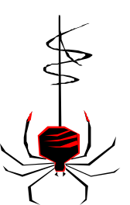
How a Spider’s Web Forms
A spider web looks delicate but it is very strong. It can hold 4000 times a spider’s weight. But how does it form?

First the spider spins a thread of silk. The thread gets blown over to a branch by the wind. Then she makes another two threads and makes a Y shape. Next she makes more threads and they look like spokes off a wheel. Then the spider goes in a spiral, out and back in, sits in the middle and waits for food.

This is how a web is formed.
www.tki.org.nz/r/assessment/exemplars/eng/

Generalized non-human participant
Present Tense
Action verb
Conjunctive relation
Action verb
Conjunctive relation

Conjunctive relation

Conjunctive relation

Passive voice

Text | Discussion
10 | Discussion

- Study the schematic structure of the following text.

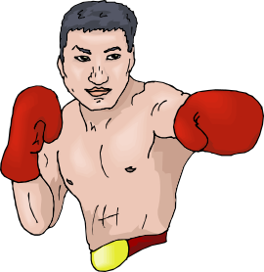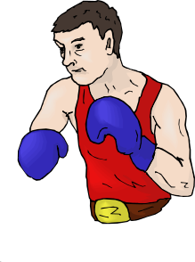
Boxing
By Kerry Williams
There was a lot of discussion about whether boxing should be banned.
Issue
Argument against
Argument for
Conclusion
The people who agree with this idea, such as Sarah, claim that if they do carry on boxing they should wear something to protect their heads. They also argue that people who do boxing could have brain damage and get seriously hurt. A further point they make is that most of the people that have died did have families.
However, there are also strong arguments against this point of view. Another group of people believe that boxing should not be banned. They say that why they invent it if it is a dangerous sport. They say that boxing is a good sport, people enjoy it. A furthermore reason is if they ban boxing it will ruin people’s careers.
After looking at the different points of view and the evidence for them I think boxing should be banned because five hundred people have died in boxing since 1884.

http://www.readingonline.or/articles/writing/discuss1.htm
- Study the linguistic features of the text.

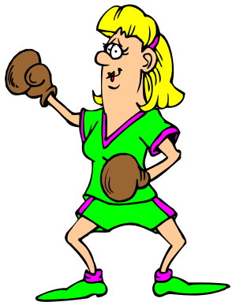
Boxing
Generic human participant
Generic non-human participant
modality
Being verb
Conjunctive relation
Mental verb
Saying verb
Conjunctive relation
modality
Mental verb
By Kerry Williams
There was a lot of discussion about whether boxing should be banned.
The people who agree with this idea, such as Sarah, claim that if they do carry on boxing they should wear something to protect their heads. They also argue that people who do boxing could have brain damage and get seriously hurt. A further point they make is that most of the people that have died did have families.
However, there are also strong arguments against this point of view. Another group of people believe that boxing should not be banned. They say that why they invent it if it is a dangerous sport. They say that boxing is a good sport, people enjoy it. A furthermore reason is if they ban boxing it will ruin people’s careers.
After looking at the different points of view and the evidence for them I think boxing should be banned because five hundred people have died in boxing since 1884.

http://www.readingonline.or/articles/writing/discuss1.htm
Text | Review
11 | Review

- Study the schematic structure of the text.

Harry Potter and the Chamber of Secrets
By J.K. Rowling
Reviewed by Emily Kremer
The book takes place in modern times, in England. The main character is Harry Potter. Harry Potter is a wizard. He goes to a school for witches and wizards, called Hogwarts.
It is Harry’s second year at Hogwarts and he and his two best friends, Hermione Granger and Ron Weasley are having a great time learning magic. There is a new professor, Gilderoy Lockhart who all the witches are crazy about! Professor Lockhart keeps nagging Harry, because the professor thinks that Harry tries to get attention to be famous! While all the witches at school love the new professor, all of the wizards think he is a big joke!
After a month of school at Hogwarts, strange attacks begin to happen. First, the caretaker’s cat, Mrs. Norris, has been found, not dead, but petrified! Not only was Filch’s cat attacked, but some of the Muggle-born students at Hogwarts have been found petrified, also. Naturally, all of the students are frightened at this, but they become even more scared when the next victim to be found petrified is the Gryffindor ghost, Nearly Headless Nick!
What kind of monster is powerful enough to kill someone who is already dead? Who will be the next victim of the monster at Hogwarts? Will the victims ever be revived? To find out you must read Harry Potter and the Chamber of Secrets! I have to say that the story was bright, fast-paced, intriguing, and ultimately satisfying.
I like this book because it kept me wanting to read next page, and the next, and so on. The book is definitely a page-turner! I recommend this book to nine years old and over.

Taken from http://nome.nosd.schoolaccess.net

Orientation:
Introduces the work elements.

Interpretative Recount:
Sets plot of the story:
Opening
Climax

Evaluative Summation:
Shows
the writer ‘s opinions or criticism.

Resolution:
The writer draws a questioning of the story ending.

- Study the following text and its language features.

Harry Potter and the Chamber of Secrets
By J.K. Rowling
Reviewed by Emily Kremer
The book takes place in modern times, in England. The main character is Harry Potter. Harry Potter is a wizard. He goes to a school for witches and wizards, called Hogwarts.
It is Harry’s second year at Hogwarts and he and his two best friends, Hermione Granger and Ron Weasley are having a great time learning magic. There is a new professor, Gilderoy Lockhart who all the witches are crazy about! Professor Lockhart keeps nagging Harry, because the professor thinks that Harry tries to get attention to be famous! While all the witches at school love the new professor, all of the wizards think he is a big joke!
After a month of school at Hogwarts, strange attacks begin to happen. First, the caretaker’s cat, Mrs. Norris, has been found, not dead, but petrified! Not only was Filch’s cat attacked, but some of the Muggle-born students at Hogwarts have been found petrified, also. Naturally, all of the students are frightened at this, but they become even more scared when the next victim to be found petrified is the Gryffindor ghost, Nearly Headless Nick!
What kind of monster is powerful enough to kill someone who is already dead? Who will be the next victim of the monster at Hogwarts? Will the victims ever be revived? To find out you must read Harry Potter and the Chamber of Secrets! I have to say that the story was bright, fast-paced, intriguing, and ultimately satisfying.
I like this book because it kept me wanting to read next page, and the next, and so on. The book is definitely a page-turner! I recommend this book to nine years old and over.

Taken from http://nome.nosd.schoolaccess.net

Specific participant
Circumstance of place
Present Tense
Specific participant
Circumstance of time
Circumstance of manner
Nominal groups
Action verb
Words to indicate writer’s attitude
Circumstance of manner

References

Boardman, C.A. and Frydenberg, J. 2002. Writing to Communicate: Paragraph and Essay. New York: Longman.
Derewianka, B. 1995. Exploring How Texts Work. Australia: Primary English Teaching Association.
Gerot, L. and Wignell, P. 195. Making Sense of Functional Grammar. NSW: Antipodean Educational Enterprises.
Hammond, J., et al. 1992. English for Social Puposes. Sydney: national Centre for English Language Teaching and Research.
Hannessy, M. 1998. The Random House: Practice for Writers. New York: American Book Company.
Harmer, J. 2004. How to Teach Writing. England: Longman.
Hartono, R. 2004. Genre-Based Writing. English Department of Semarang State University. Unpublished.
……………… 2004. Belajar Kreatif Bahasa Inggris. Bekas: Pustaka Gemilang.
Macken, M. 1991. Book 1: An Introduction to Genre-Based Writing. Australia: Common Ground for Literary & Education Research Network.
Martin, C. et al. 1985. Exploring American English: Writing Skills for Classroom and Career. New York: Macmillan Publishing Company.
Oshima, A. and Hogue, A. 1988. Introduction to Academic Writing. USA: Addison-Wesley Publishing Company, Inc.
Reid, J.M. 2000. The Process of Composition. Third Edision. New York: Longman.
Segal, M.K. and Pavlik C. 2003. Interaction 1 & 2: Writing. International Edition. 4th Edition. New York: McGraw-Hill Companies.

