UNIT 1
How to make , How to do….

Mata Pelajaran : Bahasa Inggris
Satuan Pendidikan : SMP
Kelas/Semester : IX/1

Standar Kompetensi
A. Mendengarkan
- Memahami makna dalam percakapan transaksional dan interpersonal pendek sederhana untuk berinteraksi dengan lingkungan sekitar
- Memahami makna dalam teks lisan fungsional dan monolog pendek sederhana berbentuk procedure untuk berinteraksi dengan lingkungan sekitar.
B. Berbicara
- Mengungkapkan makna dalam percakapan transaksional dan interpersonal lisan pendek sederhana untuk berinteraksi dengan lingkungan sekitar.
- Mengungkapkan makna dalam teks lisan fungsional dan monolog pendek sederhana berbentuk procedure untuk berinteraksi dengan lingkungan sekitar.
C. Membaca
- Memahami makna dalam esai pendek sederhana berbentuk berbentuk procedure untuk berinteraksi dengan lingkungan sekitar.
D. Menulis
- Mengungkapkan makna dalam teks tulis fungsional dan esei sederhana berbentuk procedure untuk berinteraksi dengan lingkungan sekitar.

Materi Pembelajaran:
A. Speech functions : Carrying out transactional or interpersonal conversation involving expressions of :
- Expressing certainty and uncertainty
B. Monolog : Listen Tell, read and write various procedures texts
C. Short Functional text : Read and write short functional text (Making Invitation letter), Giving Direction
D. Language features : Imperatives (Command and Prohibition), Past Participle, Simple present tense.
Noun Phrase, Adverb

PART 1
SPOKEN ACTIVITIES

A. Building knowledge
A.1. Speech Functions (Listening and Speaking)
A.1.1. Expression of Certainty and Uncertainty
Activity 1
Observe the dialog!
Can you spell the English alphabet fluently?
I am not sure. I just learn a little about them.
Certainly. I have learn it everyday at school.

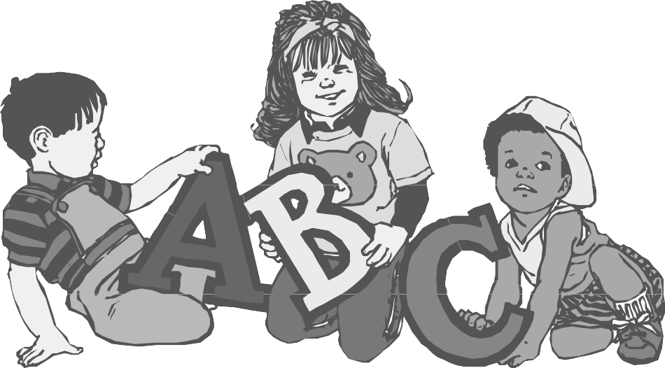

Questions :
- What does the little girl express: He expresses his ________________________________
- What does the little boy express: She expresses her ________________________________

Activity 2
Repeat after your teacher ! Then read the dialog in pairs.
A. Melly : Can I you come to my party tonight?
Kelly : I am sure I can. I have no schedule tonight
B. Kelly : Will you leave for London tomorrow?
Melly : I;m not sure. I don’t have the plane ticket yet.
C. Kelly : How about using my car. Will you accompany me?
Melly : Certainly.
D. Kelly : Will your father get better soon?
Melly : I’m not certain. He is still weak now.

Activity 3
Learn the following expression!

Expression of certain | Expression of uncertainty
I’m sure ……….  Of course  Absolutely  Definitely  I have no doubt about ……..  Of course  I one hundred percent sure that…… | I’m not sure  I doubt about…….  I’m not certain  I can’t decide  I can’t say for sure

Activity 4
Give the suitable expression of certainty or uncertainty.
1. Dina : Are you sure that your football team will lose on the first match?
Sari : ……………………………. We don’t have any preparation for that.
2. Dudi : Does Mrs. Ira teach today?
Ahmad : …………………………... I look for her at the office but she isn’t there
3. Ali : Will you come to Melly’s birthday party?
Udin : ……………………..I have prepared my best dress for that.
4. Nasrul : My friend and I plan to have a camping . Will you join us?
Fatimah : …………………… I have to finish my homework.
5. Joko : Can you save the building from the fire?
Fireman : ……………………..We are professional. We have experience about it.

A.2. Monolog
Activity 5
Listen to your teacher reading the following text!
A glass of ice tea in a hot day! Wow, it makes us fresher. If you want to make ice tea, first prepare a half glass of tea, one or two spoon full of sugar, and ice. Next step is put the sugar into the glass of tea, stir it well. After that add some pieces of ice into the glass and stir it again and the ice tea is ready to serve.
.
Answer the following questions!
- Can you guess, what is the purpose of the text!
…………………………………………………………………………………………………..
- What tense does the text mostly use?
…………………………………………………………………………………………………..
- Does the text mention the materials/ingredients needed to make ice tea?
…………………………………………………………………………………………………..
- What are they?
…………………………………………………………………………………………………..
- What kind of text is the text above called?
…………………………………………………………………………………………………..
A.3. Language features
A.3.1. Imperative
Activity 6
Observe the pictures
Lift the bag to the upper floor!
- Positive Command


Yes, Sir.

Don’t sit on the paper, please!
2. Negative Command
Uh. Ok, Sir. I’ll get down.



Activity 7.
Supply an appropriate expression (positive or negative command) in the following sentences.
1. _________________ me with this luggage. It is very heavy.
2. _________________ your car in front of my house. I can’t go in and out.
3. _________________ the application form, please.
4. _________________ the calculator please. It is prohibited
5. _________________ that radio here. It is noisy. I am reading. Don’t you know?
6. _________________ in the lesson. It’s disturbing the other students.
7. _________________ 0ut, a truck is coming.
8. _________________ a “Hello” magazine on your way home. I want to improve my English.
9. _________________ too loud. They will hear us.
10. ________________ here until I come back.

Activity 8.
Fill in the blank with the word from the box
Wait
Insert
Put
Lift
Dial

How to use a public phone
First, (1)___________ _ the phone receiver.
Then,(2) ____________the coin
Next, (3)_____________ the number you want.
(4)__________for the dial tone.
Finally, ( 5) _______________the receiver back after you finish the conversation.

A. 3. 2. Past Participles
Activity 9 .
Learn the explanation, then do the task.
Past participle (the third form of verbs) are used in a recipe, especially in the ingredients to express a passive form.
- 2 onions , sliced
- 5 carrots , diced
- meat , cut
Activity 10
Change the verb into past participles
No. | Verbs | Past participles | No. | verbs | Past participles
1. | Crush |  | 9. | Melt
2. | Quarter |  | 10. | Grate
3. | Seed |  | 11. | Mash
4. | Shell |  | 12. | Dry
5. | Remove |  | 13. | Boil
6. | Beat |  | 14. | Drain
7.. | Shred |  | 15. | Chop
8. | peel |  | 16. | slice
Activity 11.
Complete the phrases below with the suitable words from the tables above.
- 5 eggs, ___________________________________________________
- 4 big coconut, ______________________________________________
- a kilo of prawn, _____________________________________________
- 30 gram of margarine, ________________________________________
- 5 cloves of onions, ___________________________________________
- 5 potatoes, _________________________________________________
- 5 oz of cow meat, ____________________________________________
- 5 small chilies, _______________________________________________
- 1 bowl of corn, _______________________________________________
- 2 large carrots, _______________________________________________

B. Modelling of Text
Activity 12
Match these English words with their Indonesians. Number 1 has been done for you.

No | English |  | Indonesian
1 | Boil |  | Mencincang
2 | Simmer |  | Melumatkan
3 | Pour |  | Menggoreng
4 | Drain |  | Bilas
5 | Mix |  | Disajikan
6 | Spread |  | Lembut
7 | Separate |  | Mengiris
8 | Add |  | Kucek
9 | Dissolve |  | Mengupas
10 | soak |  | Bumbu
11 | Crush |  | Menambah
12 | Rub |  | Merebus
13 | Soft |  | Melarutkan
14 | Seasonings |  | Keringkan
15 | Served |  | Menuang
16 | Rinse |  | Mencampur
17 | Slice |  | Memisah
18 | Chop |  | Mengaduk
19 | Fry |  | Merendam
20 | Peel |  | Menabur

Activity 13
Fill in the blank with the words in activity 9
- If you want to wash your clothes, first ………..them into colored clothes and white ones.
- ……….the detergent into the water before the clothes.
- Can I ………….some salt? The food is rather tasteless.
- We should ………our clothes three times in order to get them clean.
- Before the instant noodle is served, ……….the fried onion to get delicious taste.
- Steer the sugar in your coffee well and make sure it ………….before you drink it.
- Mona, can you help……………and……………the onions. I’ll fry it.
- Don’t forget to put………………..to make it delicious.

Activity 14
Complete the following cooking instruction with the word provided in the box.
a. drain b. mix c. simmer d. spread e. pour f. served g. boil h. cooked

- ………… noodles into 400cc(2glasses) of briskly water and …………… for 3 minutes.
- ………… the seasoning, soy sauce, and chili sauce on a bowl while noodles is being ………….
- Take noodles from the water and …………….. it.
- Pour the cooked noodles with seasoning, soy sauce and chili sauce, ……………..well.
- ………….. the fried crispy onion and noodles is ready to be …………………….

Activity 15
Look at the following models of procedure.
Structure
How to make hamburgers
Language feature

Well, hamburgers are very simple. I am going to tell you how to make them.
All we need is a pound of minced beef, salt, pepper, paprika, a teaspoon of mustard, and an egg.
Firstly, mix a pound of minced beef with salt, pepper, paprika, a teaspoon of mustard. Now break the egg in a bowl and mix all the things together with a fork. When it’s smooth and well-mixed, make round hamburgers from the mixture, and roll them in some flour. Then we need a frying pan and some oil. Fry the hamburgers on both sides for about 15 minutes, until they are really brown. When they are ready, get some soft bread rolls and cut them in half. Put the hamburgers inside them. Finally eat them as soon as possible.

The aim or goal of procedure
The words in bold are temporal conjunctions

Materials needed
The words in italic are imperatives

A sequence of steps in the order they need to be done.
The underlined words belong to material process

Activity 16
Answer the questions based on the text above.
1. What is the goal of the text?
__________________________________________________________________________
2. What do you need to make hamburgers?
__________________________________________________________________________
3. Mention the material process?
__________________________________________________________________________
4. How do we mix a pound of minced beef with salt, pepper, paprika, a teaspoon of mustard and egg?
___________________________________________________________________________
5. What is the mixture of a pound of minced beef with salt, pepper, paprika, a teaspoon of mustard and egg covered?
___________________________________________________________________________
6. How long do we fry the hamburgers?
___________________________________________________________________________
7. Why should we eat the hamburgers as soon as they are ready to be served?
___________________________________________________________________________
8. ‘mix a pound of minced beef with salt, pepper, paprika, a teaspoon of mustard’ (paragraph 3)
This sentence is called_________________________________________________________

C. Joint Construction of Text
Activity 17
In a group of four, complete the following recipe using the words in the box.

How to make jelly
Jelly can be made very simply by following these __________.
You will need one packet of jelly crystals, a 500 ml jug, 250 ml of __________ water 200ml of cold water, a bowl.
1. __________ contents of a packet of jelly crystals in to ________.
2. Add boiling water.
3. __________ well until crystals dissolve
4. Add the cold water and stir.
5. __________mixture into a bowl.
6. refrigerate until ____________.
a. stir b. firm c. packet d. pour e. empty f. boiling g. the jug h. directions

Activity 18
In a group of four, Write a procedure how to use a coffee maker.. Use the pictures and word cues below
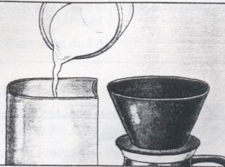
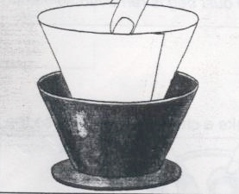
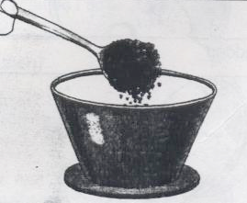
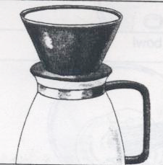

Add / water / water tank place / the filter put / coffee / in the filter the carafe
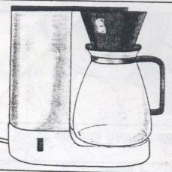
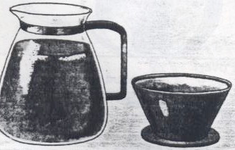
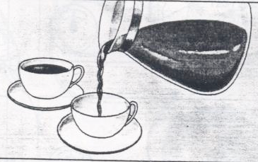

The carafe / the warming unit the carafe / filled / serve
Remove / the filter
Write your recipe here.
- ____________________________________________________________________________
- ____________________________________________________________________________
- ____________________________________________________________________________
- ___________________________________________________________________________
- ___________________________________________________________________________
- ___________________________________________________________________________
- ___________________________________________________________________________

D. Independent Construction of text
Activity 19
Tell your friends, how to do these things. Explain it in front of the class.
- How to make a tea
- How to make fried rice
- How to make donut
- How to make sandwich

Example:
Good morning my teacher, good morning my friends. This morning, I would like to tell you about how to make sandwich . Who had sandwich this morning ? Raise your hand! Good. First, __________________
And then __________________________________Next ______________________________________
Remember to ____________________________________________________Finally, _______________
Name : ________________________ Student Number: ________________________

No. | Aspects of scoring | Scoring
No. | Aspects of scoring | Low (45-59) | Average (60-75) | Good (76-100)
1. | Pronunciation
2. | Intonation
3. | Stress
4. | Gestures
 | Total
 | Total Score

PART 2
WRITTEN ACTIVITIES
A. Building Knowledge of Field
A.1. Giving Direction
Activity 1.
Study the following map and read the dialog.
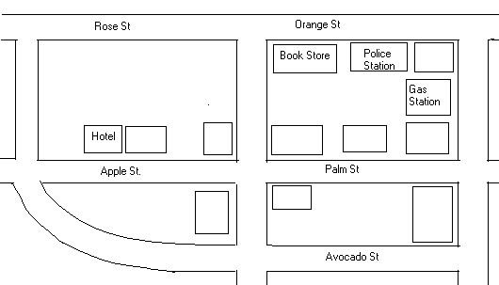

Ron and Dennis are at a gas station.
Ron : Excuse sir!
Dennis : Yes, what can I do for you?
Ron : Could you show me how to get a hotel, please?
Dennis : Sure, Go straight this street until you find the first traffic light. Then turn right. Go down Palm street so you will a cross road. Go straight a head on Apple street. The hotel is on the right side.
Ron : Thank you, Sir. I’ll try to find it.
Dennis : You’re welcome.
Activity 2
Study these words used to give someone directions
☻ Go straight on….
☻ Turn right…
☻ Turn left….
☻ Take the second turning to the left.
☻ Keep walking for two blocks.
☻ Go along the street until you come to the junction/ the crossroad/ Rose street/the second traffic light.
☻ It’s …..Street near/ behind / in front of / next to / opposite……..
☻ It’s around the corner
☻ It’s only two kilometers
☻ It’s on the right side.

Activity 3
Match the directions with the pictures
1. | 2 | 3
4  Bank | 5 | 6
7  Bank | 8 | 9

- Go straight pass the bank
2. Take the second turning on the right
3. Take the third exit off the round about
4. Turn right after the zebra crossing
5. Take the first turning on the right
6. Take the road opposite the bank
7. Go over the bridge
8. Go straight on
- Turn left at the traffic lights

A.2. Grammar Focus
A.2.1. Simple Present Tense

SIMPLE PRESENT TENSE
- (Pernyataan tentang kebenaran umum/kebiasaan)
- Kerry drives a car to his office every day
- The boyscouts always do physical exercise every morning
- Fire is hot
- The mounts are big
- I am a learner
Keterangan:
- Kalimat 1 dan 2 di atas merupakan contoh mengungkapkan peristiwa/kegiatan yang sering/biasa dilakukan
- Kalimat 3,4,5 di atas merupakan contoh mengungkapkan kebenaran umum
- Untuk mengungkapkan situasi di atas digunakan Simple present dengan pola:
Pola | Keterangan waktu
- + S + V1(-s/-es) + C  - S + do/does not V1 + C  ? Do/does + S + V + C  - + S + is/am/are + K. sifat/Ket/benda  - S+ is/am/are not + K.sifat/ket/benda  3. ? Is/Am/Are S + K. sifat/ket/benda | Every….  Sometimes seldom  Rarely usually  Ever hardly ever  Always never  Often occasionally

Activity 4
Put the verb in the bracket into the correct form.
Do as Example : Andi ….. (take ) a walk to school every day.
Andi takes a walk to school everyday.
- Kennedy …….(drink) beer in the café every night
…………………………………………………………………………………………………
- The hikers ……(cook) rice every time they have a camp
…………………………………………………………………………………………………
3. They …..(not, smoke) cigar too often
…………………………………………………………………………………………………
4. The new teacher …..(not, teach) me every day
………………………………………………………………………………………………
5. Fathur ,…….(have) running every morning?
…………………………………………………………………………………………………
6. The college students rarely……..(do) their homework ?
………………………………………………………………………………………………
7. You and I Sometimes ………(get ) angry to each other.
…………………………………………………………………………………………………
8. The moon ……..(shine) in the night .
…………………………………………………………………………………………………
9. The school principal never ……..(come) late.
…………………………………………………………………………………………………
10. The new marriage couple always……… (have) dinner every Saturday night.
…………………………………………………………………………………………………
Activity 5
Use the right verb: is, am ,or are
- …. . you Fraccesso Totti
- How ……Kelly?
- She….. very well, thank you
- How …..you, Mr. Anton
- I……fine. Thanks
- How ………you this afternoon Mrs. Hilda
- ……Rani well this morning?
- How …..Mr. And Mrs. Purwoko this afternoon?
- Mr. and Mrs.Purwoko ………fine, thank you.
- I ……..very glad to meet you

A.2.2. Noun Phrase
Learn the explanation about word orders.

Deter-miner | Quality  characters | size | Age/  temperature | Participle | Shape | Color | Origin Location | Purposel | Noun
a  an  The  This  That  Those  These  My  His | Beautiful  Ugly  fresh  Unique  nice  Wonderful  Pretty  Fine | Big  Long  Wide  Short | Old  Young  new | Crumbling  cooked | Cone  Square  Oval  Triangle | Blue  White  Yellow  Black  Violet  Red  Blue | African  Javanese  Japanese  Chinese  English  French | Serving  preserving | Cabbage  Mangoes  Potatoes  Tomatoes  Cucumber  Coconuts  meat

Example : Shop attendant : What do you want to buy, Sir?
Customer : I need a kilo of these interesting big red American Apples.
Shop attendant : Yes, Here you are.

Activity 6.
Arrange the determiners and adjectives that follow in the proper order before the noun in each group.
Example:
My aunty wants to buy (curry-fresh-Indian-)
My aunty wants to buy fresh Indian curry

- The poor man could buy (cake-expensive-an-American-big) in the restaurant.
___________________________________________________________
- My uncle gives me (round-tomato-reddish-big-a-new)
___________________________________________________________
- Sari like to wear ( the-coconut-old-black-fine)
____________________________________________________________
- Sari has just lost (green-small-wonderful- her-mangoes)
____________________________________________________________
- My Sister bought ( Japanese-some-oval-delicious-fish)
____________________________________________________________
- The restaurant is looking for (original-old- an-recipes- Javanese)
_____________________________________________________________
Activity 7.
Write phrases about this objects
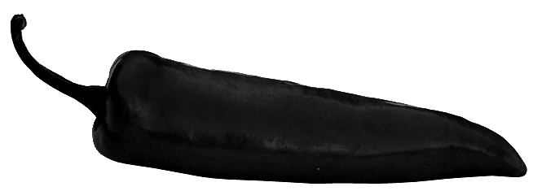
1. : __________________________________________


2. : ___________________________________________

3. : ___________________________________________


4. : ____________________________________________



5. : _____________________________________________

A.2. 3. Adverb
Study the following notes.
Note
The manner adverb has the most characteristic adverbial form( an- ly ending added to a descriptive adjective)
Example :
Quick +ly quickly.
Neat +ly neatly
Vertical +ly vertically
Awkward +ly awakwardly

But
Good becomes well
Fast becomes fast
Hard becomes hard

Activity 8
Form these adjective into adverb, No. 1 has been done for you
No | ADJECTIVE | ADVERBS
1. | Correct | Correctly
2 | Quiet
3 | Bad
4 | Clear
5 | Quick
6 | Easy
7 | Silent
8 | Wise
9 | sincere
10 | Beautiful

Activity 9
Complete these sentences using suitable adverbs
- Wash the knife _____________________________________________________
- cut the melon _____________________________________________________
- Support the base of the melon__________________________________________
- crust the ice ________________________________________________________
- Prepare the fruit_____________________________________________________

B. Modelling of Text
B. 1. Procedure Text
Activity 10
Observe the picture, then read the instruction!
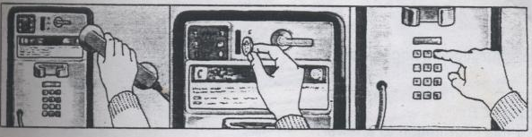

Goal | How to use a public phone
Utensil | Phone, coin
Steps | 1. First, lift the phone receiver  2. Then, insert the coin  3. Next, dial the number you want  4. Wait for the dial tone  5. Finally, put the receiver back after you finish your call.

Activity 11
Answer the question
- What does the text tell us about?
______________________________________________________________________
- What tense are used in the text?
______________________________________________________________________
- How many steps are there?
_______________________________________________________________________
Activity 12
Read the following instruction manual and answer the questions.
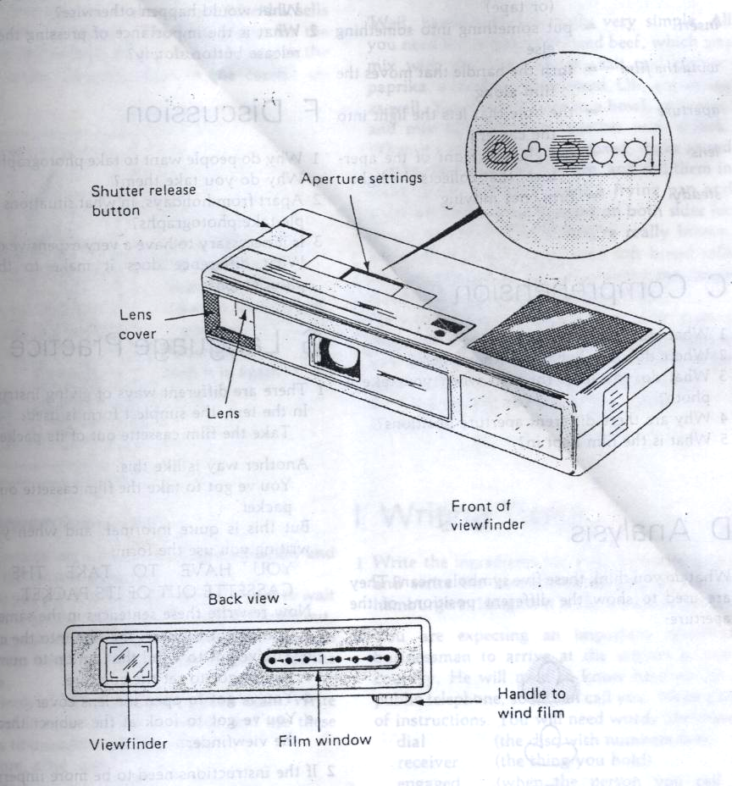

In order to take photographs with your new Fotomatic 5, you must follow these simple instructions. First, take the film cassette out of its packet, and insert it into the back of the camera. Wind the film on until a number 1 appears in the film window at the back of the camera.
Now set the aperture to one of the five positions, marked by the sun or cloud signs, according to the lighting conditions. (Don’t forget to take off the lens cover).
Look through the viewfinder and move the camera until what you want to photograph appears between the white lines. Hold the camera steady and press the shutter release button slowly. There – that’s all you have to do to get perfect pictures.
Glossary:
♦ insert : memasukkan
♦ appears : muncul/tampak
♦ the aperture : lobang lensa
♦ take off : melepas
♦ viewfinder : alat untuk menunjukkan daerah/bagian yang akan difoto
♦ steady : tetap/tidak goyah
♦ the shutter : pemetik camera

1. Where do you have to insert the film cassette into the camera?
__________________________________________________________________________
2. How do you know that the film is on after you insert it?
__________________________________________________________________________
3. How do you have to set the aperture?
__________________________________________________________________________
4. What happens if you don’t take off the lens cover?
__________________________________________________________________________
5. What do you see through to get a scene?
__________________________________________________________________________

Activity 13
Read the following instruction

Goal | Making a decorative jar of stone
Utensil/ Material | Stone, a brash, a bowl, a glass
Steps | 1. Firstly, collect some stones with interesting shapes, texture, and colours.  2. Secondly, Put them in a bowl of warm soapy water.  3. Then, scrub them with brush.  4. Rinse the stones.  5. After that, stand them on windows sill for a day.  6. Next, give the stone a thin coat of varnish. Let the varnish dry.  7. Finally, arrange the stones in glass jar or container and use it an ornament.

Activity 14
With a partner answer these questions.
- Do the time conjunctions show the order you should do?
____________________________________________________________________________
- Circle all the verbs.
____________________________________________________________________________
- Are all the verbs in the text action verbs?
____________________________________________________________________________
- Are the verb in the present tense?
____________________________________________________________________________

B.2. Short Functional Text (Invitation letter)
Activity 15.
Answer the questions based on the invitation bellow
.
1. Where can you see the invitation?
_________________________________________________________________________
2. Who writes the invitation?
__________________________________________________________________________
3. Can you guess, who is Fathur?
__________________________________________________________________________
4. Why is Fathur invited to the meeting?
__________________________________________________________________________
5. When the meeting will be held?
__________________________________________________________________________
6. Why is it called as formal invitation?
__________________________________________________________________________
Students’ Organization
SMP Negeri 1 Karanganyar
Jl. Jend. Basuki Rahmat No. 23 Telp (0271) 495171 554987

To : Fathur
Class : II/F

We invite you to attend our students’ organization meeting. It will be held :

Date : Saturday, September 30, 2006
Time : 12:30 PM
Place : Students’ organization room
Agenda : Final meeting for the preparation of Music Fest 2006

Please come on time.
See you there

Bonky Kurniawan Pratiwi Sudarwati
Chairperson Secretary

C. Joint Construction of a Text
Activity 16
In Group of four, write down the procedure to use a camera. Use the picture as a clue
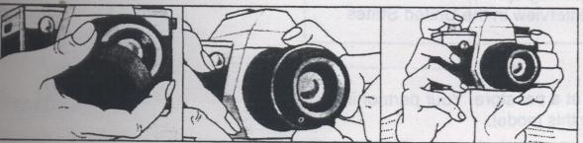

- _____________________________________________________________________________
- _____________________________________________________________________________
- _____________________________________________________________________________
- _____________________________________________________________________________

Activity 17
Work in pairs. Suppose you and your friend are the students’ organization committees of your school. You are the secretary and your friend is the chairperson. You want to invite the others committees for a meeting. Write an invitation letter to them based on the following data:
Addressee : Liana,class II/d
You plan the meeting to be held on Wednesday , October 4, 2006. at 14:00 PM
in the school hall, The main concern of the meeting is to prepare “The Class Meeting 2006”.

D. Independent Construction of Text.
Activity 18.
Write your own composition of how to do these things. Choose of the following titles.
- How to surfing and browsing in the internet
- How to paying bill with ATM
- How to use ATM card
- How to use handycam
- How to use flash disk

Goal: | ----------------------------------------
Materials/tools | - ____________________________________________________  - ____________________________________________________  - ____________________________________________________  - ____________________________________________________  - ____________________________________________________
Steps | - _______________________________________________________  - . ______________________________________________________  - . ______________________________________________________  - . _______________________________________________________  - . _______________________________________________________  - . _______________________________________________________

UJI KOMPETENSI 1

Text 1

How to Make Fried Rice
Fried rice is an easy and filling dish - great for a bachelor gentleman. You just have to remember to cook the rice the night before.
Ingredients:
- 4 c. cooked rice
- oil
- 2 eggs
- 1 carrot - diced
- 1/2 c. frozen peas
- 4 scallions - minced
- 1/2 c. leftover meat
- salt or soy sauce

1. Heat a wok or large skillet over high heat.
2. Add a little oil and wait a few moments for it to heat up.
3. Break the eggs into the wok and mix quickly to scramble.
- When the egg is well-set, remove it and chop it into bite-size pieces or
strips.
5. Wipe out the wok and add a little more oil. Wait for it to heat.
- If the rice is clumpy, break it up with your hands so that each grain is separate.
- Add the cold rice to the wok. Move the rice quickly around the hot pan by
Putting your spoon or spatula under the rice and turning it over.
(This is the basic stir-frying technique.)
- After a minute or so, add the diced carrots and move them about the pan with the rice.
9. After 3 minutes, add the frozen peas and stir-fry.
10. After 2 minutes, add the scallions, egg and meat, if using.
11. Season the rice with salt or soy sauce once the ingredients are well-mixed.
Cook another minute or until everything is heated through.
12. Remove from heat and serve.
(Taken from : Web e-How.com )

01. Ais : What kind of text is it?
Fathur : It is ……. Text.
- Recount
- procedure
- Spoof
- narrative

02. Ais : What is the purpose of this kind of text?
Fathur : As our teacher said the purpose is …
- to retell events for the purpose of informing or entertaining
- to present two points of view about an issue
- to amuse or entertain and to deal with actual or vicarious experience in different ways
- to describe how something accomplished trough a sequence of steps

03. Ais : How is the generic structure of the kind of text?
Fathur : As our teacher explained the generic structure are….
- goal, events, reorientation
- goal, materials and equipments, resolution
- orientation, steps, goal
- goal, materials and equipments, steps
04. Ais : From the text, we have this sentence, ..” You just have to remember to cook the rice the
night before. “. From the underlined verb, what kind of tense is mostly used in the text?
Fathur : It is …
- simple present tense
- simple future tense
- simple past tense
- present continuous tense

05. Ais : How many ingredients/materials needed to make fried rice?
Fathur : There are ……materials
- seven
- nine
- eight
- ten

06. Ais : How many actions or steps needed to make fried rice?
Fathur : We need …. To make fried rice?
- Ten
- twelve
- Eleven
- thirteen

07. Ais : What shape we have to made to the carrot?
Fathur : We form the carrot as …
- Cone
- dice
- Rectangle
- oval

09. Ais : What kind of seasoning we need to make fried rice?
Father : We can use …….to season the fried rice.
- Scallions
- peas
- leftover meat
- soy sauce

10. The Shop owner : Can I help you, Miss?
Ms. Enita : Yes, I want to buy….
- Pumpkin yellow Indian big and long fresh
- yellow Indian pumpkin big and long fresh
- Fresh big and long yellow pumpkin Indian
- Fresh big and long yellow Indian Pumpkin
11. Waitress : Do you ready to order, madam!
Mrs. Indri : Yes, I want to eat …
- a delicious medium Turkish steak
- a medium steak delicious Turkish
- a Turkish medium steak delicious
- a. delicious steak medium Turkish
12 M : Has Any got home, Pap? It’s half past five P.M. now.
F : No, not yet. I’m not sure she’ll be home. The underlined words express…..
a. uncertainty
b. disagreement
c. inability
d. certainty

13. X : Are you sure that Indonesia will be a great nation?
Y : ……………..we have a lot of natural and human resources support.
- I’m able to
- I’m doubt
- I’m certain
- I’m agree with you

14. X : Will Mrs. Indri come today?
Y : ……….because I saw her checking her health in the hospital this morning.
- I’m able to
- I’m doubt
- I’m certain
- I’m agree with you

15. Budi : ………..your sister usually …………….to this park every Sunday morning?
Alia : yes,
- is comes
- does – come
- does – comes
- is – coming

16. The cake maker always …………his bread every 4 o ‘clock in the morning
- baked
- baking
- bake
- bakes

17. Mirna : What should I do to this onion, Mom?
Mother : You should have the onion…… We just take the fresh part in the middle of them.
- simmered
- boiled
- fried
- peeled

18. …………….. the food dipped in the batter both side until turning golden
- fry
- boil
- burn
- bake

19. Finishing the frying , we can ………..the tempura in clean paper towel
- keep
- drain
- buy
- store

20. Mother : Grind down the knife …………….. I need it to cut the vegetables.
Lisa : OK, mom.
a. neatly
b. carefully
c. sharply
d. cleanly

ULANGAN HARIAN 1
A. Choose the correct answer
Text 1.
For three people, we take six eggs, break them into a bowl, season them with salt and freshly ground pepper, and add a good teaspoonful of water. We beat this lightly with a fork until large bubbles form on the top. This takes half a minute, it is fatal to beat too long. Meanwhile, our frying pan is getting hot, not too hot, and we drop in an ounce and a half of butter over a quick flame for a minute. We give our egg-mixture another stir and pour them into the fat, letting it spread evenly over the frying- pan.

01. What kind of genre is it?
              - Recount
              - Procedure.
              - Spoof
              - Descriptive

02.How do we know about that kind text?
a. There are steps in the text.
b. There is a twist at the end of the text
c. There is an orientation on first sentence
d. There is a reorientation in it

03. These are the materials needed, except ……..
    - Frying pan
    - Butter
    - Pepper
    - Bubbles.

04.The function of this text is to ……………
    - Tell how something is done.
    - Explain a factual event
    - Critique an art work
    - Describe a particular person, thing, place.

05.“… season them with salt …” refers to ……….
    - Three people
    - Salt and pepper
    - Six eggs.
    - the omelet

06. How do we have to beat the eggs?
  - Lightly but not too long.
  - Quickly and long enough
  - Evenly about some minutes
  - Quickly and not too long
07. How much butter should we drop on the pan?
  - Some droops
  - As we wish
  - An ounce and a half.
  - A teaspoonful

08.This sentence is INCORRECT about procedure.
  - It is a set of instructions or directions
  - It consists of goal, materials and steps
  - It uses imperatives
  - It uses some verbs in the past.

09. What is the goal of the text above?
    - Making an omelet.
    - How to do something easily
    - Don’t forget to taste it
    - It’s such a tasty omelet

10. Which words are action verbs of the discourse?
      - Think, dream, sleep
      - Say, exclaim, whisper
      - Pour, season, beat
      - Observe, see, look at

11.Arrange the following steps into a good order:
1. Cut some cheese into them
  - Put some vegetables on it
  - Put butter on each slice
  - Take two slices of bread
  - Place the slice of meat on one of the bread
  - Put the other piece of bread on top
    - 4 – 3 – 2 – 6 – 5 – 1
    - 4 – 3 – 5 – 6 – 1 – 5
    - 4 – 3 – 1 – 5 – 2 – 6.
    - 4 – 3 – 6 – 1 – 5 – 2

Text 2
Do you know how to boil egg? Well, this is the way. …(12)…heat a sauce pan of water on the …(13). Next, put the egg in the boiling water. Heat it until it boils. …(14)…,cook it for three minutes. After that,…(15)… the egg until it gets burnt. Now the egg is ready to …(16)…
12. a. Once c. One by one
b. First. d. One time

13. a. Oven c. Iron
b. Baker d. Stove.

14 a. Than c. Then
b. Rather than d. Whenever

15 a. Keep. c. Break
b. Have d. Beat
16 a. Serve. c. served
b. Be serving d. Be served

Text 3
How to cook rice using a Magic Com
First, weight the exact amount of rice that will be poured. It should not be more that 4 measure cups.
Second, wash the rice. Put it in the inner pot, and adjust the quantity of water.
At the same time, you can cook another meal, like vegetables. Put them on the steam pot.
Next, plug in the cable into the electricity socket and push the cooking button. A light red will turn on.
After cooking, open the cover and mingle the cooked rice for a while.
17. What does the text tell you about?
a. How to use a Magic Com while cooking rice
b. How to find rice and a Magic Com
c. How to cook rice using a Magic Com
d. How to wash and cook rice.

18. Where can you usually find the text?
a. At school
b. In the restaurant
c. Inside the container of Magic Com
d. In the hospital

19. Who reads the texts?
a. The seller of nice
b. The consumer of a Magic Com
c. The safety guard
d. The farmer and friends

20. Who writes the text?
a. a secretary
b. a receptionist
c. a manager of company
d. a Magic Com producer

UNIT 2
What an amazing creature!

Mata Pelajaran : Bahasa Inggris
Satuan Pendidikan : SMP
Kelas/Semester : IX/1

Standar Kompetensi
A. Mendengarkan
- Memahami makna dalam percakapan transaksional dan interpersonal pendek sederhana untuk berinteraksi dengan lingkungan sekitar
- Memahami makna dalam teks lisan fungsional dan monolog pendek sederhana berbentuk report untuk berinteraksi dengan lingkungan sekitar.
B. Berbicara
- Mengungkapkan makna dalam percakapan transaksional dan interpersonal lisan pendek sederhana untuk berinteraksi dengan lingkungan sekitar.
- Mengungkapkan makna dalam teks lisan fungsional dan monolog pendek sederhana berbentuk report untuk berinteraksi dengan lingkungan sekitar.
C. Membaca
- Memahami makna dalam esai pendek sederhana berbentuk berbentuk report untuk berinteraksi dengan lingkungan sekitar.
D. Menulis
- Mengungkapkan makna dalam teks tulis fungsional dan esei sederhana berbentuk report untuk berinteraksi dengan lingkungan sekitar.

Materi Pembelajaran:
A. Speech functions : Carrying out transactional or interpersonal conversation involving expressions of :
- Asking for repetition
- Showing attention
- Showing admiration
B. Monolog : Listen Tell, read and write various report texts
C. Short Functional text : Read and write short functional text (Writing post card )
D. Language features : Modals, question tags, conjunction, degree of comparison and linking verbs.

PART 1
SPOKEN ACTIVITIES

A. Building knowledge
A.1. Speech Fucntions (Listening and Speaking)
A.1. 1. Expression of Asking Repetition
Activity 1.
Observe the picture and the dialog!
(2) I beg your pardon!
(1)Can you accompany me to the shop, Bill!

(4) All right , My Dear

(3) Accompany me to the shop, please!



Activity 2
Read the following dialogue
A : Hello, How are you today?
B : Hi, I am fine?
A : What are you doing here?
B : I am waiting for my brother. (there is a loud bang heard)
A : I beg your pardon?
B : I am waiting for my brother!
A : Oh, I see

Activity 3
Study the following expression

I beg your pardon…
Pardon me?
Excuse me?
Repeat please!
Sorry!

Activity 4
Fill in the blank with the expression of asking repetition
1. A : would you please move ahead!
B : ……………………………………
A : Would you please move ahead!

2. A : May I borrow your pen?
B : …………………………………..
A : May I borrow your pen, please!

3. A : I will return your book tomorrow.
B : …………………………………..
A : I will return your book tomorrow!

4. A : I love English.
B : ……………………………………
A : I love English

5. A. : May I go with you?
B : ……………………………………
A : May I go with you!

A.1. 2. Expression of Paying Attention to the speakers
Activity 5
Listen to your teacher reading the following dialogs. Identify the expressions correctly below.
Dialog 1

Ina : I tell you what…
Adiarso : Yeah..
Ina : I will tell you my experience on my trip to Bandung?
Adiarso : Is it? It sound interesting. Go on.

Dialog 2
Leni : I went to Bali last week
Adiarso : Did you? Tell me about it.
Leni : OK, I will share my experience

Questions
Which expressions show the responses to the speaker’s statements?
_______________________________________________________

Activity 6
Learns these expressions
- Responses to the statements
Right..
Yeah..
I see..
Of course..
Hmmm…then
Did you?
Is it?
Really?

Activity 5.
Lets practice using the expression. In pairs, make a dialog based on the following situations
1. Your partner want to tell his vacation at Malang East Java. You give a good responses to his/her story.
accept it.
Your partner : _______________________________________________________________
You : _______________________________________________________________
Your partner : _______________________________________________________________
You : _______________________________________________________________
Your partner : _______________________________________________________________
You : _______________________________________________________________
Your partner : _______________________________________________________________
You : _______________________________________________________________
2. You retell your experience having camping at Tawangmangu Central Java. Your friend is so enthusiastic
to listen
You : _______________________________________________________________
Your partner : _______________________________________________________________
You : _______________________________________________________________
Your partner : _______________________________________________________________
You : _______________________________________________________________
Your partner : _______________________________________________________________
You : _______________________________________________________________
Your partner : _______________________________________________________________

3. You tell your friend about your trip to the TMII Jakarta. He is interested in your story.
You : _______________________________________________________________
Your partner : _______________________________________________________________
You : _______________________________________________________________
Your partner : _______________________________________________________________
You : _______________________________________________________________
Your partner : _______________________________________________________________
You : _______________________________________________________________
Your partner : _______________________________________________________________

A.1. 3. Expression of Admiration
Activity 6
Read the dialogue in front of the class with your friends!
Cecep : Hi, Yok, where are you going to?
Yoyok : I am going to Dina’s party?
Cecep : Me, too. Wow you looks great man. Your blackdress suits you very much. You
looks more handsome.
Yoyok : Thank you . you looks so lovely to. Your funny suit is very funky.
Cecep : You are welcome
Yoyok : Let’s go now.
Cecep : All right
Activity 7
Answer the questions!
- Who wants to go to Dina’s party?
………………………………………………………………………………………………….
- What was worn by Cecep?
…………………………………………………………………………………………………
- What was worn by Yoyok
…………………………………………………………………………………………………
- Which sentences expressing uprising ?
…………………………………………………………………………………………………
- Which sentence expressing response to one’s upraising ?
………………………………………………………………………………………………
Activity 8.
Learn the following expression!

Admiring someone/something | Responses
Wow, you looks greats  You look so beautiful/handsome  You are really smart  Thumb up for you  Congratulation.  This painting looks so beautiful  What a great statue it is !  What a clever student he is! | Thank you  Don’t say like that  Thanks a lot  I’m admired  Yes, you are right

Activity 9
Write dialogues based on the following situation!
- You sing a well-known love song. Every body upraises you!
…………………………………………………………………………………………………
…………………………………………………………………………………………………
- You write a touching poem. Your girl/boy friend like it!
…………………………………………………………………………………………………
…………………………………………………………………………………….…………..
- You wears a good-looking suit in the party. Your friend admire it!
…………………………………………………………………………………………………
…………………………………………………………………………………………………
- You dance so attractively. One of the audience upraise you!
…………………………………………………………………………………………………
…………………………………………………………………………………………………
- You read an amazing poem. Your teacher admire you !
………………………………………………………………………………………………..
…………………………………………………………………………………………………

A.2. Monolog
Activity 10
Fill in the blank while you are listening to your teacher reads the text.
RHINOCEROSES
Rhinoceroses are ……(1) animals which live in the forest. They have large heavy bodies. Their skins are very …….(2). They have ……(3) on their noses. Their weight can be more than 2.250 kilograms for each.
Rhinoceroses eat grass. They have so good …….(4) structures that they can run and change directions very fast. They can sprint at 56 km an hour. Rhinoceros have been reported to enter ……(5) at night, they scatter ……..(6) logs of fire, and then peacefully walk away. Rhinoceroses don’t have very good eyesight for …….(7). The oxpeckers always …………(8) them. They give them warning system.

Answer the questions
- What does the text tell us about?
………………………………………………………………………………………………………..
- What are on their noses?
………………………………………………………………………………………………………..
- What do they eat?
………………………………………………………………………………………………………..
- How fast can they run?
………………………………………………………………………………………………………..
- What do the Oxpeckers give them?
………………………………………………………………………………………………………..
A.3. Grammar focus on Report Texts

A.3.1. Modals
No | Modals | Function | Examples
1. | Can | - Menyatakan kemampuan (ability)  - Menyatakan ijin (permission) | - My sister can speak English fluently  - Can I borrow your car tonight?
2. | Could | - Menyatakan kemampuan (ability)  Di waktu lampau  b. Menyatakan ijin (permission) | - My father could dive deeply when he was a boy.  - Could you stop now!
3. | May | - Menyatakan ijin (permission)  - Menyatakan kemungkinan (possibility) | - May I take this flower. It looks good  - It may rain this afternoon
4. | Might | - Menyatakan kemungkinan besar | - She might be at home today
5. | Shall | a. Menyatakan rencana/Janji/Sumpah | - I shall return to Indonesia
6. | Should | - Menyatakan kewajiban (obligation)  - Menyatakan saran (advice) | - You should kill the criminals  - You should take a rest for a while
7. | Will | a. Menyatakan rencana | - We will marry next week
8. | Would | a. Menyatakan ijin (permission) | - Would you please lend me your pen?
9. | must | a. Menyatakan keharusan (necessity) | - I must leave now.

Activity 11
Fill in the blank with ‘ Can’, ‘may’, ‘shall’, ‘will’, ‘could’, ‘might’, ’should’, ‘would’, or ‘must”.
- The boys ………not fulfill all requirements to be swimmer. They arrived at home from yesterday
- The dentist …….operate the man’s teeth , if not he will be lame.
- ……..you open the window, please? I need some fresh air
- I promise I……..return here as soon as possible.
- …….the manager go to the business meeting tomorrow?
- You ………….read some books if you want to be clever students
- The boxer………keep his stamina until the end of the fight.
- Shinta lives in Sydney for five years. She……….speak English fluently.
- ………..you mind closing the cupboard, please?
- My aunt …………..cook 100 kg of rice when she was young.
- The internet ………send the news quicker through e-mail.
- You ……….wear a jacket to keep your body warm. It is cold outside
- Tell the police that they ……….arrest the criminals.
- Next month, the manufacture ….release new products.
- You got stomached . You……….check it to the doctor.

A.3.2. Question Tag
Question Tags
Question tags adalah pertanyaan yang ditambahkan di belakang pernyataan (statement). Fungsi dari question tag biasanya adalah untuk konfirmasi.
Tenses dari Question tag bergantung dari tenses kalimat pernyataannya (statement).
- Question tag dalam kalimat pernyataan positif (+)
- Budi always studies hard, doesn’t he?
- Andi made the toy himself, didn’t he?
- You like coffee, don’t you?
- Diana was here yesterday, wasn’t she?
- She is too young to die, isn’t she?
- You can go there, can’t you?
- Question tag dalam kalimat pernyataan negatif (-)
- Budi doesn’t always study hard, does he?
- Andi didn’t make the toy himself, did he?
- You don’t like coffee, do you?
- Diana wasn’t here yesterday, was she?
- She isn’t to young to die, is she?
- You can’t go there, can he?
- Untuk “ everybody, everyone, somebody, someone” , dipakai “they” sebagai subyek pada Question tag.
- Every one warned you , didn’t they?
- Someone hits you, don’t they ?
- Pernyataan yang mengandung kata “ neither, none, nobody, nothing, scarcely, barely, hardly, hardly ever, seldom” dianggap sebagai kalimat negatif sehingga question tag-nya berbentuk positif.
- Nothing was said, was it?
- He seldom comes to parties, does he?
- None of my friends liked the film, did they?
- “ I am “ biasanya mempunyai tag dengan “ aren’t I”
- I am very late, aren’t I ?
- I am happy man, aren’t I?
- “Let’s “ biasanya mempunyai tag dengan “ shall”
- Let’s go , shall we?
- Let’s read aloud, shall we?
- Kalimat perintah (command), biasanya mempunyai tag “ will you”
- Open the door, will you?
- Close the window, will you?

- Your sister always gets up late on Sunday, ……………..?
- The dishes we had lunch were all delicious , ……………?
- You seldom have your hair cut short, …………………….?
- There was never any talk of such a thing, ……………….?
- It could be done, ………………?
- We will have been waiting for Gunung Kerinci, ………..?
- Let’s go to the theatre now, …………….?
- I am intelligent, ………..?
- Study hard students, ……………?
- Don’t touch me, ………………….?
- Everything is all right, …………..?
- Everyone laughed at me, ……………….?
- Let’s go to the movie,…………….?
- Shut the door,…………………?
- Mr. Soeharto never dies, ………..?
- It could be done, ………………?
- The two boys should not complain so much, ……………….?
- You don’t know that John is ill, …………………….?
- Every body works hard every day, ……………….?
- You will go to Jakarta, ………………..?

B. Modelling of Text.
Activity 12
Read the dialogue carefully
Andi : Hi. Where have you been?
Budi : Hi. I’ve been to Ujung Kulon.
Andi : That’s great! What did you do there?
Budi : I observed some animals, especially rhino.
Andi : Can you tell me more about it?
Budi : Well …rhinoceroses are wild animals which live in the forest.
They have large heavy bodies, … I mean they have big bodies. And… their skins are very thick. And one more important thing is that … that they have horns on their noses. And a rhinoceros can be more than 2.250 kilograms.
As you know … rhinos eat grass. And they have very good muscle structures. That is why they can run and change directions very fast. Yeah… they can sprint at 56 km an hour. Rhinos have been reported to enter campsites at night, yeah… they scatter smoldering logs of fire, and then peacefully walk away. But… you know that rhinos don’t have very good eyesight for distance. The oxpeckers always accompany them. They give them warning system.
Rhinos are hunted for their horns. You know… they are used to make traditional medicine. The rhinos are listed as endangered on the Red List of Threatened species.
Andi : Oh… I’m sorry to hear that.
Budi : Yeah… we must protect them.
(Taken from Materials for teacher training in English, Central Java)
Answer the questions orally
- What animals are they?
…………………………………………………………………………………………………………..
- Are they tame or wild animals?
…………………………………………………………………………………………………………..
- Where can we find them?
…………………………………………………………………………………………………………..
- Are they big animals?
…………………………………………………………………………………………………………..
- How heavy do you think the big one?
…………………………………………………………………………………………………………..
- Are their skins thick or thin?
…………………………………………………………………………………………………………..
- What do they have on their noses?
…………………………………………………………………………………………………………..
- What do they eat?
…………………………………………………………………………………………………………..
- Can they run fast?
…………………………………………………………………………………………………………..
- How fast can they run?
…………………………………………………………………………………………………………..
- What do they often do in the campsites?
…………………………………………………………………………………………………………..
- Do they have good eyesight?
…………………………………………………………………………………………………………..
- What/who give them warning system?
…………………………………………………………………………………………………………..
- What do people hunt them for?
…………………………………………………………………………………………………………..
- What is used to make medicine from them?
…………………………………………………………………………………………………………..
- Are they listed as endangered species?
…………………………………………………………………………………………………………..
- What should we do for them?
…………………………………………………………………………………………………………..
Activity 13
Let’s analyze the text above
The Generic Structure of Report Text
Description | They have large big bodies. Their skins are very thick. And one more important thing is that they have horns on their noses. And a rhinoceros can be more than 2.250 kilograms
Parts  Quantities | Rhinos eat grass. And they have very good muscle structures. That is why they can run and change directions very fast. Yeah… they can sprint at 56 km an hour
Habits or Behaviour (for living-things) | Rhinos have been reported to enter campsites at night, yeah… They scatter smoldering logs of fire, and then peacefully walk away. But… you know that rhinos don’t have very good eyesight for distance. The oxpeckers always accompany them. They give them warning system.

Activity 14
Let’s study the summary about report text.
A Report has the following characteristics.
- Generic structure
- General classification :Tell what the phenomenon under discussion is.
- Description tells what the phenomenon under discussion is like in terms.
- parts,
- qualities
- habit or behaviour, if living uses, if non – natural
- Significant Lexicogrammatical features.
- Focus on Generic participants.
- Use of relational processes to state what it is and which it is.
- Use simple present (unless extinct)
- No Temporal sequence

C. Joint Construction of the text.
Activity 15
There are two text in this paragraph, but they are mixed. You have to separate them so that they can be two good and meaningful paragraph.
A sea-lions the white pelican are sea-mammals and are warm blooded is one of the most successful fish eating birds they breathe air with their lungs the success is largely due to its command hunting behaviour the scientific name for the family they belong to is Neophoca Cineriea (Nee-o-fo-ka-Sin-er-ee-a) A group, perhaps two dozens birds, will gather in a curved arc some distance offshore, beating the water furiously with their wings, driving the fish before them Australian sea-lions are about 250 cms long. Adult males (called bulls) grow to about 3 metres and are the largest Australian mammal (they no longer breed in Australia)

Text. 1
…………………………………………………………………………………………………………..
…………………………………………………………………………………………………………..
…………………………………………………………………………………………………………..
…………………………………………………………………………………………………………..
…………………………………………………………………………………………………………..
…………………………………………………………………………………………………………..
…………………………………………………………………………………………………………..
…………………………………………………………………………………………………………..

Text. 2
…………………………………………………………………………………………………………..
…………………………………………………………………………………………………………..
…………………………………………………………………………………………………………..
…………………………………………………………………………………………………………..
…………………………………………………………………………………………………………..
…………………………………………………………………………………………………………..
…………………………………………………………………………………………………………..
…………………………………………………………………………………………………………..
…………………………………………………………………………………………………………..
…………………………………………………………………………………………………………..

D. Independent construction of text.
Activity 16
Bring to the class a picture of animals or things that you know well
Activity 17.
Tell your friends using the picture you bring. Remember the “generic structure “ of report text when
You tell the animals to your friend:

ANIMALS

What is it?
Parts of the body
Habits or behaviour?

Example of telling report.
Good morning my friends. Today, I’m going to tell you about rhinoceros. Who has known Rhino ? Raise your hands. Good !. That’s wonderful. Well …rhinoceroses are wild animals which live in the forest. They have large heavy bodies, … I mean they have big bodies. And… their skins are very thick. And one more important thing is that … that they have horns on their noses. And a rhinoceros can be more than 2.250 kilograms.
As you know … rhinos eat grass. And they have very good muscle structures. That is why they can run and change directions very fast. Yeah… they can sprint at 56 km an hour. ………………………….. (Continue by yourself)

Name : ________________________ Student Number: ________________________

No. | Aspects of scoring | Scoring
No. | Aspects of scoring | Low (45-59) | Average (60-75) | Good (76-100)
1. | Pronunciation
2. | Intonation
3. | Stress
4. | Gestures
 | Total
 | Total Score

PART 2
WRITTEN ACTIVITIES
A. Building Knowledge of Field
A.1. Vocabulary Building
Activity 1
1. Name the following creatures

1 | 2 | 3 | 4
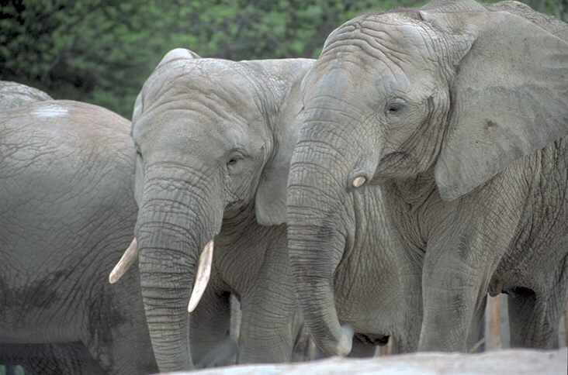
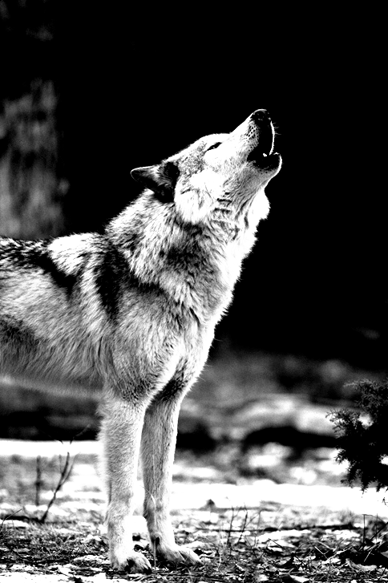
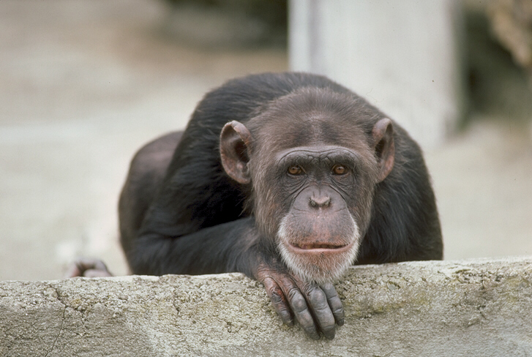
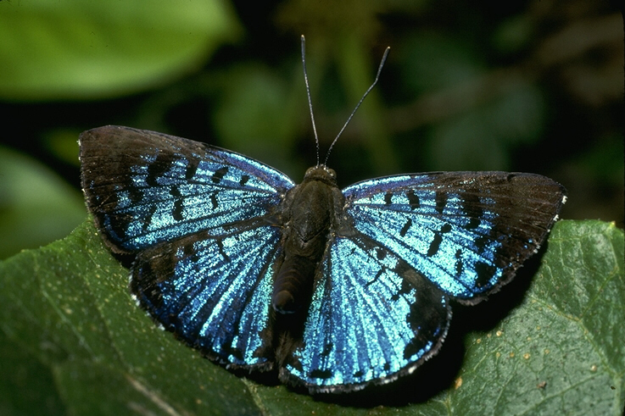

Name : ____________ | Name : ____________ | Name : ____________ | Name : ____________

1 | 2 | 3 | 4
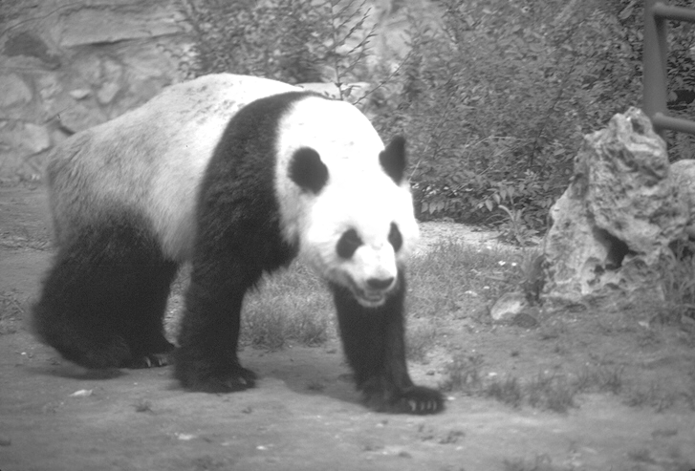
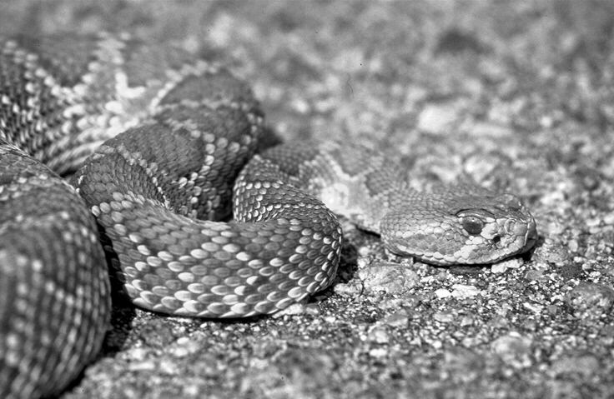
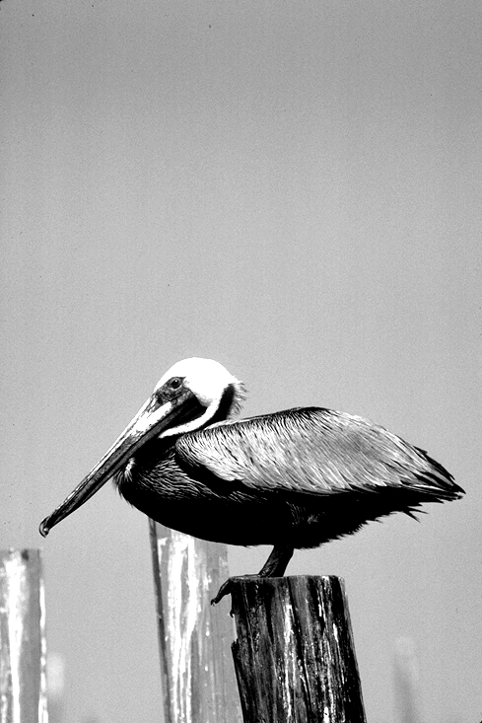
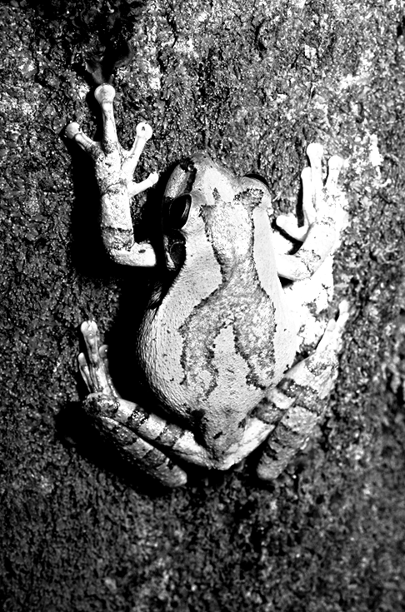

Name : ____________ | Name : ____________ | Name : ____________ | Name : ____________
Activity 2
Fill in the blank with suitable words from the box.
The white pelican is one of the most successful fish eating birds. The success is largely (1) …… its command hunting (2) ………. A group, perhaps two dozens birds, will (3) ……….. in a curved arc some distance offshore, beating the water (4) ……. with their wings, driving the fish before them.
When the water is (5) ………………enough for the birds to reach the fish, the formation (6) ………as each bird dip its bill into the water to scoop up its (7) ………... As the bird lifts its head, the water drains from its bill leaving the fish which are then swallowed.
Pelicans are among the oldest group of birds, Fossils of this genus have been (8) …….. dating back 40 millions years.
(Taken from : Wildlife: The Beauty of Animal, Spain: The Image Bank, 1989;p.74)
Found Gather Due to breaks up
Shallow Behaviour furiously meal

Activity 3

Answer the questions below.
- What animal is being reported in the text above?
…………………………………………………………………………………………………………………….
- Why this animal called as the most successful fish eating birds?
……………………………………………………………………………………………………………………
- What the birds do when they are hunting fish?
……………………………………………………………………………………………………………………
- Is the bird alone or in a group when they do hunting?
……………………………………………………………………………………………………………………
- How old is the fossil of the bird that ever found?
……………………………………………………………………………………………………………………

Activity 4
Find the meaning of the following words in the dictionary?
No. | Words | Meaning
1. | Breathe
2. | Belong to
3. | Slip
4. | Underneath
5. | Whiskers
6. | Fins
7. | Starve
8. | Squid

Activity 5
Fill in the blank with the words from the table above!
1. X : What do you like to eat?
Y : I like sea food especially fried …… It is delicious.
2. X : Whose camera is it?
Y : It ……………..Mr. John Smith.
3. X : How is our condition?
Y : We are lack up food and water supplies. If we can’t find food. We’ll ……..and die.
X : We must take the fat …………..your stomach. If not you look too fat.
Y : Yes, doctor
5 X : Look the Pinguins are swimming using its………..
Y : Yes, they are so attractive.

A.2. Grammar Focus
A.2.1. Degree of Comparison
From the text “The pelican bird” we have sentence such as :
The pelican bird is the most successful…..
The phrase “the most successful” here refers to something more than others. So we will study about degree of comparison. This pattern is used to compare the condition among things/matter. There are three basic patterns:
- Positive degree
..as …….as

Dipakai baik untuk adjective (kata sifat) maupun adverb (kata keterangan)
Example :
- Budi is 171 cm tall. Andi is 171 cm tall.
- Budi is as tall as Andi.
- Anita’s house is 40 m² wide. Tiara’s house is 40 m² wide
- Anita’s house is as wide as tiara’s.
- Comparative Degree ( tingkatan lebih)
Akhiran –er .  Dipakai untuk adjective yang terdiri dari satu suku kata. |  | Akhiran –er.  Dipakai untuk adjective bersuku kata dua berakhiran , ,-ow, -y, -er |  | Berawalan “more”  Dipakai untuk adjective lebih dari dua suku kata
Hard  Fast  Nice  Tall  Big  Small  Wide | Harder  Faster  Nicer  Taller  Bigger  Smaller  wider | Clever  Narrow  Heavy  Busy | Cleverer  Narrower  Heavier  busier | Interesting  Expensive  Beautiful  Wonderful  handsome | More interesting  More expensive  More beautiful  More wonderful  More handsome

- Superlative Degree (Tingkatan paling)
Akhiran –est  Dipakai untuk adjective yang terdiri dari satu suku kata |  | Awalan -the most  Dipakai untuk adjective adjective yang terdiri dari dua suku kata atau lebih
Clear  Nice  Fast  Hard  quick | The clearest  The nicest  The fastest  The hardest  The quickest | Interesting  Expensive  Beautiful  Wonderful  handsome | The most interesting  The most expensive  The most beautiful  The most wonderful  The most handsome

- Exception:
Kata dasar | Comparative | Superlative
Good/well  Bad/ill  Many/much  Little  Far  old | Better  Worse  More  Less  Farther/further  Older/elder | Best  Worst  Most  Least  Farthest/Furthest  Oldest/eldest

Activity 6
Write the correct form of the words in brackets to complete the sentence below.
No. | Adjective
1. | big | Blue whale is ………….animal on earth.
2. | easy | Breeding ducks is …………..than gooses
3. | accurate | The weather forecast today is ……than it was yesterday.
4. | beautiful | Vina Panduwinata sings as …………..as Melly Goeslow
5. | bad | My dog was ill yesterday. Today it’s getting …………
6. | tall | The palm tree is the …………….among trees at my field
7. | late | According to the ………..news, the cheetah at the Rgunan zoo has died
8. | Intelligent | Budi is ………….. than the other students at my class

A.2.2.Conjunctions
Conjunctions are words which join words or groups of words. There are two principle types of conjunctions: coordinate and subordinate
A coordinate conjunction joins words or groups of words of equal value
They are and, but, or, nor, for etc.
Example : The students must buy bag and uniform for going to school
My aunt likes western music but my mother likes Javanese.
The bowl could be on the cupboard or in the table
We must clean the river from pollutants so water can be drunk
A subordinate conjunction join a dependent clause with an independent clause. They are when, while, where, since, because, if, unless, until, although, as soon as etc.
Example : My father doesn’t go to his office because he is ill
The employee keeps working although his body is weak

Activity 7
Fill in the blanks with the suitable conjunctions
- You can choose basket …football as your favourite sport.
………………………………………………………………………………………………………………….
- …it doesn’t rain this evening, I will go out.
………………………………………………………………………………………………………………….
- My mother was sleeping in the living room ….I came home last night.
………………………………………………………………………………………………………………….
- My aunt lives by herself at village….she feels happy.
………………………………………………………………………………………………………………….
- You must take some exercise ….you’ll be fatter and fatter
………………………………………………………………………………………………………………….
- I’ll visit my grandma at hospital …. I finish doing my homework .
………………………………………………………………………………………………………………….
- The boy was just going to cross the street …the officers shouted “Stop!”
………………………………………………………………………………………………………………….
- They always do their paper well….we don’t
………………………………………………………………………………………………………………….
- Asri could pass her final test …she studied very hard.
………………………………………………………………………………………………………………….
- I visited my doctor last night …she gave me a prescription for my stomached.
………………………………………………………………………………………………………………….

A.2.3. Linking verbs
Linking verbs are verbs or the “be’ which are used to give information about Subjects’ to give qualities, to explain the parts or the characteristics/features of the subjects.
The other names of linking verbs are relating verbs or relational processes.
There are some lists of linking verbs. Find out their meaning by using dictionary.

 | Meaning |  | Meaning |  | Meaning
be (is, am, are) |  | feel |  | keep
be (was, were) |  | become |  | weigh
seem |  | remain |  | stay
appears |  | turn |  | cost
sound |  | grow |  | measure
look |  | go |  | make
taste |  | run |  | realize
smell |  | come |  | denote

e.g. Whales are mammals
The creatures have special features
Its appearance resembles fish
Activity 8
Find the linking verbs in the text below.
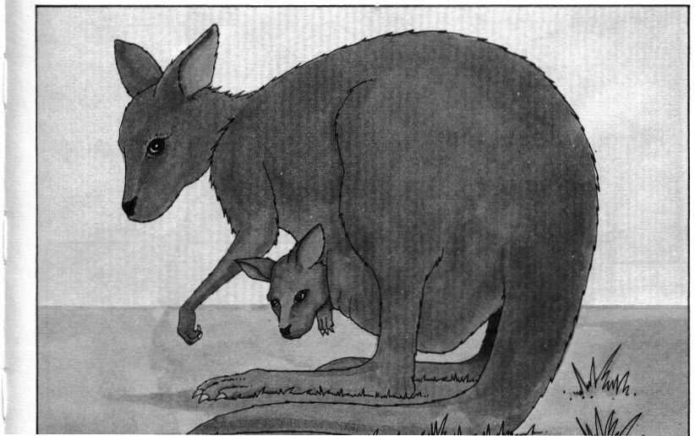

What is a kangaroo?
A kangaroo is an animal found only in Australia, although it has a smaller relative, called a wallaby, which lives on the Australian island of Tasmania and also in New Guinea.
Kangaroos eat grass and plants. They have short front legs, but very long, and very strong back legs and a tail. These they use for sitting up on and for jumping. Kangaroos have been known to make forward jumps of over eight metres, and leap across fences more than three metres high. They can also run at speeds of over 45 kilometres per hour.
The largest kangaroos are the Great Grey Kangaroo and the Red Kangaroo. Adults grow to a length of 1.60 metres and weigh over 90 kilos.
Kangaroos are marsupials. This means that the female kangaroo has an external pouch on the front of her body. A baby kangaroo is very tiny when it is born, and it crawls at once into this pouch where it spends its first five months of life.
Text Source: Peter Haddock Ltd., Ref.083
  - ………………….
  - ………………….
  - ………………….
  - ………………….
  - ………………….
  - ………………….

B. Modelling of Text
B.1. Report Text
Text 1
Activity 9
Read the text carefully then answer the questions
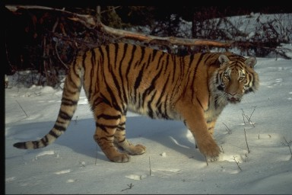

No. | Title | Tigers
1. | General Classification | Tigers vary in size and appearance. The Siberian tiger weighs up to 650 pounds (295 kilograms) and may be 13 feet (4 meters) from its nose to the tip of its tail. It is the largest of all cats. Indian, or Bengal, tigers may weigh from about 300 to 550 pounds (about 135 to 250 kilograms) and are about the size of a lion. Tigers in Malaysia and Indonesia are smaller.
2. | Detailed Description
 | Parts | The background of the tiger’s coat is usually a bright reddish orange or a pale yellow-brown. The stripes that mark the body and limbs are usually back.  The appearance of the tiger depends to a great extent on where the animal lives. Tigers that live in cold regions are pale in color and large in size. Their fur is long and thick. In warmer climates tigers are smaller and more colorful. They have shorter, thinner fur.  Like all cats, tigers have sharp claws and teeth, and they can move quickly and quietly. Springing with ease, tigers may cover 15 feet (4,5 meters) in one leap. They rarely climb trees but are very good swimmers.
 | Quantities | Young tigers, or cubs, are born from 100 to 112 days after the parent have mated. There may be from one to six young in a litter, but the usual number is two or three. Cubs weigh a couple of pounds when they are born. The tiny cubs open their eyes about 10 to 16 days after birth. At the age of 6 or 8 weeks, the young begin to go on hunting trips with their mother. They usually stay with the mother for at least a year. At the end of this time they can hunt for themselves. By the time ready to raise their own families.
 | Habits or behaviour  (For living-things) | Tigers usually stalk their prey alone and a night. To make a kill, the tigers leaps on the animal, biting its neck. It then takes the slain prey to some hidden spot. If it is a large animal, the tiger may feed on it for several days. During this time the tiger does not kill again. Tigers eat deer pigs, cattle, goats, and some smaller animals.

- How many kinds of tigers do you know ?
…………………………………………………………………………………………………………..
- From the several kinds of tigers which one is the biggest ?
…………………………………………………………………………………………………………..
- Mention the characteristics of tiger live in cold regions !
…………………………………………………………………………………………………………..
- How many meters in one leap that tiger can reach !
…………………………………………………………………………………………………………..
- How long does tiger pregnant its babies ?
…………………………………………………………………………………………………………..
- When is tiger able to raise their on families ?
…………………………………………………………………………………………………………..
- Their striped bodies blend well with the underbrush through which they move.
What does the underlined word mean ?
…………………………………………………………………………………………………………..
- In zoos tigers may live to be 20 years old. Why they seldom survive larger in the wild ?
…………………………………………………………………………………………………………..
- It then takes the slain prey to some children spot. The word “it “ refers to …
…………………………………………………………………………………………………………..
- Where does tiger prefers to live ?
…………………………………………………………………………………………………………..
Text 2
Activity 10
Read the text carefully then answer the questions
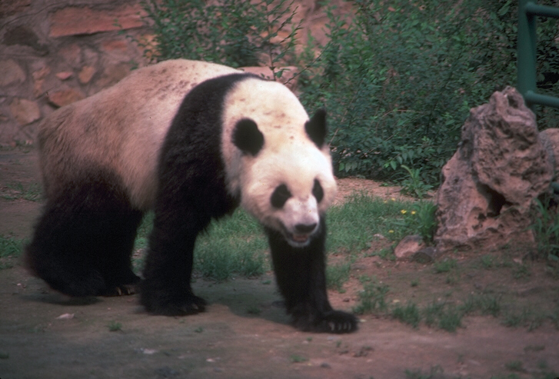

Text Organization  General Classification | Pandas are extremely rare, bearlike animals that inhabit the snowy regions of central China. | Language Features.  1. Technical term  - bear like animals
Description  - Parts  - Qualities  - Habit/behaviours | There are two kinds of pandas – the giant panda and the red panda, also called the lesser panda. The giant panda, with its distinctive black and white markings, is the more familiar of the two. Giant pandas and red pandas belong to their own separate animal family, the Ailuropodidea. Their closest living relativites are the bears.  Most Giant pandas start life at the surprisingly small weight of 4 ounces (104 grams), about the size of a stick of butter. This tiny infant grows into an adult weighing between 180 and 270 pounds (80 and 120 kilograms). Adult giant pandas have coarse black and white fur, small black ears, and large black eye patches that give them their unique appeal. | Description.  1. “Timeless” present tense  - belong to  2. Relational(linking verbs)  - are  3. General Participants  - bears  4. Quantifiers  - most  - Action verb  - start

Answer the questions
1. The type of the text above is called ?
………………………………………………………………………………………………………………
2. The generic structure of the text consist of two main parts. Mention!
………………………………………………………………………………………………………………
- What is the function of the text above?
………………………………………………………………………………………………………………
4. What the text tells us about?
………………………………………………………………………………………………………………
5. What tense is mostly used in the text?
………………………………………………………………………………………………………………
6. What is the focus participant of the text?
………………………………………………………………………………………………………………
B.2. Short Functional Text
Activity 11
Read the postcards below.
Nadia has a pen pal. Her name is Aisyah. Two days ago, she sent Aisyah a postcard, telling about whales that she observed at Sea World Jakarta where she studies at.
Dear Ais,

Aisyah Nasta Lutfindra
Jl. Literari 80
Perum Dosen UNS Jati
Jaten Karanganyar
Love
Nadia
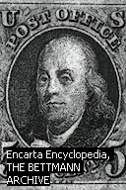
stamp
Ais, I’ll tell you about whales. I observed it at Sea world.

Whales are sea-living mammals.
They therefore breathe air but cannot survive on land. Some species are very large indeed and the blue whale, which can exceed 30m in length, is the largest animal to have lived on earth. Superficially, the whale looks rather like a fish, but there are important differences in its external structure: its tail consists of a pair of broad, flat, horizontal paddles (the tail of a fish is vertical) and it has a single nostril on top of its large, broad head. The skin is smooth and shiny and beneath it lies a layer of fat (blubber). This is up to 30cm in thickness and serves to converse heat and body fluids.

Responding to Nadia’s postcard, Aisyah writes the following card

Dear Nadia,

I’m very glad to receive your marvelous postcard.
What a nice animal it is!. It makes me jealous to you
That you can study well-programmed at your school.
I wish I could go there someday. Sea world is one of
My favourite place to visit. When the time comes,
Don’t forget to accompany me there
Give my best regards to your family.
Nadia Hutabarat
Jl. Buncit Raya 32
Love, Palmerah Jaksel
Ais

Stamp

Questions:
1. What is the function of a post card?
_____________________________________________________________________
- Where can you buy a post card
______________________________________________________________________
- How will you send your post card?
______________________________________________________________________
- What must you put on the post card so that the post office will send it to the addressee?
______________________________________________________________________

C. JOINT CONSTRUCTION OF TEXT
Activity 12
Group in two. Complete the report text by filling the blank with the words from the box.

Sea-Lions
Sea-lions are …………(1) and are warm blooded . they breathe air with their ……(2). The scientific name for the family they belong to is ……………..(3) (Nee-o-fo-ka-Sin-er-ee-a)
Australian sea-lions are about 250 cms long. ………(4) males (called bulls) grow to about 3 metres and are the largest Australian mammal (they no longer breed in Australia). The female sea-lions are always smaller than the bulls in length and weight. Australian sea- lions have a body shaped for …………(5) smoothly through the water and a thick layer of fat ……….(6) their skin . They have a covering of hair, large eyes and long stiff ……..(7). They have long nostrils, long sharp teeth and two pairs of short legs with the five toed feet flattened like …….(8) or fins.

Paddle adult underneath slipping moustache
Whiskers lungs mammals Neophoca Cineriea underbow

Activity 13
State true or false
No. | Statements | T | F
1. | Sea –lions are pregnant and give a birth
2. | Sea-lions lays their eggs in the beach.
3. | The male sea-lions are smaller than the female ones
4. | The sea-lions pups can struggle to live without their parents
5. | Sea-lions used wing to swim in the sea water.
6. | The sea-lions area is in the northern coast of Australia
7. | Many fishermen hunt sea-lions for their whiskers
8. | Sea-lion main food are shells and turtles

D. INDEPENDENT CONSTRUCTION OF TEXT
(Portofolio Task)
Activity 14
- Plan text of report about the creatures below. Use the text organization available.
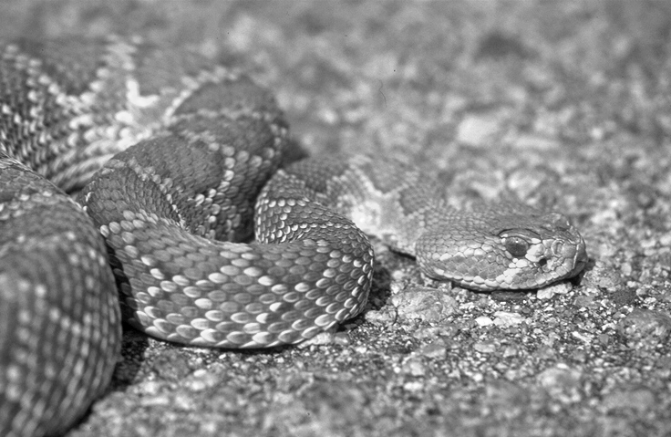

………………………….
Text Organization  General Classification | ……………………………………………..  ……………………………………………..  …………………………………………….. | Language Features.  1. Technical term  …………………………
Description  - Parts  - Qualities  - Habit/behaviours | ……………………………………………..  ……………………………………………..  ……………………………………………..  ……………………………………………..  ……………………………………………..  ……………………………………………..  ……………………………………………..  ……………………………………………..  …………………………………………….. | Description.  1. “Timeless” present tense  …………………………..  2. Relational(linking verbs)  …………………………..  3. General Participants  …………………………..  4. Quantifiers  …………………………..  5. Action verb  ……………………………..
- Show the draft to your teacher and keep it as Portfolio
Activity 15
You got a post card from your best friend, Bayu Arga Kusuma, From Matesih Karanganyar. Read the post card below. Understand its message. Make a reply trough a postcard, too.

Dear Indri,

I would like to tell you about .
Three days ago. I went to Karimun Jawa island
with my family. It was a great experience. You Know what!.
I did snorkeling and I found a lot of sea creatures.
I also took some photograph of special sea creatures.
I’ll show you later.
Tell me about your holiday. Where did you go. Please Indri Wuryaningsih
Tell me. Jl. Veteran 82
Cheers Sukoharjo
Aditya Central Java

Stamp

Write your reply here.

Stamp

UJI KOMPETENSI 2
- Choose the correct answer by crossing A,B,C,D or E
Text 1.
Whale
Whale are sea-living mammals. They, therefore, breathe air but cannot survive on land. Some species are very large indeed and the blue whale, which can exceed 30 metres length , is the largest animal to have lived on earth. Superficially, the whale looks rather like a fish, but there are important differences in its external structure. Its tail consists of a pair of broad, flat horizontal paddles, compared with the tail of fish that is vertical. It has a single nostril on top of its large, broad head. The skin is smooth and shiny and beneath it lies of fat. This is up to 30 cm in thickness and serves to conserve heat and body fluid.

01. Sandy : The genre of the text above belongs to…….
Harun : ……………….
- narrative
- recount
- report
- descriptive

02. Beni : What is the purpose of the text above ?
Beno : It is to ……………..
- entertain people
- amuse people
- inform people about natural phenomena
- give step by step understanding about natural phenomena

03. Malisa : What is the generic structure of the text?
Merry : ………………….
- General description – Detailed classification
- General classification –detailed description
- General News worthy event – Background description
- General classification – background description

04. Nano : What tense is used ?
Nina : Based on my observation it uses …………
- simple present tense
- simple past tense
- simple future tense
- past future tense

05. Hartono : What makes whale different from the other sea creatures?
Sugiyanto : it is ………
- reptile
- amphibian
- bird
- mammal

06. Dani : What is the biggest mammals on earth?
Sari : it is …………..
- black whale
- blue whale
- white whale
- green while

07. Dr. Lazaruz : What is the biggest difference between whale and fish?
Dr. Nanung : In their ……………….
- external structure
- internal structure
- abdominal structure
- fat layer

08. ……….. and beneath it lies of fat. The word it refers to..
A.. tail
B. paddles
C. nostril
D. Skin

09. This is up to 30 cm in thickness and serves to conserve heat and body fluid. The synonym of the
underlined word is ……
- acts
- functions
- uses
- meets

10. Whale can not live at……
- ocean
- water
- land
- sea

11. Mrs. Budiman sometimes …………….flower in the garden.
- to pick up
- picks up
- picked up
- picking up

12. It is hard for me to find my purse. It ………have lost.
- could
- may
- might
- must

13. Diandra looks pale . She ………….visit a doctor
- should
- could
- would
- might

14. Mr. Alessandro likes football ……….his wife doesn’t
- and
- or
- but
- nor
15. Mr. Sandwich : Which one do you prefer , pancake …….French Fries?
Mr. Butter : Oh, I like pancake
- and
- or
- but
- nor

16. Mr. Agus is ……………….than Mr. Pranowo
- handsome
- more handsome
- most handsome
- as handsome as

17. Deni : How is your condition
Jono : I am getting …………………than yesterday
- good
- gooder
- goodest
- better

18. You will come to my birthday party, ……….?
- will you
- won’t you
- do you
- don’t you

19. I am very happy this morning,……?
- are I
- aren’t I
- am I
- am no I

20. I planted a mango tree a year ago. It ……..higher and higher.
A. tastes
B. smells
C. grows
D. has

- One of the iguanas …..my uncle’s pet.
A. is
B. are
C. was
D. were

- Dolphin are sea mammals. What characteristics does the sentence contain?
A. Singular, verb, past tense
B. Singular, linking verb, present tense
C. Plural, verbs, past tense
D. Plural, linking verb, present tense

23. X : Tell us. Where did you go yesterday?
Y : I went to Pasar Klewer Solo
X : ………………… It is not clear
Y : I went to pasar Klewer Solo
- do you agree?
- I have no doubt
- Pardon me?
- I’m sure

24. X : Can you help me?
Y : ……………. I can’t hear you
X : Can you help me. I need to cross the road.
The following are the possible answers, except…
- excuse me?
- I beg your pardon
- Repeat please
- I beg you apologize me

25. Rina : Look ! I always get ten at English test
Anita : …. .
Which of the following utterances that expresses Anita’s admiration to Rina.
A. That’s awful
B. That’s not your fault
C. You’re really dull
D. You ‘re really clever

ULANGAN HARIAN 2
A. Choose the correct answer by crossing A,B,C,D or E

Text 1
Piranha fish are the fiercest animals in the world. They live in the fresh water rivers of South America, from Venezuela to Northern Argentina. These fish hunt in groups, called schools. They usually eat other fish smaller than themselves. Sometimes Piranhas will attack and eat each other.
There are about 18 kinds of piranha fish. Only four kinds attack man. Piranhas have large head and short thick bodies. They are usually about 20 cm ( 9 inches long) but one kind can be as much as 60 cm (two feet). It lives in the Sao Francisco river from Eastern Brazil. It is one of the most dangerous fish.
The most noticeable thing about Piranha fish is the large mouth. The mouth has a lot of triangular teeth with sharp point. The points pierce the skin of the prey. The razor sharp edges of the teeth chop out pieces of flesh. The teeth of the upper and lower jaws fit together like scissors. The muscles moving the jaws are big and very powerful.
On the back of the Piranha fish there is a ridge called a keel. There is another keel running along it belly. The tail is slender and muscular. Its tail fins are broad. All these features held the piranha to swim fast through the water. The piranha fish eat a large South American rat-like animal, called a Capybara, weighing 50 kilos ( 100 ponds) to a skeleton in less than 60 seconds.

01. What is the social function of the text above ?
- To explain .
- To retell events
- To amuse the readers
- To describe

02. What are schools in the text mean .... .
- Piranha fish are the fiercest animals in the world.
- Piranhas will attack and eat each other.
- Piranha fish has a large mouth
- Piranhas fish hunt in groups

03. These are the characteristics of piranha, EXCEPT ... .
- They live in the fresh water rivers.
- They usually eat other fish smaller than themselves
- Piranha fish has large mouth with of triangular teeth with sharp point.
- The muscles moving the jaws are small and very weak

04. The razor sharp edges of the teeth chop out pieces of flesh.
The synonym of the underlined word is .... .
- give up c. cut
- throw away d. bend

05. Why can piranha swim fast through the water.
- Piranha fish has a ridge
- there is another keel running along its belly
- they live in the fresh water rivers of South America
- the tail is slender and muscular

Text 2
Cheetahs are members of the cat family and are the world’s fastest land animals. They inhabit open grasslands and scrub in Africa, southern Asia and Middle East.
Cheetahs are often mistaken for leopards and have many similar features.
Their distinguishing marks are the long, teardrop-shaped lines on each side of the nose from the corner of the eyes to the mouth.
The animals have muscular and powerful bodies which are aerodynamically perfect for short, fast runs. Their bendy backs keep the body flexible as they sprint.
They can accelerate from standing to 40 mph in three strides and to a full speed of 70 mph within seconds. Cheetah’s feet are like running shoes and have grips and spikes to dig into the ground. The grips are special ridges on the animal’s footpads and the claws act as spikes. These claws stay out all the time. This is different from other cats, whose claws tuck away in special sheaths in their paws.
Cheetah are carnivores and eat gazelle and small antelope. A long tail helps the cheetah keep its balance as it serves after its prey, using large eyes that point forward to judge distance accurately. Once the cheetah has pounched, the victim is gripped by the throat to stop it breathing. However, the cheetah has weak jaws and small teeth and cannot always protect its kills or its young, especially if tired out after a run.
Female cheetahs gave birth to an average of three young that they rear by themselves. Once fully grown, the animals usually live alone, though males sometimes form small groups. Most cheetahs live about twelve years.
Cheetah are now an endangered species and many conservationists are trying to help protect the habitats of these interesting creatures.

06. What is the social function of the text above ?
- To amuse the readers
- To describe the cheetah
- To retell events of carnivores
- To explain the process involved in the cheetah.

07. Based on the text above what are cheetahs classified into?
Cheetah are .... .
- Herbivores
- mammal
- omnivores
- carnivores
08. Which of the following is NOT TRUE based on the text ?
- Cheetahs are the same creature with leopards.
- Cheetahs have muscular and powerful bodies.
- Cheetahs kill their preys by gripping their throat to stop them breathing
- Female cheetahs usually give birth three babies.

09. Their bendy backs keep the body flexible as they sprint.(prg 4). The underlined word refers to..
a. leopard
b. cheetah
c. cat family
d. gazelle

10. Cheetah are now an endangered species and many conservationists are trying to help protect the
habitats of these interesting creatures.
The synonym of the underlined word is ….
a. to endanger
b. to keep
c. to guard
d. to save

Text 3.
The white pelican is one of the most successful fish eating birds. The success is largely due to its command hunting behaviour. A group, perhaps two dozens birds, will gather in a curved arc some distance offshore, beating the water furiously with their wings, driving the fish before them.
When the water is shallow enough for the birds to reach the fish, the formation breaks up as each bird dip its bill into the water to scoop up its meal. As the bird lifts its head, the water drains from its bill leaving the fish which are then swallowed.
Pelicans are among the oldest group of birds, Fossils of this genus have been found dating back 40 millions years.
11. X :Why is White Pelican called as the most successful fish eating bird?
Y : I think it is because…..
- its two dozen birds gather together
- its command hunting behaviour
- its curved arc
- its beating the water furiously

12. X : How do they hunt for fish?
Y : they do it ….
- Individually
- One by one
- In a group
- With other animals

13. X : How do they beat the sea water?
Y : …..
- largely
- clearly
- furiously
- quietly

14. X : What is the main idea of the text above?
Y : It is about…
- The death of White Pelican
- The history of White Pelican
- The breeding behaviour of White Pelican
- The Hunting behaviour of White Pelican

15. X :How old was the fossil of the Pelican ?
Y : ……
- 20 million years
- 30 million years
- 40 million years
- 50 million years

16. … beating the water furiously with their wings, driving the fish before them.(prg 1). The underlined
word refers to…
- fish
- White Pelican
- Birds
- A group

17. … When the water is shallow enough for the birds to reach the fish (prg. 2). The underlined word has
the similar meaning with..
- quite
- too
- more
- much

18. The text above is belong to ………..genre.
- report
- narrative
- recount
- procedure

19. The generic structure of the text above is….
- orientation – events –reorientation
- orientation- events – twist
- General classification – detail description
- Goal – steps

20. What is the purpose of the text?
- Describing a natural phenomena
- Entertaining audience
- How to do something
- Explaining how to do something

PERSIAPAN UJIAN AKHIR SEMESTER

A. Choose the correct answer by crossing A,B,C,D or E
Text 1
Do you know Rhinoceros?. Where do you see it?. Rhinoceros are big and heavy animals. They are also quiet. They pay little attention to the surroundings. Rhinoceros eat grass like horses. They have one or two horns above their nostrils. There are five types of rhinoceros in the world. Two types are in Africa, the black and the white rhinoceroses. Three others are in India, Sumatra and Java. The Javanese and the Indian have only one horn. The Sumatran type is the smallest . A Sumatran rhinoceros can be one meter or somewhat more up to the shoulder . It can one ton in weight . The white African is the biggest. It can be twice higher and three times in weight.
01. .Aprilia : How is Rhinoceros natural character?
Sandy : It has ………….character.
- anger
- calm
- fierce
- mad

02. Budi : How many types of rhinoceros are there in Africa?
Ery : there are ………..types.
- one
- two
- three
- four

03. Naning : What type of Rhinoceros is the smallest?
Fatonah : I think it is ………….type.
- African
- Asian
- Javanese
- Sumatran

04. The text above is belong to ………..genre.
- report
- narrative
- recount
- procedure

05. The generic structure of the text above is….
- orientation – events –reorientation
- orientation- events – twist
- General classification – detail description
D Goal – steps
06. What is the purpose of the text?
A. Describing a natural phenomena
B. Entertaining audience
C. How to do something
- Explaining how to do something

07. What kind of tenses is mostly used in the text above?
- Simple present tense
- Present continuous tense
- Simple past tense
- Past continuous tense

Text 2.
Computer is part of our daily life today. Computer are machines that handle information automatically. They can perform calculation and the process data. Computers can work with numbers to solve problems in a few second. Computer can remember a great deal of information and make practically no mistakes. That’s why computer are widely used in a places such as banks, offices, and companies.
Computer works like calculator. We tell them what to do by pressing various button. To do the same work, we can gives series of instruction to a computer. We call this computer program. If we set up a program the computer can provides other information, such as list number, letters, words or even graph or pictures. Once we provide program the computer can do all this work automatically without further help or instruction.
08. John : According to the text, What is the computer for?
Smith : it is used for…..
- Typing without mistakes
- Giving us code
- Handling information
- Making us happy

09. Dodo : What does paragraph 2 tell us about?
Dudi : It tells about…….
- How to set up the program
- How computer works
- What computer can do
- What a man can do with computers

10. Ade’ : What are stored by computer?
Aa’ : It stores…..(except)
- pictures
- screen
- letters
- numbers

11. Dania : What is needed by computer to run?
Solichin : It needs …….
- gas
- electricity
- gasoline
- lubricant

Text.3

Making Stained Glass Figures
First you take a piece of cardboard and one piece of chalk.
Then you draw something on the cardboard.
Next you cut it out where you want light to go trough.
Then use a text to trace around the thing you drew.
Stick different coloured cellophane paper over the areas that have a hole.
When you have finished this, stick it on the window.
12. What is the purpose of the text above?
- describe how something is got
- describe how something is accomplished
- describe how something is bought
- describe how something is broken

13. What is the text structure?
A. Orientation – events – re-orientation

B. Orientation –events - twists

C. Goal – events
D. Goal –steps

14. What part of speech is mostly used in the text above?
- noun
- verb
- adverb
- phrase

15. Next you cut it out where you want light to go trough. The underlined word refers to …
- cardboard
- chalk
- light
- coloured paper

16. What tenses is mostly used in the text?
- present tense
- past tense
- future tense
- perfect tense

Text 4
How to use a Cassette Player
First, to turn on the player, plug the wire in to the socked
Second, press the eject button
Third, put in the cassette
Fourth, press the play button to start it.
Fifth, to make the tape go forward quickly, press the “FF” or Fast Forward button. Or, press the “RWD” or Rewind button to make it go back.
Then, to record something, press the play and record button at the same time.
Finally, to turn off the tape, press the stop button.
17. What is the purpose of the text?
A. to give information
B. to describe a thing in general
C. to describe particular thing
D. to operate something step by step

18. What do you need to play the player?
A. button and the player
B. Wire and cassette
C. Socket and button
D. The player and the socket

19. How can you record something?
A. By plugging the wire into the socket
B. By leaving the play and record buttons at the same time
C. By pressing the play button and “FF” at the same time.
D. By pressing the play and record buttons together.

20. Look at the picture!
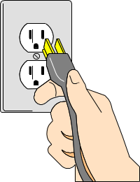
What step is it?
A. first
B. second
C. third
D. fourth

Text 5
Complete the following text.
Kangaroos eat grass and plants. They have short front legs, (21) … very long, and very strong back legs and a tail. These (22) … use for sitting up on and for jumping. Kangaroos have been known to make (23) … jumps of over eight metres, and (24) … across fences more than three metres high. They can also run at speeds of over 45 (25) … per hour.
21. A. and
B. but
C. because
D. since

22. A. Their
B. they
C. it
D. its

23. A. Forward
B. Beside
C. backward
D. behind

24. A. leap
B. creep
C. sleep
D. clap

25. A. Kilometres
B. metres
C. decimetres
D. centimetres

26. Kenia : Nobody in this village consumes dog meat
Narnia : ……? But I saw one consuming it this morning
A. Are you with me
B. I don’t know
C. I’d like to know
D. Are you sure

27. Melly : Could I go tonight with Linda, Mom?
Mom : …… But be careful and come home before nine o’clock.
A. Of course not
B. Certainly
C. I am not sure.
D. I am afraid you can’t.

28. Lary : Hary gets the first rank in his school.
Meti : ____________. I always admire his smartness.
A. Great
B. Poor Hary
C. He is so a pity
D. He is so awful

29. Nena : Look at Aisyah. She always helps her parents. She does all the house works by herself.
Sweeping the floors, boiling some water and cooking rice.
Melly : …………….
A. What is Aisyah a diligent girl !
B. What is a diligent girl Aisyah!
C. What a diligent girl is Aisyah!
D. What a diligent girl Aisyah is !

30. Mita : May I sit at this chair , please?
Dina : ……………. I can’t hear you
Mita : I said May I sit at this chair
Dina : Of course. Please. Sit down.
The following are the possible answers, except…
A. Repeat please
B. I apologize you
C. excuse me?
D. pardon me?
31. Mrs. Saleha : Danang, ………the TV please. It’s time to pray maghrib to the mosque.
Danan : All right mom.
A. Turn on
B. Turn in
C. switch on
D. Switch off

32. Michael : What does your sister do every evening?
Wendy : Oh, she always ……..her dirty clothes.
A. to wash
B. wash
C. washs
D. washes

33. Bambi : Where is your sister?
Bombo : Look at the girls over there. My sister is the girl which wears …...
A. a wonderful new small black leather cap
B. a wonderful small new black leather cap
C. a wonderful leather new small black cap
D. a cap small new black wonderful leather.

34. Cole : I don’t like this shoes. It is not comfortable. Moreover, it is ….. than the one in the corner.
Melly : Let’s find it on the other shop
A. cheap
B. more cheaper
C. expensive
D. more expensive

35. Conny : I think Mr. Agus Wuryanto does his duty ……. It is right that he gets the honour.
Kelly : Yes, I think so.
A. with careful
B. with carefully
C. carefully
D. careful

36. Mr. Bo : It’s very hot here. Open the window, _____ ?
Mrs. Bo : Wait a minute. I am cooking darling.
A. Aren’t you?
B. Don’t you?
C. will you
D. won’t you?

37. Malik : I am very sad
Anik : Why ?
Malik : We will leave our school and be separated. We rarely meet then, ______?
Anik : Don’t worry. We can send e-mail each other.
A. Don’t we
B. do we
C. aren’t we
D. are we

38. Giraffe ……….run at 45 mill per hour.
A. can
B. could
C. should
D. must

39. Mr. Kromo : The paddy plants are dying _____ there is no water.
Mr. Samijo : Why don’t we pump the water from the river ?
Mr. Kromo : We don’t have enough money to buy the fuel.
A. since
B. therefore
C. when
D. but

40. Because of overheated, the cake ………burning. The fumes is everywhere.
A. tastes
B. looks
C. smells
D. feels

- Essay
41. Fill the blank with suitable expression.
Ida : Why don’t you ask John to repair your car? I ______________ he can fix it.
Yudi : That’s a good idea. I know he is an experienced mechanic.

42. Dian : How do you like your steak, Miss.
Lisa : ……………Can you repeat once again?
Dian : How do you like your steak, Miss.
Lisa : Oh I like my steak well-done

Fill the blank with suitable conjucntion
43. Dora : When do you read newspaper or magazines?
Dona : I usually read it …….I come from school. I have no schedule at that time

Fill the blank with suitable question tag.
44. A : Traveling by plane costs a lot, ……. ?
B : Yes, you are right.

45. You want to cook some rice. Write a procedure on “How to cook rice” based on the pictures.


