UNIT 1
Tell me, what is it?
Text type : Report

In this unit, you will learn how to:
- Carry out interpersonal conversation involving :
  - Expression of asking and giving opinion
  - Expressions of satisfaction and dissatisfaction
- Reporting natural or social phenomena using spoken English.
- Read report texts
- Listen short functional texts (Banners)
- Write short functional texts ( Banners)
- Write report texts

Language features
    - Simple present tense.
    - Linking verbs
    - Conjunctions
    - Gambits

Step 1(Spoken)
Listening and speaking

A. Speech Function
A.1. Asking and giving opinion
Activity 1.
Listen to your teacher reading the following dialogs. Identify the following expressions
Dialog 1.

Look, Jane!. The palace looks so great, Doesn’t it?
Yeah. It is wonderful!

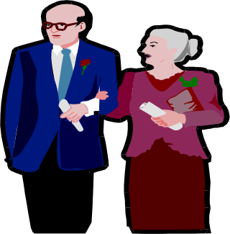

Dialog 2.
Merry : Look those guys are very talented in music.
Andi : Are you sure?
Merry : I think so
Andi : I don’t think so. It’s boring
Merry : Really?
Andi : They just play the same song monotonously.
Merry : Yes, You are right.

Questions:
1. Which expression are giving for opinion ?
2. Which expression are asking for opinion?
3. Which expression are disagreeing with an opinion?

Learn the expression
- Asking for opinion
What do you think of …..?
What is your opinion about …?
The house is so excellent, isn’t it?

- Giving opinion
I think …….
You’re right…
Yeah. I like it …
absolutely

- Disagreement to an opinion
No. I don’t think so..
I am not with you.
I am not in line with you
I have different opinion about..
Absolutely no…

Activity 2.
Lets practice using the expression. In pairs, make an interpersonal dialog based on the following situations
- You and your friend is having a trip to Safari park. Your friend think that the animal should be let free. You disagree with his/her opinion.
Your partner : ______________________________________________________
You : ______________________________________________________
Your partner : ______________________________________________________
You : ______________________________________________________
Your partner : ______________________________________________________
You : ______________________________________________________

2. A new hall is being built at your school. You think it is a great structure. You ask your friend’s
opinion about it.
You : ___________________________________________________________
Your partner : ___________________________________________________________
You : ___________________________________________________________
Your partner : ___________________________________________________________
You : ___________________________________________________________
Your partner : ___________________________________________________________
You : ___________________________________________________________
Your partner : ___________________________________________________________

3. You and your friend’s are in Ari Lasso concert. You ask him/her opinion about the show. He/she
doesn’t like it too much.
You :___________________________________________________________
Your partner :___________________________________________________________
You :___________________________________________________________
Your partner :___________________________________________________________
You :___________________________________________________________
Your partner :___________________________________________________________
You : __________________________________________________________
Your partner :___________________________________________________________

A.2. Expressing satisfaction and dissatisfaction
Activity 3
Read the dialogue carefully!
Dialogue 1.
(Danto and Danti are at a museum watching painting exhibition)
Danto : Wow. Look at this painting Isn’t this painting great?
Danti : Yes, The combination of colours is so perfect. It looks like that the object of
painting is alive. That’s great.
Danto : Yes, you are right. What about if we buy this one?
Danti : It’s a wonderful paintings. I agree with you.

Dialogue 2.
(Kania is accompanying her mother to a market)
Kania : Mom, what will we buy?

Mom : We need some vegetables and fruits for the “selametan” of your late grandma.
Kania : What kinds of vegetables do we need?
Mom : spinach leaves, beans, cauliflower, carrots and lettuce. We also need coconut for
the sauce.
(They are busy looking for the vegetables)
Kania : Look at these spinach leaves. It looks green and fresh. Isn’t that great?
Mom : Yes you are right. I like them . I’ll take these ones. I think it’s enough. Let’s go
home.

Answer the question based on the texts above
1. Where do Danto and Danti?
2. What are they doing?
3. Do they interested in the paintings?
4. Do they buy the painting?
5. Why do they buy the painting?
6. Where do Kania and her mom?
7 What do they do there?
8. What does Kania show to her mother?
9. What is Kania’s mother response?
10. Find out the expression of pleasure found in the text!

Activity 4
Study the following expression
1. Expressing Satisfaction.
It’s wonderful.
How marvelous
I am please with it / that.
It’s my pleasure.
It’s give me pleasure.
That’s great.
That terrific.
I am happy with ……
I like it.
I love it.

2. Expressing Dissatisfaction.

What a nuisance !
I am fed up with
I really hate it.
I dislike it.
It’s extremely annoying.
I am dissatisfied with it / that
I am disappointed with it / that.

Activity 5.
Give response to the following utterance!.
1. X : Here is your new trousers. What do you think?
Y : ……………………………It suits to my body. Thanks

2. X :The steak smell good. It must be great taste.
Y : ……………………………It so delicious

3. X : Do you like your hotel room.
Y : …………………………….The toilet is too dirty.

4. X : This Ice tea is so fresh. ……………………………….
Y : Yes, It is

5. X : Have you read “Harry Potter and the Prince of Adzkaban”? . That book is great. I read it
four times and I still want to read it again and again.
Y : ………………….I don’t like the end of the story. It’s too sad for me.

B. Grammatical feature In report text.

Activity 6

Reading for comprehension. Read the text carefully. Pay attention to the language features used in the text.
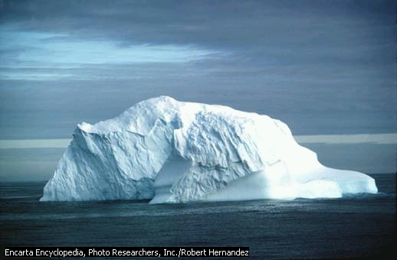
An iceberg is an enormous piece of ice floating in the sea. ‘Berg’ is the German word for mountain. In the coldest parts of the earth, around the North and South Poles, land and sea are both covered by sheets of ice, over 300 metres deep at the centre.

Tongues of ice, called glaciers, stretch out into the open waters of the oceans. The sea water melts the bottom parts of these glaciers, then the top part slides into the water with a mighty roar. The great piece of ice sinks for a short time beneath the surface then it rises again, and floats away as a new iceberg. Some icebergs are miles across to begin with, and travel for thousands of miles and several years before they finally melt. The part of an iceberg which can be seen above the water is only about one-ninth of the total size. The rest is hidden beneath the waves.

(Materi Pelatihan Terintegrasi: 2005: 23-24)

Questions
1. What is iceberg
2. Where can you find it?
3. What is glaciers?
4. How big is iceberg?
5. How big is the iceberg seen above the water?

Simple Present Tense
Activity 7
Let’s learn about “Simple present tense”
Pay attention to the following sentences:
1. An iceberg is an enormous piece of ice floating in the sea
2. Tongues of ice, called glaciers, stretch out into the open waters of the oceans
3. The sea water melts the bottom parts of these glaciers, then …..

In reporting something, we use simple present tense. Read the explanation below. Discuss with your friends or teacher if you don’t understand.

A. General pattern
Pattern | Time reference
a. Verb pattern  (+) S + V1(-s/-es)  (-) S + do/does not V1  (?) Do/does + S + V1  b. To be pattern  (+) S + is/am/are + adjectives/adverbs/nouns  (-) S+ is/am/are not + adjectives/adverbs/nouns  (?) Is/Am/Are S + adjectives/adverbs/nouns | Every….  Always never  Often occasionally  Sometimes seldom  Rarely  Ever

B. Functions
1. Expressing habitual actions or customs
2. Expressing general truth

C. Special Note
If the subject is third singular person (e.g) he, she, it John, Smith, Karen, the earth), we
should add –s/–es to the verb.
1. Add –es if the verb ends in ss, sh, ch, x or z
cross – crosses
crush - crushes
catch - catches
mix - mixes
buzz - buzzes
2. If the verb ends in –y preceded by a consonant , change the –y into I and add -es
cry - cries
fry - fries

Activity 8
Change the be/verbs in the bracket into correct order.
A tornado (1).………….(be) a powerful, twisting wind storm. This is one of the most destructive of all the storms that we (2) ………(have) on earth. Tornadoes (3)…….(be) long clouds which (4)……(come) down from the sky. Weather scientists (5)……(be) unable to know exactly, when a tornado (6)……..(occur). Fortunately, it (7) …………..(not, last) long. So, (8) ……….you have clear understanding about tornado?

C. MONOLOG

C.1. Building Knowledge of Field
Activity 9
Listen to your teacher reading a report text while you are completing the blank spaces below.

PENGUINS
Penguins are ……(1) , but they are unlike other birds in several ways. Their wings are …….(2), and they cannot fly in the air. Penguins do, however, “fly” in the water, at ……(3) to 30 miles (48 kilometers) an hour. While swimming, they can ……(4) with a thrust of their flippers and travel 30 feet (9 meters) underwater before surfacing. They surface with such force that they may ……(5) into the air, like porpoises. Some can ……(6) cut of the water onto a ledge 7 feet (2 meters) above the surface.
On land, penguins use their flippers for fighting and for balancing as they walk. Penguins ……(7) slowly along, standing up straight like a person. When traveling over snow and ice, they may …..(8) on their bellies and “row” with their feet. They also use their flippers when in a great …..(9). This way of traveling is called …….(10).

Answer the questions orally
1. What do you know about penguins ?
2. What makes penguins unlike birds in several ways ?
3. How many meters penguins can dive and travel underwater before surfacing ?
- On land, penguins use their flippers for ….
- When penguins flop op their bellies and ran with their feet. We called this ?

C.2. Modelling of Text
Activity 10
Look at the picture. Listen to your teacher. Then answer the questions. (Text is enclosed)
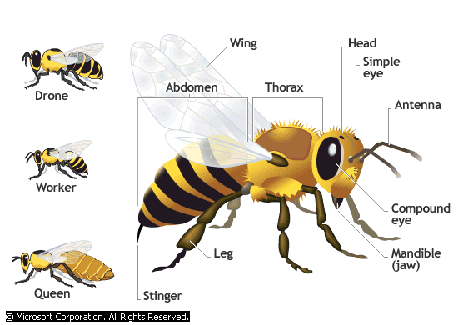

Taken from : Microsoft ® Encarta ® Reference Library 2005.

Questions
- What do bees do in the summer time?
- What do bees eat?
- Where do bees get pollen from?
- How do they bring the pollen?
- Why do plants need the pollen?
- Based on the picture above. How many kinds of bee are there in a colony?
- What is the text about?
- Is it the text about something factual or fictional?
- Is it about a specific bee or bees in general?

C.3. Joint Construction of Text
Activity 11
Work in pairs. Look at this picture. Observe it. Take notes if necessary. Then fill in the chart below.

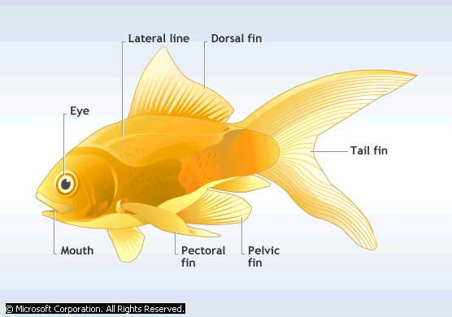
Microsoft ® Encarta ® Reference Library 2005.

No. | Questions | Answers
1. | What kind of animal does fish belong to ? | -  -
2. | Where can usually you find fish? | -  -  -  -
3. | What does fish in general look like? | -
4. | Mention the parts of a fish? | -  -  -  -  -  -  -
5. | What are the fish used for? | -  -  -  -
Activity 12.
Tell your report to your friend

C.4. Independent Construction of Text.
Activity 13
Make your own report. Then, Tell your friends using a picture of an animal, a plant or a thing
Example:
Well, good morning, friends. I’ll tell you trees that grow at our school garden. Hmm….the trees, in general, has similar parts as the other. They have leaves, branches, trunks and roots. ……(Continue by yourself)

Step 2 (Written)
Reading and writing

- Building Knowledge Of Field
Activity 1
Name the following creatures

1 | 2 | 3 | 4

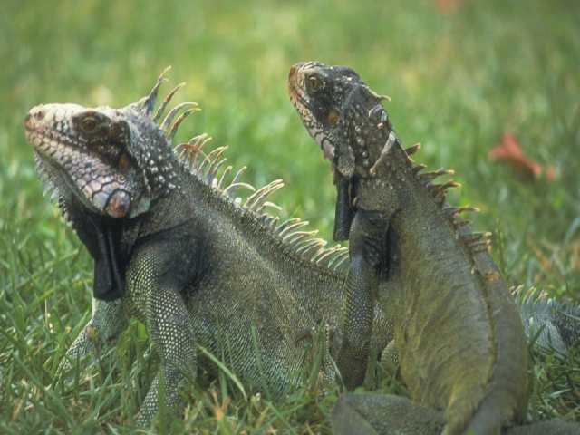
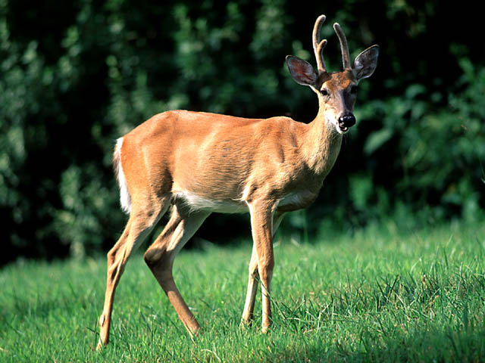
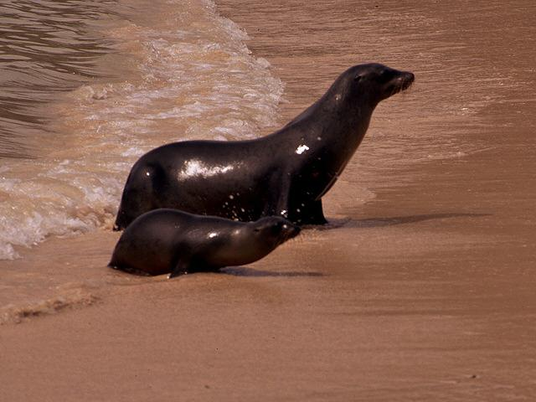

_________________ | ________________ | _______________ | ________________

5 | 6 | 7 | 8
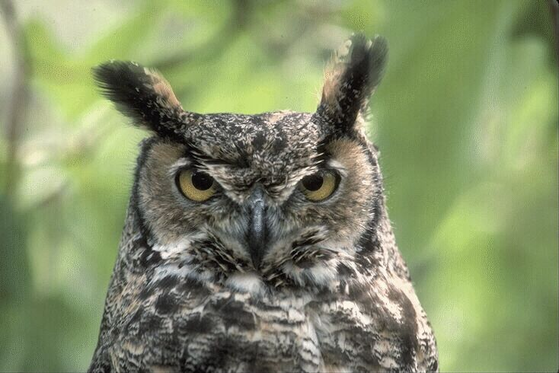
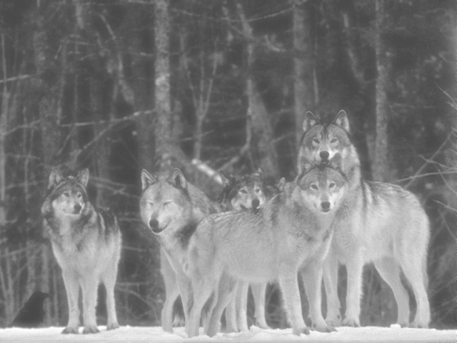
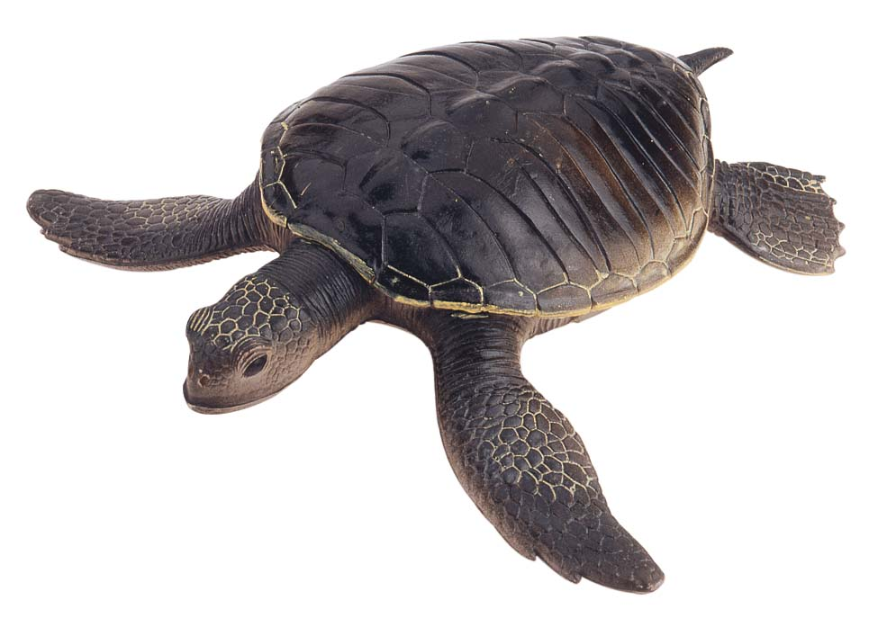
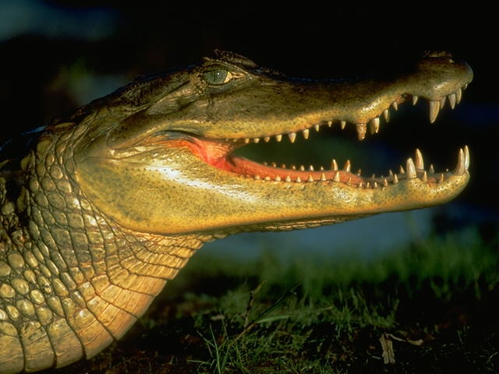

_________________ | ________________ | ________________ | ________________

2. Grammar Focus
2.1.Conjunctions
Conjunctions are words which join words or groups of words. There are two principle types of conjunctions: coordinate and subordinate
A coordinate conjunction joins words or groups of words of equal value
They are and, but, or, nor, for etc.
Example : The students must buy bag and uniform for going to school
My aunt likes western music but my mother likes Javanese.
The bowl could be on the cupboard or in the table
We must clean the river from pollutants so water can be drunk
A subordinate conjunction join a dependent clause with an independent clause. They are when, while, where, since, because, if, unless, until, although, as soon as etc.
Exmple : My father doesn’t go to his office because he is ill
The employee keeps working although his body is weak
Activity 2
Fill in the blanks with the suitable conjunctions
- You can choose basket …football as your favourite sport.
……………………………………………………………………………………………………
- …it doesn’t rain this evening, I will go out.
……………………………………………………………………………………………………
- My mother was sleeping in the living room ….I came home last night.
……………………………………………………………………………………………………
- My aunt lives by herself at village….she feels happy.
……………………………………………………………………………………………………
- You must take some exercise ….you’ll be fatter and fatter
……………………………………………………………………………………………………
- I’ll visit my grandma at hospital …. I finish doing my homework .
……………………………………………………………………………………………………
- The boy was just going to cross the street …the officers shouted “Stop!”
…………………………………………………………………………………………………….
- They always do their paper well….we don’t
…………………………………………………………………………………………………….
- Asri could pass her final test …she studied very hard.
………………………………………………………………………………………………………
- I visited my doctor last night …she gave me a prescription for my headache.
………………………………………………………………………………………………………

Activity 3
Make your own sentence by using the following conjunctions!
- because : ………………………………………………………………………………
- if :………………………………………………………………………………
- unless :………………………………………………………………………………
- until :………………………………………………………………………………
- although :………………………………………………………………………………
- And : ………………………………………………………………………………
- But : ………………………………………………………………………………
- or : ………………………………………………………………………………
- when : ………………………………………………………………………………
- since : ……………………………………………………………………………….

- Modelling Of Text.
B.1. Report Text
Activity 5
Read and observe the characteristic of the report text.
Text Organization  General Classification | Pandas are extremely rare, bearlike animals that inhabit the snowy regions of central China. | Language Features.  1. Technical term  - bear like animals
Description  - Parts  - Qualities  - Habit/behaviours | There are two kinds of pandas – the giant panda and the red panda, also called the lesser panda. The giant panda, with its distinctive black and white markings, is the more familiar of the two. Giant pandas and red pandas belong to their own separate animal family, the Ailuropodidea. Their closest living relativites are the bears.  Most Giant pandas start life at the surprisingly small weight of 4 ounces (104 grams), about the size of a stick of butter. This tiny infant grows into an adult weighing between 180 and 270 pounds (80 and 120 kilograms). Adult giant pandas have coarse black and white fur, small black ears, and large black eye patches that give them their unique appeal. | Description.  1. “Timeless” present tense  - belong to  2. Relational(linking verbs)  - are  3. General Participants  - bears  4. Quantifiers  - most  - Action verb  - start

Questions
1. The type of the text above is called ?
2. The generic structure of the text consist of two main parts. Mention!
3. What is the function of the text above?
4. What the text tells us about?
5. What tense is mostly used in the text?
6. What is the focus participant of the text?

B. 2. Short Functional Text
Activity 6
Observe the banners
Banner 1

Welcome to The English Debate Contest 2008

Banner 2


Read the definition..
Banner : cloth suspended between two poles: a long piece of cloth, often bearing a symbol or slogan, and attached at each end to a pole or hanging from the top of a pole
Microsoft® Encarta® Reference Library 2005. © 1993-2004 Microsoft Corporation.

Questions :
1. Where do you usually see banner?
2. What are usually written at a banner?
3. What is the purpose of the making of banner?
4. What kind of organization uses banner?

C. Joint Construction Of Text
Activity 7
In a group of four. Discuss the definition of the general classification of certain creatures or natural phenomena
Example :
X : What is snake
Y : Oh, Snakes are reptiles (cold blooded creatures). They belong to the same group
as Lizards . It belongs to Serpentes
1. Whales : ______________________________________________________
_______________________________________________________
2. Spider : _______________________________________________________
_______________________________________________________
3. Rhinoceroses : _______________________________________________________
_______________________________________________________
4. Volcano : ______________________________________________________ _______________________________________________________
5. Tornado : ______________________________________________________
_______________________________________________________
Activity 8
In pairs. Make a banner based on the following information
1. Your favourite basket team will have a final match tomorrow night. Make a banner to show your
support to the team

- You want to warn every student in your class to put the garbage in the dustbin properly. Make
banner about it, then put it on the wall.

D. Independent Construction Of Text
(Portfolio Task)
Activity 9
- Plan text of report about the creatures below. Use the text organization available.
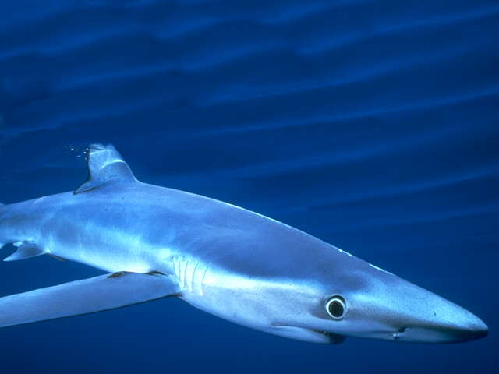

………………………….

Text Organization  General Classification | ……………………………………………..  ……………………………………………..  …………………………………………….. | Language Features.  1. Technical term  …………………………
Description  - Parts  - Qualities  - Habit/behaviours | ……………………………………………..  ……………………………………………..  ……………………………………………..  ……………………………………………..  ……………………………………………..  ……………………………………………..  ……………………………………………..  ……………………………………………..  …………………………………………….. | Description.  1. “Timeless” present tense  …………………………..  2. Relational(linking verbs)  …………………………..  3. General Participants  …………………………..  4. Quantifiers  …………………………..  5. Action verb  ……………………………..

- Show the draft to your teacher and keep it as Portfolio
SUMMARY
REPORT TEXT
Social Function/Purpose | Describe the way thins are. The things must be representative of their class.
Generic Structure | - General classification  Tells what the phenomenon under discussion is  - Description  Tells what the phenomenon under discussion is like in term of  parts, qualities, habits or behaviors, uses/function)
Language Features | - the use of general nouns  - the use of present tense  - the use of relating verbs  - the use of behavioral verbs  - the use of technical terms

Test 1
- Choose the correct answer by crossing A,B,C,D or E
Text 1.
Piranha fish are the fiercest animals in the world. They live in the fresh water rivers of South America, from Venezuela to Northern Argentina. These fish hunt in groups, called schools. They usually eat other fish smaller than themselves. Sometimes Piranhas will attack and eat each other.
There are about 18 kinds of piranha fish. Only four kinds attack man. Piranhas have large head and short thick bodies. They are usually about 20 cm ( 9 inches long) but one kind can be as much as 60 cm (two feet). It lives in the Sao Francisco river from Eastern Brazil. It is one of the most dangerous fish.
The most noticeable thing about Piranha fish is the large mouth. The mouth has a lot of triangular teeth with sharp point. The points pierce the skin of the prey. The razor sharp edges of the teeth chop out pieces of flesh. The teeth of the upper and lower jaws fit together like scissors. The muscles moving the jaws are big and very powerful.
On the back of the Piranha fish there is a ridge called a keel. There is another keel running along it belly. The tail is slender and muscular. Its tail fins are broad. All these features held the piranha to swim fast through the water. The piranha fish eat a large South American rat-like animal, called a Capybara, weighing 50 kilos ( 100 ponds) to a skeleton in less than 60 seconds.

01. What is the social function of the text above ?
- To explain .
- To retell events
- To persuade the readers
- To amuse the readers
- To describe

02. What are schools in the text mean .... .
- Piranha fish are the fiercest animals in the world.
- Piranhas will attack and eat each other.
- The piranha fish eat Capybara
- Piranha fish has a large mouth
- Piranhas fish hunt in groups

03. These are the characteristics of piranha, EXCEPT ... .
- They live in the fresh water rivers.
- They usually eat other fish smaller than themselves
- Piranhas have large head and short thick bodies.
- Piranha fish has large mouth with of triangular teeth with sharp point.
- The muscles moving the jaws are small and very weak

04. The razor sharp edges of the teeth chop out pieces of flesh.
The synonym of the underlined word is .... .
- give up d. cut
- throw away e. bend
- run out

05. Why can piranha swim fast through the water.
- its tail fins are broad
- Piranha fish has a ridge
- there is another keel running along its belly
- they live in the fresh water rivers of South America
- the tail is slender and muscular

Text 2

Whales are sea-living mammals.
They therefore breathe air but cannot survive on land. Some species are very large indeed and the blue whale, which can exceed 30 m in length, is the large animal to have live on earth. Superficially, the whale looks rather like a fish, but there are important differences in its external structure; its tail consists of a pair of broad, flat horizontal paddles ( the tail of a fish is vertical) and it has a single nostril on top of its large, broad head. The skin is smooth and shinny and beneath it lies a layer of fat ( blubber). This is up to 30 cm in thickness and serves to conserve heat and body fluids.

06. What is the social function of the text above ?
- To explain the process involved in the whales.
- To retell events of mammals
- To persuade the readers
- To describe the whales
- To amuse the readers

07.Which sentence below belong to general classification?
- It has a single nostril on top of its large, broad head.
- They therefore breathe air but cannot survive on land.
- Superficially, the whale looks rather like a fish.
- Whales are sea living mammals
- The skin is smooth and shiny.

08. What is the largest creature lived on earth ?
It is .... .
- an elephant d. blue whale
- a rhinoceroses e. shark
- giraffe

09. What is blubber ?
Blubber is .... .
- the hole on the head
- the paddle of the tails
- the skin of the fish
- the fins of the fish
- the layer of fats

10. Where is the nostril to spray the sea water ?
- in the fin d. on top of broad head
- in the tail e. in the skin
- in the paddle

11. The little bee always ……………. flowers in the garden to seek pollen.
- to fly around
- flies around
- flew around
- flying around
- has flown around

12. Dodi : ……..the sun ………. every night?
Neni : yes, it does
- do –sets
- does –sets
- do –set
- does –set
- does – setted

13.
Fasten your seatbelt
while seated

Where do you usually find this banner of instruction?
- In the truck
- In the cart
- In the bus
- In the ship
- In the plane
PLEASE KEEP YOUR CLASS CLEAN
DON’T DROP LITTER
14.

What does the banner mean?
- You are not supposed to put the garbage in the dustbin
- You are not allowed to put the garbage properly
- You are not allowed to throw garbage everywhere
- You are not supposed to clean the garbage in the class
- You must drop the garbage into the class

15. Mr. Alessandro likes football ……….his wife doesn’t
- and
- or
- but
- nor
- although

16. Mr. Sandwich : Which one do you prefer , pancake …….French Fries?
Mr. Butter : Oh, I like pancake
- and
- or
- but
- nor
- although

17. Mr. Agus is ……………….than Mr. Pranowo
- handsome
- more handsome
- most handsome
- as handsome as
- handsomer

18. Deni : How is your condition
Jono : I am getting …………………than yesterday
- good
- best
- gooder
- goodest
- better
19. Belinda : Look! There is Mr. Agus, the new English teacher. He is smart, isn’t he?
Betty : …………Mrs. Andjani is better.
- I think so
- Yes, you are right.
- I don’t think so
- Yeah, I like him very much.
- Pardon me!

- Mr. Director : This is the example of the newest toy product. It is better than the old one,
isn’t it?
Employee : …………………………….It is too old fashioned. We need new radical design
- I am satisfied with it.
- That’s wonderful
- I am so pleased
- I am sorry to hear that
- I am disappointed with it.

- Essay
21. Fill in the blank with the correct conjunction
Lion always hunts every day………..leopard hunts only when it is hungry

22. What does this notice means:
No Littering

It means : ……………………………………………………………………………………….

23. Fill in the blank with the expression of giving opinion
X : Our neighbourhood is too dirty. What should we do !
Y : …………………………………………………………………
24. Fill in the blank with the expression of satisfaction
Dr. Chen : How are you Mr. Wu. Is there any complain with our service at this hospital.
Mr. Wu : ………………All the doctors and nursed care me well. Thank you very much.

25. Write a general classification about this animal:
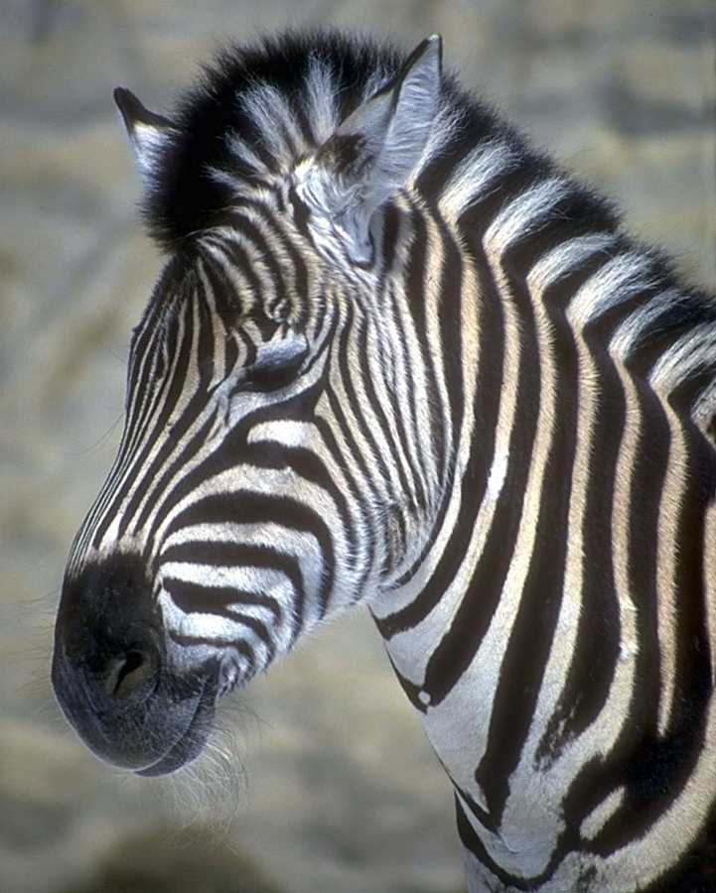

Zebra is _____________________________________________________________

UNIT 2
I’ll tell you a story, …
Text type : Narratives (Fables and legends)

In this unit, you will learn how to:
1. Carry out interpersonal conversation involving :
  - Expression of advising
  - Expressions of warning
  - Expression of giving permission
2. Tell narratives using spoken English.
3. Read narrative texts
4. Listen short functional texts (Poster)
5. Write short functional texts ( poster)
6. Write narrative texts

Language features
    - Simple past tense (Irregular verbs)
    - Conditional IF
    - Preferences
    - Gambits

Step 1 (Spoken)

Listening and Speaking

A. Speech Function
1. Giving Advice/suggestion
Activity 1
Observe the picture. Then, with your pair, read the dialog aloud
How is my dog, sir? Is it OK?
Don’t worry. It is OK. It is just common fever for dog. No, serious things

What should I do to it. I need your advice!
I recommend you to bathe the dog with hot water, not cold water

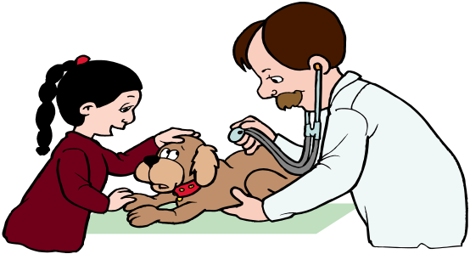

Questions
1. The italic utterance expresses …………………………………………………………..
2. The bold typed utterance expresses …………………………………………………..
Activity 2
Listen your teacher’s reading the dialogue
Adi : Why do you look thinking so hard?
Andi : Yes, I think about Indonesian traditional stories. They have been forgotten by most of us.
Adi : You can do something to save it.
Andi : What do you suggest ?
Adi : I advice you to make a web or blog in the internet about Indonesian stories.
Write all the stories there. Many people will read it.
Andi : Wow, that ‘s a brilliant idea?
Adi : Thanks.

Questions
1. Who are they?
2. What are they talking about?
3. What does Andi worry about?
4. What does Adi suggest to solve the problem
5. Can you mention the other examples of expression of giving advice/suggestion?

Activity 3.
Learn these expressions
Asking for suggestion
What do you suggest?
What do you recommend?
Can you recommend….?
I need your advice.

Giving suggestion
Can I make a suggestion?
I advice you to …
I urge you to …
I recommended that ….
You should …..
You ought to ….
You must ….
You had better ….
How about ……
Why don’t you ….

Responding to a suggestion
That sounds good
That sounds great
What a good idea
That a good advice
I hadn’t thought of that before
That never entered my mind
What an Excellent suggestion that is !

Activity 4
Work in pairs. Make a sustained interpersonal conversation that contains expression of asking and giving suggestion/advice based on the following situation.

You like a girl at your class. Her name is Indri Wuryaningsih. She is the most beautiful and the cleverest students in your class. But you are to shy to show your feeling to her. You ask your best friend, Andi, to give suggestion about that.
You : May I sit here, Ndi?
Andi : Please. Have your seat.
You : What a nice day, isn’t it?
Andi : Yeah. It is nice to sit here. Do you want some candy? I Have some . Here’s for you?
You : Thanks. Uhm … delicious. Ndi , I have a problem. Can you help me? (continued by your group)
Andi : ____________________________________________________________________
You : _____________________________________________________________________
Andi : _____________________________________________________________________
You : _____________________________________________________________________
Andi : _____________________________________________________________________
You : _____________________________________________________________________
Andi : _____________________________________________________________________

2. Expression of and allowing a request
Activity 5
Observe the picture. Then, with your pair, read the dialog aloud
Yes sir, I’ll keep it well.
Be careful with this book. It is very expensive!



Questions:
What does the man expresses: ____________________________________________

Activity 6
Listen your teacher’s reading the dialogue
Adi : Mom, where are you ?
Mother : I am in the kitchen. What’s up?
Adi : It’s six thirty. I leave for school now.
Mother :OK. Go!
Adi : But, Can I ride my new motor cycle
Mother : That’s all right. But take care on the road. It is very busy in the morning.
Adi : Don’t worry mom!

Questions
1. Who are they?
2. What are they talking about?
3. What does Adi ask to her mother?
4. Does Adi’s mother allow him to ride the motor cycle? What does she say?
5. Does Adi’s mother warn him before he rides the motor cycle? What does she say?

Activity 7
Learn these expressions
Giving a warning
Be careful
Take care
Keep the ……safely
Don’t forget to bring ….it’s cloudy
Don’t forget to ….
Watch your back!
Beware of dog
Beware of ….

Allowing a request
That’s all right
That’s OK
Don’t worry. You can use it
OK. Please
Please
No, problem

Activity 8
Work in pairs. Make a sustained interpersonal conversation that contains expression of giving a warning and allowing a request based on the following situation.

You and your friends are having an experiment in the chemistry lab. Unfortunately, one of your friends broke the glasses. Some dangerous chemical liquid spilt on the floor. You ask permission from your teacher to clean the floor but he warns you about the chemical liquid.

You : ________________________________________________________________
Teacher: _______________________________________________________________
You : ________________________________________________________________
Teacher: ________________________________________________________________
You : _________________________________________________________________
Teacher: ________________________________________________________________
Teacher: ________________________________________________________________
Teacher: ________________________________________________________________
You : _________________________________________________________________
Teacher: ________________________________________________________________

B. Listening
Activity 9
Fill in the blank with the words you heard.
On a hot day, a thirsty crow flew over a field looking for water. For along time, she (1) _______ not find any. She felt very exhausted, almost giving up. Suddenly, she (2) ________ a water jug below her, she flew straight down to see if there was any water inside. It (3)_________ a surprise because there was some water inside the jug!
The crow (4) ________ to push her head into the jug. Sadly, she found that the neck of the jug was too narrow. Then, she tried to push the jug down for the water to flow out but she (5) ________ that the jug was too heavy.
The crow thought hard for a while. Then looking around her, she saw some pebbles. She suddenly (6) _________ a good idea. She (7) _________ picking up the pebbles one by one, dropping each into the jug. As more and more pebbles filed the jug, the water level (8) ___________ rising. Soon it was high enough for the crow to drink, “It’s working!” she said.

Activity 10
What is the moral of the story ?
Moral
__________________________________________________________________

Activity 11.
We have the following words in the story above. Find their meaning in your dictionary.
1. exhausted : _________________________
2. giving up : _________________________
3. suddenly : _________________________
4. jug : _________________________
5. flow out : _________________________
6. pebbles : _________________________
7. Picking up : _________________________
8. filed : _________________________

Activity 12
Fill in the blank with the suitable words from activity 12. Make tense adjustment if necessary.
1. When I was young I usually shot birds using ______________with my slingshot.
2. I saw some women _____________the tea leaves when I visited tea garden last week.
3. My friends and I were driving along the empty road when _____________ a car hit us from our
back.
4. After The farmers had harvested all the paddy, they ___________ the piles with it.
5. In the countryside, people usually use __________ to serve tea because teapot is rarely there.
6. I was so ____________________after I had run about 10 miles around the stadium.

C. Grammar Focus
1. Simple Past Tense Review. (Irregular verbs)
Activity 13
Let’s learn about “simple past tense”
Pay attention to the following sentences.

1. A thirsty crow flew over a field looking for water
2. She felt very exhausted, almost giving up
3. Sadly, she found that the neck of the jug was too narrow.

From the examples above we observe that the verbs used are in irregular forms. So, you learn the simple past tense with irregular verbs.
Examples:
V base | V past |  | V base | V past |  | V base | V past
Begin  Buy  Bring  Come  Cost  Do  Drink | Began  Bought  Brought  Came  Cost  Did  drank |  | Eat  Fall  Find  Fly  Get  Give  go | Ate  Fell  Found  Flew  Got  Gave  went |  | Have  Hear  Know  Lose  Make  Meet  Put  Etc. | Had  Heard  Knew  Lost  Made  Met  Put
Activity 14
Complete the sentences with the correct forms of the verbs. When you have finished, read your work aloud.
The two wanderers and a bear
Two persons were traveling to a town from their village when ,suddenly, a bear (1) _______ (run) to them fiercely.
One of the men hurriedly climbed up a mango tree and (2) ____________(hide) among the branches. The other, feeling that he would be attacked, (3) _____________(fall) flat on the ground.
The bear (4) ________ (come) up and (5) ____________ (feel) him with his snout, and (6) ______
(smell) him all over. The man (7) _________ (hold) his breath, and pretended to be dead.
The bear soon (8) __________ (leave) him, because it is (9) __________ (say) that bears will not touch a dead body.
Feeling safe, they continued their travel till they (10) ___________ (meet) their destination.
(Bahan Pelatihan Terintegrasi: 2004)
Activity 15.
In pairs, make sentences using the words below.
Example : fly - We flew to Hong Kong Yesterday.
1. to think : _________________________________________________________________
2. to shoot : __________________________________________________________________
3. to sweep : __________________________________________________________________
4. to keep : __________________________________________________________________
5. to see : __________________________________________________________________

2. Conditional Sentence
From the listening text above we have this sentence:

She flew straight down to see if there was any water inside

The pattern of the sentence above is present conditional. Means that someone makes a supposition of his/her real condition he/she faces now. The general pattern of Conditional sentences is as follow:

No | Type: | If Clause | Main Clause | Examples:
1. | Future conditional sentence | If Present tense:  S + V1/ V1-s/-es  Is, am, are | Present future  S + shall/will + Vi  Will be | If You come to the party, I will come too  If Rina is rich, She will buy a mansion
2. | Present Conditional  sentences | If Past tense  S + V2  were | Past future  S + would + V1  Would be | If you came to the party, I would come too  If Rina were rich, she would buy a mansion
3. | Past Conditional Sentence | If Past Perfect  S + had + V3  Had been | Past Future Perfect  S + would have V3  Would have been | If you had come to the zoo, I would have come too  If Rina had been rich, She would have bought a mansion

Activity 16
Put the verb in the correct form.
Example If Sari had some money , she ……………..(visit) her parents
If Sari had some money, she would visit her parents.

1. If my sister …………(be) here, I will be very happy.
………………………………………………………………………………………………
- If Linda did her homework, the teacher …………..(praise ) her.
………………………………………………………………………………………………
3. If I had finished my study, I ……………(travel) around the world.
……………………………………………………………………………………………
4. If Doni …………(kick) the ball correctly, the goal keeper could not catch it.
..…………………………………………………………………………………………
5. If the farmer …………..(spray) their plants properly. The crops would have been well
………………………………………………………………………………………………
6. Mr. Andi would go to Paris on a vacation if he …………(get) a lot of money.
………………………………………………………………………………………………
7. We wouldn’t have been able to catch the thief if he ………….(not, jump) to the river.
………………………………………………………………………………………………
8. If you didn’t hurry, we (be) late for class.
………………………………………………………………………………………………

D. Monolog
D.1. Building knowledge of field
Activity 17
Answer the questions orally.
1. What is fable?
2. Do you know Aesop? Who is he?
- Why fables are interesting to read?
- What is your most favourite fable title?

D.2. Modeling of Text
Activity 18
Read the text aloud using proper intonation and pronunciation !
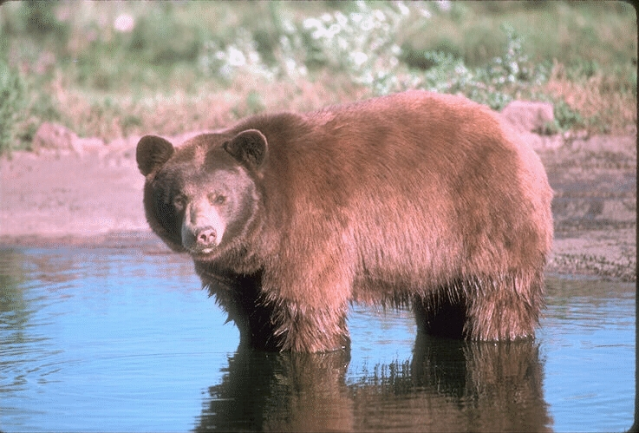

Why Doesn’t a Bear Have a Long Tail?
One afternoon, a mouse deer was sitting in a pit, eating nuts. He heard a tiger was coming closer and he thought the tiger was going to eat him.
The mouse deer was very scared and his heart beat so hard.
Then, an idea came to his mind and he made a loud noise of chewing nuts, saying, "Wow, how delicious is this tiger's eye!"
He repeated it for five times.
Tiger, the king of jungle, was so scared to hear that and he moved back.
Tiger met a bear on the way and he said, "Hey, Bear. Do you hear what did the animal on the pit over there, eating tiger's eyes?"
Bear said, "I don't know, Your Majesty,"
Tiger said, "Then let's see."
Bear replied "But I'm scared, Your Majesty"
Tiger said, "Don't worry. Let's make a deal with me. We're going to stay together, uniting our tails. If anything happens, both of us will face it."
Tiger and Bear tied their tails and moved into the pit with full cautions because they were expecting to see a big enemy.
The mouse deer was surprised again.
He thought quickly and yelled, "Oh, that's the glutton tiger! His father owes us a white bear, now he will pay us with a black bear. Come on black, over here."
Bear was so surprised. "Hey, it's a Tiger's trick! He wanted to use me to pay his father's debt!"
Bear went into a panic, which also made Tiger panic because they were tied each other.
Accidentally, Tiger stepped on the Bear's tail, then jumped. Bear was beaten on the ground hard, and his tail was cut off.
That's why Bear doesn't have long tail.
Thus the mouse deer escaped from the tiger twice.
(Sahadadi Mulyana: 2004)

The story you’ve just heard is a narrative text. Someone tells a narrative text in order to entertain, stimulate emotion or to teach.
A narrative text has tree elements or parts: the orientation, complication and resolution. The orientation introduces main characters in a setting of place and time. The complication tells the problems of the story and how the main characters solve them. The resolution tells the ending of the story.

Questions:
1. What does the story tell you?
2. Who are the main characters of the story?
3. Where is the setting of the story ?
4. Why did the mouse deer feel so scared?!
5. What did the mouse deer do to frighten the tiger?
6. How did the bear lose his tail? Tell us!
7. Is there any moral value of the text above? Mention!

Activity 19.
Listen to your teacher or friend read this legend carefully

Tangkuban Perahu
Dayang Sumbi was exiled in the jungle, because she was unmarried but pregnant. She gave a birth to a baby boy and named him Sang Kuriang. And he became a young and hard working boy. He was a good hunter too.
One day he went hunting with his dog, Si Tumang. In the bush he saw a pig, Wayungyang. He wanted to shoot Wayungyang but Si Tumang hindered him. He was angry at it and killed it, and then took its heart home. He cooked it and ate it with his mother. When he told that it was Si Tumang's heart, she was very angry and hit Sang Kuriang 's head with a spoon. And he ran away and left his mother to the east. He did not know himself and forgot his name. He was about 16 years of age.
After a long time Sang Kuriang came back to the jungle where his mother lived. She looked younger than her age, so Sang Kuriang fell in love with her. "Will you marry me?" one day he asked her. But Dayang Sumbi refused because she recognized that he was her son. He insisted to marry her and Dayang Sumbi asked him two marriage settlements (requirements). One, he had to dammed Citarum river, and two, had to make a boat in one night.
Sang Kuriang almost finished his work but Dayang Sumbi cheated him. He was angry and kicked the boat. The boat fell upside down on the peak of mountain. It was known as mount Tangkuban Perahu, at the northern of Bandung, West Java.

Questions
1. Who were main characters of the legend?
2. Why did dayang Sumbi exile to the jungle?
3. What was the name of her baby boy?
4. How was the nature of Sang Kuriang?
5. Why was dayang Sumbi angry with sang Kuriang?
6. How old was Sangkuriang when he left the jungle?
7. How did dayang Sumbi refuse sang kuriang proposal to marry her?
8. According to the legend, what was Tangkuban Perahu ?

D.3. Joint Construction of Text
Activity 20.
Read the story, work in group of three. Continue the story based on your own knowledge.

The Legend of Jaka Tarub
Jaka Tarub is the hero of a legend that is very popular among the people of Central Java. Although he was only the son of a simple farmer, he was handsome as well as kind, honest and brave. He liked to help other people. He was always sided with those who were weak but innocent and those who were poor but honest.
One day, a long time ago, when he was returning home from hunting, he happened to pass by a lake. How amazed he was to see several beautiful girls bathing in the lake amid a dense jungle.
Jaka Tarub had reached the age of marriage, and he thought of possibility of getting of the pretty girls as his wife.
As he was thinking hard of a way to get acquitted with any one of them, he caught sight of their clothes, which were piled up under a tree on the bank of the lake. He decided to steal one of the garments. That was what he did and then he did.
After they had finished their bath, the girls walked ashore to fetch their garments. One of them, however, screamed suddenly and wept as she found that her own garment was gone. ____
________________________________________________________________________________________________________________________________________________________________________________________________________________________________________________________________________________________________________________________

D. 4. Independent construction of text.
Activity 21.
- Now, individually, write a well-known legend in your place.
- Don’t forget to write the legend based on narrative structure; orientation, complication, and resolution
- Tell the story to your friend in front of the class.

Step 2 (Written)
Reading and Writing

A. Building knowledge of field
Activity 1.
Since grade X, you have heard and read many kind of stories, right? So to warm up your mind, match the kind of the story and its main characters.

Answer | No. | Kinds of stories |  | No. | Main Character(s)
______ | 1. | Fable |  | A. | Cinderella
______ | 2. | Fairy tales |  | B. | Malin Kundang
______ | 3. | Legend |  | C. | The grasshopper and the ants
______ | 4. | Myth |  | D. | Zeus and demeter
______ | 5. | Folktales |  | E. | Roro Jonggrang

Activity 2.
Fill in the blank spaces with the words in the box.
Fortunately receive neverland stepmother
Evil witch poisoned dwarfs

Long ago, in the ……..(1), there lived a very beautiful princess, snow white. The Queen was her ………..(2). She was very jealous of her beauty. So she wanted her to die.
Snow White knew about her …….(3) plan. She escaped into a forest. There she made a friend with seven …….(4).
The Queen turned into a ……..(5). Snow White did not realize it. The witch gave her ……(6) apple. As a result, Snow White was put into sleep for years.
……….(7), in the end, Prince Charming ……..(8) her with a kiss. They lived together happily ever after.
(Free adaptation from Grimms’ fairy tale)
Questions:
- Who is the main character of the story?
- Where did the story happen?
- When did the story happen?
- What problem faced by the main character?
- Can she solved the problem? How?
- How is the ending of the story, sad or happy ending?
- What kind of story is it?

Activity 3
Use the words in activity 2 to complete these sentences.
- Peter pan is popular children story. It is told the he lives in ……… .
- When she wants to go somewhere, the …….uses her magic broom to fly to the destination.
- Cinderella was sad knowing that she didn’t ……….. an invitation to the ball in the palace.
- Cinderella’s ……….is a cruel and bad tempered. She always ordered Cinderella to do a lot of works.
- The ……….helped snow white and took care of her in their home in the wood.
- The lion was caught in a cage by some hunters. …………., the mice helped him by cutting off the rope tied the cage.
- To carry out his ……..mind, the witch uses her black magic to kill the Prince.
- The King died because he drank a …………..juice from his enemy.

Reading Comprehension
Activity 4.
Building Vocabulary. Match the following words with its definition

Answer | No. | Words |  | No. | Definition
______ | 1. | Shepherd |  | A. | make rumbling noises
______ | 2. | Chase |  | B. | smile broadly
______ | 3. | Grumble |  | C. | express something while crying tears
______ | 4. | Delight |  | D. | in a number of different places far away from each other
______ | 5. | Sternly |  | E. | roam an area stealthily for prey
______ | 6. | Grin |  | F. | somebody tending sheep
______ | 7. | Prowl |  | G. | strict: rigid, strict, and uncompromising
______ | 8. | Weep |  | H. | somebody who tells lies
______ | 9. | Scatter |  | I. | gain enjoyment from something
______ | 10. | liar |  | J. | pursue somebody or something

Activity 5
Read the text carefully. Then, answer the questions.

The Boy Who Cried Wolf
There once was a shepherd boy who was bored as he sat on the hillside watching the village sheep. To amuse himself he took a great breath and sang out, "Wolf! Wolf! The Wolf is chasing the sheep!"
The villagers came running up the hill to help the boy drive the wolf away. But when they arrived at the top of the hill, they found no wolf. The boy laughed at the sight of their angry faces. "Don't cry 'wolf', shepherd boy," said the villagers, "when there's no wolf!" They went grumbling back down the hill.
Later, the boy sang out again, "Wolf! Wolf! The wolf is chasing the sheep!" To his naughty delight, he watched the villagers run up the hill to help him drive the wolf away. When the villagers saw no wolf they sternly said, "Save your frightened song for when there is really something wrong! Don't cry 'wolf' when there is NO wolf!"
But the boy just grinned and watched them go grumbling down the hill once more.
Later, he saw a REAL wolf prowling about his flock. Alarmed, he leaped to his feet and sang out as loudly as he could, "Wolf! Wolf!" But the villagers thought he was trying to fool them again, and so they didn't come.
At sunset, everyone wondered why the shepherd boy hadn't returned to the village with their sheep. They went up the hill to find the boy. They found him weeping.
"There really was a wolf here! The flock has scattered! I cried out, "Wolf!" Why didn't you come?" An old man tried to comfort the boy as they walked back to the village.
"We'll help you look for the lost sheep in the morning," he said, putting his arm around the youth,
Nobody believes a liar...even when he is telling the truth!" .
(source: Mahayana : 2004)
Questions
1. What is the main idea of the first paragraph?
2. What are the characters in the story?
3. Where and when did the story take place?
4. What does the word “their” in the second paragraph refers to?
5. What does the word “he” in the second paragraph refers to?
6. Who was the boy?
7. What did he do?
8. Why did he like to sing out” Wolf! Wolf!. The wolf is chasing the sheep?
9. Why didn’t the villager believe him anymore?
10. What did the boy do when the real wolf came?
11. What is the lesson taken from the story?

Grammar Focus
1. Past Verbs Review
From the listening text above we have these sentences
She escaped into a forest.
There she made a friend with seven dwarfs.
Remember that narrative text uses past verbs to tell the events.

Activity 6
Change the bold italic verbs into past forms
1. A rich man gives a great feast, to which he invites many friends and acquaintances.
_________________________________________________________________________
2. His dog avails himself of the occasion to invite a stranger Dog,
_________________________________________________________________________
3. A Cook see him moving about among his dishes and, seizing him by his fore and hind paws,
_________________________________________________________________________
4. He falls with force upon the ground and limped away, howling dreadfully.
__________________________________________________________________________
5. His yelling soon attracts other street dogs,
__________________________________________________________________________
6. ………..who comes up to him and inquired how he had enjoyed his supper.
__________________________________________________________________________
7. He replies, "Why, to tell you the truth,
__________________________________________________________________________
8. I drink so much wine that I remember nothing. I do not know how I got out of the house."
___________________________________________________________________________

2. Preferences
Activity 7
Lets learn about “preferences”
Pay attention to the following sentences.
She was very jealous of her beauty. So she wanted her to die.
The word “wanted’ means,” to feel a need or desire for something or choose something despite others”

So if you want to say that you like someone or something better than others or other things you can use preferences patterns.
1.
Subject | prefer | V-ing | to | V-ing
Subject | prefer | Noun | to | Noun

Examples;
Aisyah prefers cooking food to sewing clothes
We prefer mango to durian
2.
Subject | Like | V-ing | Better than | V-ing
Subject | Like | Noun | Better than | Noun

Examples;
Aisyah likes cooking food better than sewing clothes
We like mango better than durian
3.
Subject | Would rather | Vbase | than | Vbase
Subject | Would rather | Noun | than | Noun

Examples;
Aisyah would rather cook food than sew clothes
We would rather mango than durian

Activity 8.
Fill in the blanks with prefer……to/like…………better than or would rather…..than.
1. Sinta ……………collecting stamp …………….antiques.
___________________________________________________________________
2. Budi ………….playing pencak silat ………….kungfu.
___________________________________________________________________
3. My father ………..read a novel ……….a comic
___________________________________________________________________
4. I ………….enjoy pop music ………….jazz
____________________________________________________________________
5. My sister …………….singing ………….dancing
____________________________________________________________________
6. My brother …………..see Indonesian films …………….Westerns one.
_____________________________________________________________________

Activity 9.
Answer the following questions about yourself. Use ……to/like…………better than or would rather…..than. Give your reasons.
Example : to be a scientist or historian?
I would rather a scientist than historian because the work of scientist is more
challenging.
1. to have motorcycle or bicycle?
__________________________________________________________________
2. to eat hamburger or fried rice?
__________________________________________________________________
3. to have a dog or cat?
__________________________________________________________________

B. Modeling of text
Activity 10.
Pre-reading. Answer the question !
- What do you think about a wanderer ?
- What do you do if you get last in a wood ?
- Do you want to keep the valuable thing for yourself, although it is not yours ?
- What do you want if you have candle which can grant anything you ask ?
- What is a suitable punishment for greedy man ?

Activity 11
Read the text carefully. Answer the questions

The Magic Candle

One day, a young wanderer got lost in a wood. Suddenly he saw a light from an old hut. He knocked on the door, and an old woman opened it. She was crying.

She said that the devil had stolen her magic candle. The candle grant anything she asked. The wanderer asked her where the devil lived. “In a castle it is not far from here,” said the old woman sadly.
The wanderer went to the castle. There he found the devil, but he was old and weak. Therefore when the wanderer grabbed the magic candle from the devil’s table and ran away, he couldn’t chase him.
But the wanderer was not a kind man. He didn’t return the candle to the old woman, but kept it for himself. He lit the candle and made a wish proudly “I want to go far away from here.” Suddenly the genies appeared and took him to a beautiful palace. There was party in the palace. The wanderer wanted to make some money. So he lit the candle again and wished or some jewelry. He sold them to the guests and was soon making a lot of money. Then he Princess came to buy jewelry, but there was nothing left. The wanderer fell in love with her and asked her to marry him. The kind princess said yes, and they got married the next day In his happiness, the wanderer told the princess about his adventure and the magic candle.
Hearing that, the princess got very angry. At night she lit the candle and wished that the wanderer disappear.
As the morning the wanderer awoke and found himself back in his ugly house in the village.
(Adapted from Fun Plus 05)
Orientation

Complication

Resolution

Complication

Resolution

Reorientation

Questions.
1. Who are the participants of the story ?
2. What do you think about their character and give some reasons to support your answer ?
3. Which of the sentence does it refer to orientation ?
4. What is the complication of the above text ?
5. What is the resolution in this text ?
6. Do you think it has a happy ending or a sad one
7. Can you find any moral value from this story ? Explain it ?

Activity 13
Activity 6.
Observe the following poster


(Source: www.puresaturday.wordpress.com)
Questions.
1. What is the purpose of a poster?
2. From the example above, what are the parts of a poster?
- What does the poster tell about?
- Where will the party be held?
- When will the party be held?
- What music groups will performance at the party?
- If you buy the ticket a day before the show, how much money do you have to pay?

C. Join construction of text
Activity 12
Work in pairs, find out the meaning of the following words from the dictionary!
No. | Words | Meaning
1. | Woods
2. | Roof
3. | Shut
4. | Suddenly
5. | Master
6. | Bark
7. | Cave
8. | Famous

Activity 13
Work in pairs, fill in the blank below with the suitable words from the box above!
- If you have finished using the computer , please ………..it down.
- When I stopped my car in the spot light in the junction, ……….A car bumped my back.
- My little puppy always ………..to everyone who passes my house.
- Budi is mending the ……….of his house. It is leaking.
- In early society, people usually cut the trees in the ………as fuel.
- Britney Spears is one of the ……………….females singers in the world.
- Because of the big storm, the hiking team must shelter themselves in a ………
- One who has graduated from post graduate programme in a university has a right to be called as a ………..

Activity 14
Discuss the following story with your friends, then answer the questions
One day when a seven-year old boy and his dog were walking trough the woods in Kentucky, they came to a cave. What the boy wanted to do was to go inside the cave to see what was in it. But what happened suddenly after he was inside made the boy cry. A very big piece of rock fell from the roof of the cave, shutting him in.
The dog, that left outside, was unable to help its master. What it could do was only to bark all the time. At last it ran to the nearest house. There it barked until the owner knew that something was wrong. He and some of his friends followed the dog until it stopped in front of the cave. What the men saw was the big stone that shut the mouth of the cave. When they moved it away they were very surprised. What they found inside was a crying boy. The boy was Abraham Lincoln, who later became one of the most famous presidents of the U.S.A.
(Taken from : English for SLTA: Student Book II)

- Where did the little boy come from?
- Where did he walk to?
- Why did he go there?
- What happened with him?
- What did the dog do?
- Who helped the little boy?
- Who was the little boy?
- What is the purpose of the kind of text?
- What is the moral value of the story above?

Activity 15
Find out the reference of the following pronouns.
- One day when a seven-year old boy and his dog were walking (Prg 1 stc 1). The underlined word refers to…
- What the boy wanted to do was to go inside the cave to see what was in it. (prg 1 stc 2) The underlined word refers to…
- What it could do was only to…(Prg 2 stc 2). The underlined word refers to…..
- He and some of his friends followed the dog….(Prg 2 stc 4). The underlined word refers to…
- When they moved it away they were very surprised…(Prg 2 stc 6). The underlined word refers to…

Activity 16
Analyze the schematic structure of the text above, then put the story into the following form.
Orientation

Complications

Resolutions

Activity 17.
Work collaboratively, make a poster based on the following data.
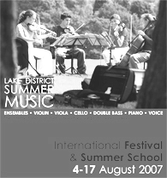
- The poster is about entertainment.
- It persuade to come to a music concert.
- Illustrated with appropriate pictures or photo if necessary.
- You can design it with computer help such use Photoshop, Corel draw or other design program.
- After finishing the poster. Put on your class wall.

Source : www.ldsm.org

D. Independent construction of text.
Activity 18
Write a legend that is exist at you town. Follow the steps
When you have finished your work. Show them to your teacher.
Step 1 Make the outline
Step 2 Write the draft
Sep 3 Revised your work based on your friend’s suggestion
Step 4 Write the story
Step 5 Revised your work based on your teacher’s suggestion
Step 6 Write your final story
Orientation
Complication
Resolution
Re-orientation
(Optional)

TEST 2

A. Choose the correct answer by crossing a,b,c,d or e
Text 1
Long long ago, mosquitoes didn’t buzz, they talked and talked.
One day, Mosquito was talking to Iguana, telling her about his vacation, about every minute of his vacation. Mosquito would not let Iguana say one word. Iguana was so annoyed that she walked away, leaving Mosquito still talking. Iguana grumbled and waved her tail.
She was still grumbling when she passed her friend Snake, and forgot all about saying hello. Snake was feeling hurt. He let so sad that he slithered down a rabbit’s hole.
“ Help !” yelled Rabbit as she scurried out hole, terrified of Snake.
“ What’s wrong?” cawed Crow as he saw Rabbit racing. Danger must be near,” Run for your lives !” cawed Crow.
Monkey heard Crow’s warning and took off through the treetpos, leaping branch to branch. Wehen monkey landed on Owl’s branch, high up in a leavy tree. Owl’s nest tipped of the branch and fell to the ground, breaking Owl’s eggs. Owl was heartbroken, so much that she didn’t hoot for the sun to come up.
The whole jungle was mad at Mosquito. Finally Owl hooted for the sun to come up and when it did, Mosquito lost his voice. All he could do was buzzing in everyone’s ears. “ Zzzzzzzzzz ! Is everyone still mad at me ?”

01. What did the Monkey do to the Owl’s eggs ?
- Monkey broke the Owl’s eggs when he was on the branch.
- Monkey climbed on Owl’s tree when he heard Crow’s warning.
- Monkey damaged the Owl’s nest when he climbed the tree.
- Monkey fell on the Owl’s eggs when he climbed the tree
- Monkey made the Owl’s nest fall when he landed on Owl’s branch

02. The communicative purpose of this text is ….
- to describe a place.
- To entertain or amuse.
- To explain a place.
- To give a view of an art work.
- To inform

03. Why did Iguana grumble ?
Because .... .
- Mosquito told him about his vacation
- Iguana was annoyed so he walked away
- Mosquito wouldn’t allowed him to say a word.
- Mosquito talked and talked
- Iguana waved her tail

04. She was still grumbling when she passed the Snake.
The underlined refers to ... .
- the Snake d. Iguana
- the Owl e. Rabbit
- The Mosquito

05. Finally, Owl hooted for the sun to come up and when it did, Mosquito lost his voice. ( Pr. 7 )
The underlined means .... .
- the Owl hooted d. the Crow cawed
- Mosquito lost his voice e. the sun came up
- The Snake hissing

Text 2
Once upon a time there was a poor widow who had an only son named Jack. They were so poor that they didn’t have anything except a cow. When the cow had grown too old, his mother sent Jack to he market to sellit. On the way to the market, jack met a butcher who had some beautiful beans in his hand. The butcher told the boy that the beans were of great value and persuaded the silly lad to sell the cow for the beans.
Jack brought them happily. When he told his mother about this, his mother became so angry that she threw the beans out of the window.
When jack woke up in the morning, he felt the sun shining into a part of his room, but all the rest was quite dark and shady.
So he jumped to the window. What did he see ? The beabstalk grew up quite close past, Jack’s window. He opened the window and jumped to the beanstalk which ran up like a big ladder.
He climbed... and climbed till at last he reached the sky. While looking around, he saw a very huge castle. He was very amazed.
Then Jack walked along the path leading to the castle. There was a big tall woman on the doorstep. Jack greeted her and asked for the giantees, mecy to give him breakfast, because he felt very hungry. Although the giantees grumbled at first, finally she gave Jack a hunk of bread and cheese and a jug of milk.
Jack hadn’t finished when the whole house began to tremble with the noise of someone’s coming.” Oh ! It’s my husband !” cried the giantees.” What’s on earth shall I do ?”
Hastily the giantees opened a very big cupboard and hid Jack there.

06. Where did Jack sell his cow ?
- At a castle
- At the market
- At the gian’ts castle
- At the butcher’s house
- On the way to the market.

07. What is the story about ?
- Jack and butcher
- Jack and the giantess
- Jack and the beanstalk
- A poor widow and his son
- The giantess and her husband

08. ”Oh! It’s my husband !” cried the giantees.
(Paragraph 7 )” What’s on earth shall I do
From the sentence we know that the giantees is ... .her husband.
- afraid of d. annoyed with
- angry with e. displeased with
- fed up with

09. Jack’s mother looked very furious when jack told that ...
- the beans were very precious
- the butcher bought his cow.
- he had sold his cow to a butcher
- he traded his cow to the beans
- he met a butcher on the way to the market.

10. What did we learn from the text ?
- Sincerity makes jack get something precious.
- Jack’s moher was a furious mother.
- Poverty makes people hopeless
- The giantees took pity on Jack
- Jack was an innocent boy.
11. Alia : When did you make this coffee?
Nina : I …. . the coffee this morning while you were taking a bath.
- Make C. to make E. making
- Makes D. made

12. Lina : ……Mitha …… to your house this morning ?
Ani : Yes, she did.
- do, come C. did, come E. was, came
- does , come D. did , came

13. Budi : My father will come from Hanoi tonight.
Ali : What did he say?
Rara : He said that … .
- my father will come from Hanoi tonight
- his father will come from Hanoi the following night
- His father would come from Hanoi tonight.
- His father would come from Hanoi the following night.
- His father would came form Hanoi the following night.

14. Adi : Can you meet me tomorrow?
Ali : What did he say to me?
Ria : He asked you …. .
- If I can meet you tomorrow. D. whether you could meet him the following day.
- If can you meet me tomorrow E. Whether you can meet him tomorrow.
- If you can meet him the following day

15. Malik : “Switch on the lamp!”
Ali : What did he say?
Zahro : He ordered you … .
- not to switch on the lamp D. to not switch on the lamp
- switch on the lamp E. switch not the lamp
- to switch on the lamp

16. Arin : Where is your sister?
Katty : My sister is the girl …gown is blue.
- Who C. whose E. when
- Whom D. which

17. Kelly : Can you meet me with Sania, the movie star?
Arin : You have met her. She is the girl ….you talked to yesterday.
Kelly : Oh, my God. I didn’t know.
- Who C. whose E. when
- Whom D. which

18.
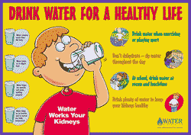

What does the poster suggest ?
  - Drink a lot of water is useless
  - Drink water is good for our brain
  - Drink a lot of water is too consuming
  - Drink water in proper amount keeps our body healthy
  - Drink water in improper amount keeps our body healthy

19. Agus : “Which one is better, going by bus or by taxi?”
Wuryanto : … .
  - I am sure you must go by taxi. It is faster than bus
  - I think you must go by bus
  - Perhaps you can go by taxi
  - You will go by taxi
  - You will go by bus

20. Lina : This telegram is from my father. He ask me to go home soon. What do you
recommend me to do?
Dina: Why don’t you ring him first?
In the dialog above, Lina is asking for Dina’s __________

- warning D. suggestion E. permission
- allowance E. question

B . Essay
21. Linda : Where were you last night
Dina : What did she say?
Anita : She asked you …………………………………………

22. Put the verb in the bracket into its correct form.
Lina : When did you fix my skirts
Dia : I ……..(fix) it last night.

23. Combine the sentences with suitable relative pronouns
Cinderella is wearing a blue gown.
You looked for her for a long time.
……………………………………………………………………………

24. Fill in the blank with suitable expression of giving allowance
Lina : Can I wear your blouse mom, Mine is to tight.
Mother : ……………………….. ,but don’t forget to wash after you wear it

25. Fill in the blank with suitable expression of giving warning.
Andi : Can I go to Budi’s house tonight, mom?
Mother : ………………………….. It is raining. Don’t forget to bring raincoat.

UNIT 3
I think … .
Text type : Analytical Exposition

In this unit, you will learn how to:
1. Carry out interpersonal conversation involving :
  - Expression of relief
  - Expressions of pain
  - Expression of pleasure
2. Tell analytical exposition using spoken English.
3. Read analytical exposition texts
4. Listen short functional texts (Pamphlet)
5. Write short functional texts ( Pamphlet)
6. Write Analytical exposition texts

Language features
    - Connectives
    - Passive voice
    - Complex sentences
    - Gambits

Step 1 (Spoken)
Listening and Speaking

A. Building knowledge of field
Speech Function

1. Expression of relief
Activity 2
Read the dialogue aloud.
Oh, I am extremely relieved to hear the news. Lets check him!
Well, darling. Our son is getting better from his illness. He can go home from this hospital tomorrow morning

Activity 2.
Read aloud this dialogue.
Andika : What a terrible journey it is!
Andina : Is there any problem with your journey my husband?
Andika : Yes, I took a flight from New York to come here. When I were in the middle of the
journey. My plane struck a turbulence . It shook hard and went down a couple of feet.
My head hit the front chair. Look! It is wounded. I feel headache and all my body is in
pain.
Andina : Thanks God. You are still alive.
Andika : Yes, thanks for the heaven. Fortunately, the pilots are the experienced ones. They can
handle the problems
Andina : Ok. Go to the bed and take a rest first.

Questions
1. Who are Andika and Andina?
2. Where did Andika come from?
3. Why did he say “ What a terrible journey it is” ?
4. What kind of transportation mean did he take ?
5. What happened to Andika in the turbulence?
6. What did Andina say to show her relief?
Activity 3.
Learn the following expressions

- Good heavens
- Thanks God I am alive
- Thanks for heaven
- I am relief that..
- God bless me
- God bless you

Activity 4.
Complete the dialog with suitable expressions
01. Ais : I got a crash this morning. When I crossed the crossroad. A car hit my back.
Ina : ___________________________. You are not wounded at all.
Ais : Yes. But I am still trembling

02. Jerry : Dina look at this announcement. You are the winner of the singing contest.
Dina : _________________________ I can’t imagine I am the winner
Jerry : Congratulation
Dina : Thanks

03. Father : Look? You got a car in this quiz!
Mother : A car! ____________________
Father : you are lucky woman, ma.

04. Sinta : Have you heard that “Kambuna” ship was sink last night?
Dina : What! Oh no. My sister, lina, was on the ship. She was on the way to Ambon.
Is there any news about the passanger?
Sinta : All the passengers were alive. The navy ships have rescued them all.
No casualties.
Dina : ___________________. I can meet her again someday.

05. Alia : How was the result of your final exam?
Ndari : I passed with flying colour?
Alia : ____________ I always pray day and night for you.
Alia : Thanks.

2. Expression of Pain
Activity 5.
In pairs. read aloud the following dialogue.

Karen : Hi, … Sally. What’s wrong with you. You look so sad.
Sally : Please, leave me alone.
Karen : What’s the problem? Tell me.
Sally : I can’t tell my pain in words.
Karen : Oh, I guess. It must be about Josh . Am I right?
Sally : Yes. He broke my heart again.
Karen : Please. Come on girl. Don’t take it into your heart. There is not only one guys, right?
Sally : Yes, you are right. But I love him so much.
Karen : OK. Let’s go to Disneyland and make some refreshing there. It will open your mind and heart.
Sally : OK. Let’s go.

Question
The underlined utterances express Sally’s ____________________

Activity 6.
Learn the following expressions

- Please, leave me alone.
- I can’t tell my pain in words
- It brought me a lot of miseries
- My heart is so burdened
- I’m so sad to hear this
- I’m feeling bad at this time being

Activity 7.
In pairs. Write an interpersonal dialogue based on the situation given.
01. Your friend’s dog has just died. He/she is sad now. He/She sharing his/her pain with you.
You : _________________________________________________________
Your friend : Well, my beloved cat died last week. I can’t forget it .
You : _________________________________________________________
Your friend : _________________________________________________________
You : _________________________________________________________
Your friend : _________________________________________________________
(continue by your self)

02. You are falling in love with a girl. But she refuses you. One of your friends knows your pain
Your friend : Hey, why do you look so sad? I know, it must be about Lina. She refused you, didn’t she?
You : __________________________________________________________
Your friend : __________________________________________________________
You : __________________________________________________________
Your friend : __________________________________________________________
(continue by your self)

3. Expressing Pleasure
Activity 8
Read the dialogue aloud

Dialog 1
Budi : Look at this painting. How do you think?
Lina : It’s wonderful! How if we buy it?
Budi : How much?
Lina : It’s about $ 1.000,00
Budi : That’s not too expensive. OK

Dialog 2
Budi : Here it is.
Lina : What is it?
Budi : Open the box!
Lina : Wow. A golden necklace!. How marvelous. Bud, It must be very expensive!
Budi : For you, I don’t care.

Question:
What does Lina express?. She expresses her _________________________________

Activity 9.
Learn these expressions. Repeat after your teacher!

- It’s wonderful.
- How marvelous
- I am please with it / that.
- It’s my pleasure.
- It gives me pleasure.
- That’s great.
- That terrific.
- I am happy with ……
- I like it.
- I love it.

Activity 10.
Work in pairs. Make a sustained interpersonal conversation that contains expression of pleasure based on the following situation.

You are having a vacation at Bali. You stay at a five star hotel. The service is very good. You satisfied with the hotel and you show your pleasure to your friend.
You : Hello,Ndi, Good morning.
Andi : Morning, Gus. Wow. You are wet!
You : Yes, I have just swum at the swimming pool. It’s big and clean.
Andi : What do you think of this hotel?
You : __________________________________________________________________
Andi : Do you like with the service of this hotel?
You : __________________________________________________________________
Andi : __________________________________________________________________
You : __________________________________________________________________
Andi : __________________________________________________________________
(Continued by yourself)

Activity 11.
Listen to your teacher reading a short text then fill in the blank with the word or phrase you heard.
Some people like to spend their …..(1) making longs trips. I am one of them. I prefer to ……(2) by train rather than by bus, ships or …….(3). There are several reasons for this. Going by train, I do not have to …….(4) about bad roads and heavy (5). It is also less tiring than traveling by bus. The beautiful ……(6) makes the journey by trains more interesting than by ships or aeroplanes. Seeing the …….(7), the blue mountains, the rivers and the …….(8), I do not feel bored in the train. To hear the ……(9) of the sellers of food and drink at the station is great fun. Finally, It is safer to travel by train than by other ……..(10) of transportation.
(Taken from : English for SLTA: Student Book II)

Activity 12
Your teacher will read once again the text, then answer the questions below.
- What does some people do to spend their vacations?
- How do people travel from one place to others?
- Why does the speaker choose train besides others vehicles?
- What is the interesting experience traveling by train?
- Do you think so? What is your opinion?

B. Modeling of Text
Activity 14
Your teacher will read an exposition text about the Australian government.

The Importance of School Extracurricular
Students, besides learning formal lessons, are able to develop their personality through joining certain school extra held at school such as boy scouts, martial arts, school band, speaking club, sports etc. The activities have important roles for students. The roles are, among others:
Firstly, the school extra reveals student’s hidden potency. This is important since knowing students potency will ease school to direct and manage the students progress in certain talents. If some students join musical extra, for example school band, it is easy for school to choose the best students will be sent if there is student band competition.
Secondly, extra school activities increase the students self-confidence. Self-confidence is important. If students have strong and high self-confidence, it is easy to direct them for self-progress and achieve higher achievements.
Thirdly, joining school extra trains students to learn how to organise certain kind of organization. This knowledge and experience is important to build the student’s leadership. They have to choose the leader of the school extra, making the administration of the extra, promoting their activities to other students, build a well communication with school management and run the activity continuously. This needs strong leadership and full commitment and cooperation among members.
It is obviously clear that school extras have important values for student’s personal development and it is a good investment for their bright future.

Questions
- What is considered important by the speaker?
- Mention the reasons why joining school extra is important?
- What kind of school extras are useful for students?
- What is the purpose of the text?
- What tense is mostly used in the text?
- Do you found “relational process” in the text? Mention
- The statements in the beginning of the text is repeated again in the end of the text.
What is the purpose of reiteration ?

The text you heard is analytical exposition. It is usually used to express an opinion about certain issue whether the issue is in the case or not in the case.
The text structure consist of three main parts. Thesis, states what problem must be concerned about. Arguments, gives the sequence of reason why we must put attention to the problem and Reiteration, reinforces statement about the thesis.

Activity 15
Practice the following speech. Pay attention to the text organization.

Greetings
Good evening ladies and gentlemen.

I would like to thank “ PT. Kereta Api Indonesia” , for inviting me to speak at the thirty fifth anniversary of PT KAI . The director asked me to speak “ Why I like travel by train”.

Some people like to spend their vacations making longs trips. I am one of them. I prefer to travel by train rather than by bus, ships or aeroplanes. There are several reasons for this.

Firstly, Going by train, I do not have to worry about bad roads and heavy traffic. Secondly, It is also less tiring than traveling by bus.
In addition, The beautiful scenery makes the journey by trains more interesting than by ships or aeroplanes. Seeing the green fields, the blue mountains, the rivers and the bridges, I do not feel bored in the train.
Furthermore, To hear the shouting of the sellers of food and drink at the station is great fun.
Finally, It is safer to travel by train than by other means of transportation.

From the facts above , I conclude that I like traveling by train than any means of transportation.

My dear friends, I thank for your kind attention and I am looking forward to another opportunity of seeing you again. Thank you very much.

Introduction

Thesis

Arguments
Argument 1

Argument 2

Argument 3

Argument 4

Reiteration

Closing

C. Joint Construction of text
Activity 16
Work in group of four. Now compare the model of Australian government to Indonesian government.

Activity 17.
Work in groups of eight. Divide your group into subgroup of four. One will be “pro” group and the
other will be “contra” group.

Read the issue carefully. Then each group list 2 or 3 arguments for and against the issue.
The issue is :
- School uniform is not necessary?
- School tuition must be free
- Choose your own issue

 | Pros Group | Cons group
 | Arguments | Arguments
1
2
3

b. Have a small debate about the issue
Use the following gambits while debating.
1. Personal opinion
- I personally think…..
- To our opinion
- In my opinion
2. Emphasizing a point
- But, can’t you see…?
- This raise the problem of ……
- But the question is ………
3. Arguments
- Yes, but
- Yes, but don’t forget
- That’s a good idea, but
4. Counter arguments
- Even if that is so ..
- Even so….
- That may so, but

D. Independent Construction of Text
Activity 18
Now, make your own oral presentation in the form of analytical exposition. Choose your own thesis/issue.

Step 2 (Written)
Reading and Writing

A. Building Knowledge of Field
1. Grammar Focus On Analytical Exposition
1.1. Connectives (Conjunctions)
In the listening text above, there are some words like firstly, secondly, thirdly. The words are called connectives. Here a brief explanation about connectives.
No. | Function | Examples of connectives | Sentence examples
1. | Contrast | However  Although  Whereas  On the other hand  On the contrary  Yet | I like Nia. She, however, hates me  I will come to school although It rains hard  We like eating rice whereas they like eating breads  We plan to Bali. On the other hand they plan to Bandung  We like sweet tea. On the contrary they like bitter one  We have come. They haven’t come yet
2. | Comparison | Also  In addition  As well as  similarly | We use phone for communication and he is also  We cook rice. In addition we fry some eggs  My computer work fast as well as yours  I use a stop watch to count similarly as my teacher does
3. | Explaining | Since  Because  Therefore  Hence  consequently | I have to handle this job since my assistant fail to do it  Because of heavy rain, we fail to reach the home on time  I miss the bus therefore I take a taxi  My headache was gone hence I can study again  I lost my school tuition consequently I can’t take the test
4. | Ordering | Firstly,  secondly,  thirdly,  then  after that  furthermore  finally | I like bald head. Firstly. It is fresh and cool  Secondly, I don’t have to buy hair shampoo  Thirdly, I don’t have to wash my hair to often  Furthermore, I can do the other activities  Finally, bald head is healthy

Activity 1
Complete this text using the appropriate connectives provided in the box.
Cigarettes must be banned from school neighbourhood.
Smoking becomes a trend for youngsters today. …….(1)for the student of junior and senior high school. It is often seen that some students smoking around their school, for example at the streets, at bus or motorcycle or in canteens around schools ……..(2) they are still wearing school uniform. This view is so miserable. It is, ……..(3), important to make a strict rule to restrict the activity. The reasons are:
………(4) , smoking is bad for the students health. It can cause lung cancers. The disease will decrease the physical fitness of the students . ………..(5) it affects their school achievements.
………(6), buying cigarettes which is getting more and more expensive will minimalise the student to spend their pocket money for useful things. Buying their school needs, such as book, pen or nutritious food.
………(7), smoking will let the students to try heavier bad deeds such as associating with the bad guys, trying alcohol or even stealing money or corrupting their school tuition for buying cigarettes.
From the statements above, it is clear the smoking must be banned from school neighbourhood.
In addition consequently therefore even
Finally firstly whereas on the contrary

1.2. Passive Sentences
Pay attention to the following sentence.
From the statements above, it is clear the smoking must be banned from school neighbourhood

The sentence above contain “Passive construction” stating that something must be done . The passive emphasizes that the object got certain treatment by the object.
The general patterns are:

S + be + past participle

No | Tenses | Active pattern  of Verb | Passive pattern  Of be | Illustrative sentences
1 | Simple present | V1/V1-s/-es | Is/am/are V3 | The bus is pulled out of the mud
2 | Simple past | V2 | Was/were V3 | Anita was killed yesterday
3 | Present continuous | Is/am/are Ving | Is/am/are +being + V3 | My car is being repaired now
4 | Past continuous | Was/were Ving | Was/were +being + V3 | My room was being fixed yesterday morning
5 | Present perfect | Has/have V3 | Has/have been V3 | The chicken have been fed by Joko for two hours
6 | Past perfect | Had V3 | Had been V3 | The car had been burnt when I came here
7 | modal | Can  May  Must + V1  Shall  Will | Can  May  Must + be + V3  Shall  Will | The fish must be cooked for an hour

Activity 2.
Change the sentences into passive construction.
1. We had finished the decoration before the ceremony opened
______________________________________________________________________
2. Dina can climb the wall easily
______________________________________________________________________
3. She would take her child to the zoo
______________________________________________________________________
4. The old man warns us not to play with fire
______________________________________________________________________
5. I must submit my homework tomorrow
______________________________________________________________________
6. Someone is writing a letter in the classroom
______________________________________________________________________
7. Someone repaired the roof yesterday
______________________________________________________________________
8. The maids were sweeping the yard this morning
______________________________________________________________________
9. Someone accused me stealing his wallet.
_______________________________________________________________________
10. Someone has found rubbish hidden under the table
_______________________________________________________________________

1.3. Complex sentences
Study these sentences
1. My father doesn’t go to his office because he is ill.
Independent clause dependent clause
2. although his body is weak, the worker keeps working
dependent clause independent clause
The sentences above are called complex sentences. The complex sentences has two parts: an independent clause and a dependent clause.
The independent clause can stand as a sentence by it self. It consist of an important idea. While a dependent clause depends to the independent clause to get it’s meaning. Usually the two clauses are linked with dependent words. They are:

No. | Function | Examples of dependent words
1. | Expressing contrast | Though, although, even though, on the other hand
2. | Expressing condition | If, if only, unless
3. | Expression cause | As, since , because
4. | Expressing time | When, while, as, until, before, after, since
5. | Expressing purpose | So, so that, in order that
6. | Expressing identification | Who, which, where, when, that

Activity 3.
Combine the two sentences to make complex sentences. Use the dependent word necessarily .
Example : Charles stayed at home
Charles had to study.
Charles stayed at home because he had to study.

1. Nicholas apologized to his teacher.
The teacher let Nicholas attend his class
____________________________________________________________________
2. Shirley worked hard all year
Shirley made excellent grades
____________________________________________________________________
3. I waited for my friend
I read the newspaper
____________________________________________________________________
4. You may go to the concert.
You may stay here watching television
____________________________________________________________________
5. My uncle had an accident yesterday.
You met him in the hospital.
____________________________________________________________________
6. They are not intelligent.
They are very stupid
____________________________________________________________________
7. The boy often plays truant.
The boy deserves to be punished
____________________________________________________________________
8. You wouldn’t pass your exam
You study hard
____________________________________________________________________
9. Some one knocked the door.
I was reading the magazine
____________________________________________________________________
10. I came late
My teacher was angry with me
_____________________________________________________________________

B. Modeling of Texts
Activity 4
Answer the question?
1. Does your town has a town park?
2. Does your town has a community hall
3. Does your town has a square or field for general purposes?
4. Mention the public spaces that are constructed at your town

Activity 5
Read the following text.
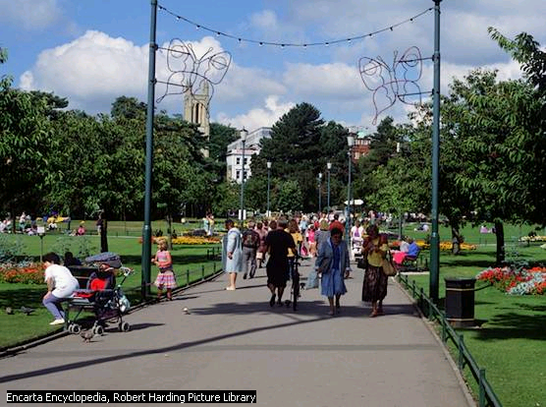

Town Center Gardens, Bournemouth
The scenic seaside resort of Bournemouth, located in Dorset, England, stands at the mouth of the Bourne River overlooking the bay. The city has dedicated much of the inland pine woods to public parks and gardens, such as the Town Center Gardens. (Source: Microsoft ® Encarta ® Reference Library 2005)

Title | Public Space
Thesis | I think the Canterbury Council should construct more Activity Centres in most local areas.
Arguments | Firstly, children can keep busy as well as have fun in holidays. Secondly, they learn a lot about how to do certain things. Finally, it might stop children vandalising properties that don’t belong to them because they can go to the activity centers.  During the school holidays, many children who don’t much on their minds can attend their local Activity Centre. It will keep them busy and they can also learn to do lots of different things.  Another reason is children can encourage others to attend the local Activity Centre. This way children will not get so bored because they can have lots of fun.  Moreover, it could stop children from vandalising other’s property because they have better things to do like going to the Activity Centre and having fun and enjoying themselves.
Reiteration | These are the main reasons why I think we should have more Activity Centres. It will be very educational and a very good experience for lots of children.
(Taken from : Teaching Factual Writing: A Genre Based Approach)
Activity 6
Answer the questions based on the text above!
1. What organization must construct more activity centres?
2. What is activity centres?
3. What kinds of activities are provided by activity centre?
4. What did children usually do if there are no place such as activity centre?
5. Mention the reasons why there must be more activity centre in the town?
- It will keep them busy and they can also …. (prg 3).The underlined word refers to……
- and having fun and enjoying themselves (Prg 5). The underlined sentence refers to…
- What tenses is mostly used in the text above?
- Find out the connectives used in the text?
- What is the function of connectives in a text?
- Does the text influence you to agree to certain issue?

Activity 8
Read the other exposition text. Answer the questions

Social and Economic leaders should not have high formal education
Thesis | That formal education is important for people has been known to all. However, whether people will be good social and economic leaders does not always depend on their formal education. It is believed that experience is also a salient contribution to success
Arguments | It is true that formal education gives benefits to leader- to-be, but things they have got from formal education are not necessarily applicable in the society where they later become leaders. In fact, at schools and universities people only “learn” theories, while in society, people do learn actual lives through their experience. This experience, then, often creates good social and economic leaders. They are actually born from what they have learned in the society.  To take some examples of good social and economics leaders, we can mention some figures. The late Adam Malik was appointed Indonesian Vice President not because of his formal education- he just finished a certain level of elementary school- but because of his capacity acquired from his autodidactic learning. The late Hamka was another leader born from his own way of learning. He also became a well-known religious man and literary man as well because of his autodidactic learning. Even Einstein did not have a good reputation in his formal education, but through his real learning in society he turned out to be a distinguished expert in Physics.
Reiteration | It is clear, then, trough formal education people only learn how to learn, not how to live. Although formal education is necessary, it is not the only way leading people to be social and economics leaders.
Questions
1. According to the writer, is a formal education important to bring one into his/her success?
2. What factors affect people to be good social and economic leaders?
3. What is learnt at university ?
4. Mention the leaders that are taken as examples by the writer?
5. What is the purpose of the text?
6. What is the conclusion of all the statements mentioned in the text?
7. …..but things they have got from formal education are not necessarily applicable…. (prg 2).
The word “they” refers to ……..
8. ….. He also became a well-known religious man and literary man….(prg 3)
The word “he” refers to……
9. The synonym of the word “distinguished” in the paragraph 3 is……….

Activity 9
Observe the pamphlet


(source : www.co.ho.md.us)

Questions
1. What is pamphlet?
2. What is the purpose of pamphlet?
3. What is the content of the pamphlet above?
4. What is EPA?
5. What organization published the pamphlet?
Note :
Pamphlet is a small leaflet or paper booklet, usually unbound and coverless, that gives information or supports a position

- Joint Construction of Text
Activity 10
In group of four, try to complete the text with your own arguments and reiteration!

Title | The Importance of school library
Thesis | From my point of view, School library plays important roles for the success of the students. Why did I state like that?
Argument (1) | Firstly, ……………………………………………………………………………  ……………………………………………………………………………………  ……………………………………………………………………………………  …………………………………………………………………………………..  ………………………………………………………………………………….  ……………………………………………………………………………………
Argument (2) | Secondly, ………………………………………………………………………  ……………………………………………………………………………………  ……………………………………………………………………………………  …………………………………………………………………………………..  ………………………………………………………………………………….  ……………………………………………………………………………………
Argument (3) | Finally……………………………………………………  ……………………………………………………………………………………  ……………………………………………………………………………………  …………………………………………………………………………………..  ………………………………………………………………………………….  ……………………………………………………………………………………
Reiteration | In conclusion, …………………………………………………………………  ……………………………………………………………………………………  ……………………………………………………………………………………  …………………………………………………………………………………..
Activity 11
Make a pamphlet based on the following information.

1. It is about education
2. Persuade people to join an English course
3. Use persuasive sentence
4. Add pictures if necessary
5. If you can, design with computer help.
6. Put on your class wall when you have finished
your work
(Source: www.traininglinkonline-australia.com.au)
D. Independent Construction of Text
Activity 12
Writing a letter.
- Think about public facilities in your neighbourhood that need improving.
- Write a letter to your head of village, head of sub district, regent or mayor.
- In your letter, mention the problems you see and give suggestions to solve the problem.
You can develop these issues or your own issues.
- The number of public dustbin must be increase
- The importance of water sanitation
- Your own issues

________________________
( the date of the letter)

Dear Sir,

Thesis
(What is the purpose of your letter?)
________________________________________________________
________________________________________________________

Arguments
(Explain what facilities are poor and how they disadvantages the people live in your neighbourhood)
________________________________________________________
________________________________________________________

Reiteration
(The restatement of the thesis about the poor facilities)
________________________________________________________
________________________________________________________

_____________
(your name)

TEST 3
A. Choose the correct answer by crossing a ,b, c, d or e
Text 1.
The Importance of The English Language.

I personally think that English is the world’s most important language. Why do I say that ?
Firstly, English is an international language. It is spoken by many people all over the world, either as a first or second language.
Secondly, English is also the key which open doors to scientific and technical knowledge, which is needed for the economic and politics development on many countries in the world.
Thirdly, English is a top requirement of those seeking jobs. Applicants who master either active or passive English are more favorable than those who don’t.
From the facts above, it is obvious that everybody needs to learn English to greet the global era.

01. The purpose of the text is ... .
- to describe something that happens
- to evaluate the necessity of cars in the city
- to persuade readers that something is in the case
- to introduce readers that here are many problems.
- to make readers know about cars in the city

02. How many arguments are stated in the text ?
- 1 D 4
- 2 E 5
- 3

03. What is the first paragraph ?
It is .... .
- Title D elaboration
- Thesis E reiteration
- arguments

04. Why do the writer think that English is an international language ?
Because .... .
- it is a top requirement for job seekers
- it is taught at schools
- it also the key which open doors to scientific and technical knowledge.
- It is spoken by many people all over the world.
- It is needed for the economic and politics development on many countries in the world

05. What for everybody needs to learn English ?
All the answers are correct, EXCEPT .... .
- to communicate with other people
- to study scientific knowledge
- to get a job
- to greet the global era
- to get a better harvest crops

04. English is a top requirement of those seeking jobs.
( Pr.4)
The synonym of the underlined is ... .
- finding D looking after
- getting E looking for
- looking at

05. If people from Saudi Arabia meet a Japanese and Danish in Indonesia they will speak using ... .
- Arab language D Indonesian
- Japanese language E. English
- Danish language

Text. 2
Australian Government System
In Australia, there are three levels of government, the federal governments, state governments and local governments. All of these levels of governments are necessary. This is so for a number of reasons
First, The federal government is necessary for the big things
They keep the economy in order and look after things like defense.
Similarly, the state governments look after the middle sized things. For example they look after law and order, preventing things like vandalism in schools.
Finally, local governments look after the small things
They look after things like collecting rubbish, otherwise everyone would have diseases
Thus, for the reasons above we can conclude that the three levels of government are necessary.

06. Bajuri : What affairs are looked after by the state government?
Oneng : As I know they look after about ….
- preventing attacks from foreign countries
- preventing diseases at small town
- Keeping the economical growth of the country.
- Keeping vandalism in the country
- Keeping law and order

07. Bobi : What business done by the local government?
Boni : They do …………….
- international things
- national things
- state things
- local things
- village things

08. Andi : What is the genre of the text above?
Ani : It belongs to ………… genre
- explanation
- narrative
- anecdote
- hortatory exposition
- analytical exposition

09. Amin : What is the purpose of the text?
Budiman : The purpose is…..
- to persuade the reader or listener that something should or should not be the case
- to persuade the reader or listener that something is the case
- to inform readers, listeners or viewers about events of the day which considered newsworthy
- to share with others an account of an unusual or amusing incident
- to explain the processes involved in the formation or workings of natural or sociocultural phenomena

10. Kelly : How is the generic structure of the text above?
Alan : It is ………
- Thesis – arguments – reorientation
- Thesis – arguments – twist
- Thesis – arguments –recommendations
- Thesis –arguments – reiterations
- Orientation –events – reorientation

11. Hans : in the text we found sentence, “Thus, for the reasons above we can conclude
that the three levels of government are necessary.” What part is it?
Christine : It belongs to …
- thesis
- arguments
- reiteration
- recommendation
- closing

12. I think it’s good to be bald. Firstly, you don’t have to wash your hair. Secondly you don’t have to comb your hair. And ……..you don’t have to go to the barber. So you’re lucky if you are bald.
- whereas
- since
- as well as
- similarly
- finally

- Having breakfast is important for our health. Firstly, it gives us the energy for the day. Secondly, it will keep our stomach processing food, by not letting it empty. Empty stomach causes stomachache. Thirdly, Having breakfast is refreshing our brain. Brain need nutrient to support its works. ……………have your breakfast before leaving for office or school.
- Therefore
- However
- Then
- In addition
- As well

- The welfare officer announced that food supplies ………….to the flood victims
- were being send
- were been sent
- were being sent
- were sent
- were sending

- The medicine …………by John because he is sick
- must take
- must took
- must be taken
- must have taken
- must be taking

- A new science laboratory ………….in our school compound now.
- is been built
- is being built
- is building
- have been built
- is built

- The food ………..several hours before the guests arrived.
- were cook
- had been cooking
- had been cooked
- had cooked
- is cooked

18. Mr. John : Remember to call home …………you arrived at London
Dalton : All right dad.
- since
- even though
- unless
- where
- as soon as

19. Teacher : I will punish you, ………you finish your homework
Students : Yes, Sir!
- before
- because
- in order to
- unless
- if

20. Riana : …………I was playing the piano, Mr. Rudi phone me .
Deni : What did he talk about?
Riana : He told me that I would be sent to international piano contest at Beijing
- while
- as
- although
- since
- so that

B. Essay
21. Fill in the blank with the expression of relief
Dina : From the car accidents. Only our father who survives
Lina` : …………………………………………………………………

22. Fill in the blank with the expression of pain
Kerry : Why do you look so sad? What’s the matter?
Marry : ………………………My boy friend just broke our relationship.

23. Fill in the blank with the expression of pleasure
Mr. John : How is your meal. Is it delicious ?
Mr. Keen : ……………… This is the most delicious food I ever ate

24. Change the sentence into passive construction
Rina has fed the chicken for an hour.
……………………………………………………………………………………………………….

25. Combine the sentences into complex sentence by using suitable dependent word
Dina lives alone
Dina feels happy
…………………………………………………………………………………………………………

UNIT 4
Lets write a story
Text type : Narratives (Fables and )

In this unit, you will learn how to:
1. Carry out interpersonal conversation involving :
  - Expression of love
  - Expressions of sadness
2. Tell narratives using spoken English.
3. Read narrative texts
4. Listen short functional texts ()
5. Write short functional texts ( )
6. Write narrative texts

Language features

    - Gambits

Step 1(Spoken)
Listening and speaking

A. Building knowledge of field
Speech Functions
1. Expression of love.
Activity 1.
Observe the dialogue
Here is the picture of our news apartment. It was taken two days ago. It is so lovely, Isn’t it?
Yes, It’s marvelous. I love it. When will we open it?

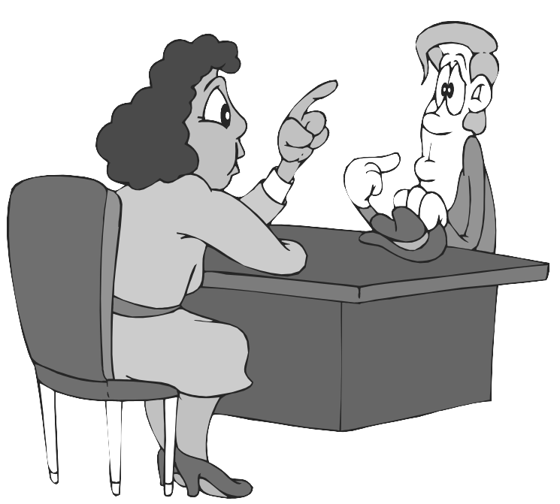

Activity 2.
Listen your teacher’s reading the dialogue
Adi : Have you ever read “Aesop’s Fables”?
Andi : Not yet. How about you?
Adi : I have read it twice
Andi : What kind of book is it?
Adi : It’s a fable. You know.. animal story.
Andi : Wow. ..you mean story which the main characters are animal?
Adi : You are right.
Andi : Why do you like fables?
Adi : First, the story is very amusing. Second, it has moral value that is useful for our life.
Andi : You must like such kind of books very much, mustn’t you?.
Adi : Yes, I even love the story. If I have much money. I’ll buy the new series of fables. I want to collect
Them. I want to build a mini library about fables.
Andi : That’s a good idea!.
Adi : Thanks.

Answer these questions
1. Who are they?
______________________________________________________________________
2. What are they talking about?
______________________________________________________________________
3. What book has Adi read to?
______________________________________________________________________
4. How is his feeling about the book?
______________________________________________________________________
5. Can you show his expression to show his feeling?
______________________________________________________________________
6. Can you mention the other examples of expression of love?
______________________________________________________________________

Activity 3.
Learn these expressions

Expression of love | Responses
I love you  I love you so much  I love you from the bottom of my hard  I must love it  I really love it  I am crazy about you  I am crazy of … | I love you too  So do I  Me too  I love it too  I feel the same with you

Activity 4.
Fill the blank with suitable expression of love and its responses
1. Sonia : Khan, Why do you always send me this love letters, call me any time, come to my
house? Why you do that?
Khan : _______________________of you Sonia. I can forget you.

2. Sandy : Aulia, I love you from the bottom of my heart.
Aulia : Oh, Aulia , __________________________________
Sandy : Really?
Aulia : Yes

3. Amin : Here is your folktales book.?
Ari : Yes, Isn’t this book great.
Amin : Yes, what do you feel about the book?
Ari : ________________________. I’ll buy some others if I have money.

4. Kane : Here a present for you. Happy birthday Ary.
Ary : Oh, thank you. What is it?
Kane : Just open!
Ary : Wow. a laptop . _____________________ .

5. Andi : Can I be frank about what I’m really feeling?
Rika : Yeah…
Andi : __________________________________________
Rika : Really? Do you ?
Andi : Yes, I do.

Activity 5.
Work in pairs. Make a sustained conversation that contains expression of love based on the following situation.

You like a girl at your class. Her name is Tiara. You try to express your feeling to her. Start with small talk with her. She is sitting at a bench at the school park.

You : May I sit here, Tiara?
Tiara : Please. Have your seat.
You : What a nice day, isn’t it?
Tiara : Yeah. It is nice to sit here. Do you want some candy? I Have some . Here’s for you?
You : Thanks. Uhm … delicious. Tiara, Won’t you be angry if I (continued by your group)
Tiara : ____________________________________________________________________
You : ____________________________________________________________________
Tiara : ___________________________________________________________________
You : __________________________________________________________________
Tiara : __________________________________________________________________
You : __________________________________________________________________
Tiara : __________________________________________________________________
You : __________________________________________________________________
(continue by yourself)

2. Expression of Sorrow
Activity 6
Observe the picture
No, John, I am not Ill. But I am very sad today because all my data was damaged by computer virus .
Why do you look so pale. Are you ill, Robert?




Question
The underlined utterances express Robert’s ____________________

Activity 7
In pairs. read aloud the following dialogue.

Karen : Hi, … Sally. What’s wrong with you. You look so sad.
Sally : Please, leave me alone.
Karen : What’s the problem? Tell me.
Sally : I can’t tell my pain and sorrow in words.
Karen : Oh, I guess. It must be about Josh . Am I right?
Sally : Yes. He broke my heart again.
Karen : Please. Come on girl. Don’t take it into your heart. There is not only one guys, right?
Sally : Yes, you are right. But I love him so much.
Karen : OK. Let’s go to Disneyland and make some refreshing there.
It will open your mind and heart.
Sally : OK. Let’s go.

Question
1. Who are Karen and Sally?
2. Why is Sally sad?
3. Which utterance expresses Sally’s feeling?
4. What does Karen suggest to Sally?

Activity 8.
Learn the following expressions

- Please, leave me alone.
- I can’t tell my pain and sorrow in words
- It brought me a lot of miseries
- My heart is so burdened
- I’m so sad to hear this
- I’m feeling bad at this time being
- I regret having to do this

Activity 9.
In pairs. Write an interpersonal dialogue based on the situation given.
01. Your friend’s father has just passed away. He/she is sad now.
He/She sharing his/her sorrow with you.
You : ____________________________________________________
Your friend : Well, my father died last week. I can’t forget him until this time.
He was a good man.
You : ____________________________________________________
Your friend : ____________________________________________________
You :_____________________________________________________
Your friend : ____________________________________________________
(continue by your self)

02. You are falling in love with a girl. But she refuse you. One of your friends knows your sorrow
Your friend : Hey, why do you look so sad? I know, it must be about Dina. She refused you, didn’t she?
You :______________________________________________________
Your friend :______________________________________________________
You : _____________________________________________________
Your friend : _____________________________________________________
(continue by your self)
03. Your friend has just broken up with her girlfriend. He is sad now.
He is sharing her sorrow with you.
You : ______________________________________________________
Your friend : Well, I broke up with Alia.
You : ______________________________________________________
Your friend :_______________________________________________________
You :_______________________________________________________
Your friend :_______________________________________________________
(continue by your self)

2. Fables
Activity10.
Listen to your teacher reading the text while you fill in the blank with the word/words you heard.

Antlers
A handsome ….(1) with majestic … (2) admired himself in a lake. As he looked at his reflection he thought, "My antlers are beautiful! But these …. (3) legs of mine are so skinny I wish I could hide them in shame." Just then a hunter's arrow ….(4) and the stag bounded into the woods. As he ran, his beautiful antlers ….(5) and snagged on the … .(6) of a low-growing tree. Struggling, he finally pulled himself free. If it weren't for the …..(7) speed of his legs, he would surely be captured.
After that, when he ….(8) his spindly legs, his pride would swell. "In times of danger," he thought, "They serve me well."

Activity 11
What is the moral of the story above
MORAL:
…………………………………………………………………………………………………………..
…………………………………………………………………………………………………………..
…………………………………………………………………………………………………………..

Activity 12
Match the word/phrase in column A with its meaning in column B
No. | Words/phrase (A) |  |  | Meaning (B)
1. | Gazed at |  | A. | to move swiftly with a humming, hissing, or buzzing noise, or to cause something to move in this way
2. | Branches |  | B. | Very beautiful and delicate
3. | Caught |  | C. | an adult male deer
4. | Stag |  | D. | The condition of being trapped
5. | Spindly |  | E. | bony outgrowth on head of deer
6. | Exquisite |  | F. | a woody limb of a tree that grows out from a larger limb or from the trunk
7. | Antlers |  | G. | to look for a long time with a fixed stare
8. | Whizzed by |  | H. | long or tall, thin, and weak-looking

Activity 13
Fill in the blank with the suitable word from activity 12
1. Look at the mango tree. It has a lot of fruits on its ___________
2. My uncle is a hunter. He likes to hunt deer. He collects some ___________ exhibited on
the wall.
3. I ____________ some deer at the woods for long time. I like them because they are so lovely.
4. We saw some ___________grassing at the Bogor palace yard when we went there.
5. Because of its carelessness, the rabbit ___________in trap.
6. Look at the deer. They are so ______________, aren’t they?

3. Grammar focus
a. Subjunctives
Activity 14
Pay attention to the following sentence:
……are so skinny I wish I could hide them in shame.

The pattern of the sentence above is subjunctives . Means that someone makes a wish of his/her real condition he/she faces now. The general pattern of subjunctives is as follow:
Subjunctive sentence uses “wish”, “if only”, “would rather”, “as if” or “as though”

Kinds of Subjunctive Sentences
- Future Subjunctive
It shows on the future time (in the fact) which has the opposite meaning. And it always uses a clause in the past future tense
………..wish  ………..would rather would + V1  ………. If only S + ………  ………. As if would be + adv/adj/noun  ………..as though | Tonight  Tomorrow  Later  Next…

Example : I wish you would stop saying that.
(the fact) : you won’t probably stop

- Present Subjunctive
It shows on the present time (in the fact) which has the opposite meaning. And it always uses a clause in the simple future tense
………..wish  ………..would rather V ₂  ………. If only S + ………  ………. As if were + adv/adj/noun  ………..as though | today  now  at this time  at present  at this moment

Example : - I would rather you told me the news now.
( the fact ) : you don’t tell me the news now
- he behaves as if he were the owner of the hotel
( the fact ) : He is not the owner of the hotel

- Past Subjunctive
It shows on the past time (in the fact) which has the opposite meaning. And it always uses a clause in the past perfect tense
………..wish  ………..would rather Had V₃  ………. If only S + ………  ………. As if had been + adv/adj/noun  ………..as though | Yesterday  This morning  Last ….  …. Ago  in ….(tahun lampau)  when S + V₂

Example : - She wished she had had more time last night
( the fact ) : she didn’t have more time last night
- If only they had been my friend.
( the fact ) : they were not my friend.

Activity 15
Put the words in the bracket into the correct form and explain about the fact.
- If only his son (study) harder yesterday
___________________________________________________________________
- If only you (leave) now.
___________________________________________________________________
- We would rather (study) at home tonight
___________________________________________________________________
- Mr. Woo would rather (work) on Monday the on Sunday.
__________________________________________________________________
- The old lady dresses as if it (be) winter even in the summer
__________________________________________________________________
- She looked as though she (run) ten miles
___________________________________________________________________
- My sister wish they (stop) making so much noise that I could concentrate.
___________________________________________________________________
- Denny wished that the editors (permit) him to copy some of their material
___________________________________________________________________

Activity 16.
Find out the facts of the following subjunctives .

B. Modeling of text

